2. JavaScript Foundation

2. Javascript Engine

There are 2 ways we can convert our code into machine language either by using an interpreter or compiler

Interpreter: with this, we translate and read the files line by line on the fly. The drawback with the interpreter is that it doesn’t optimise the code. Meaning, in the below code, the function someCalculation() returns the same output over and over.

Compiler: takes time in up and running, but it optimises the code like in the below function if the input param and output is same it converts the function into something like 9 which is the output of this code. So it doesn’t have to run it over-2 again.

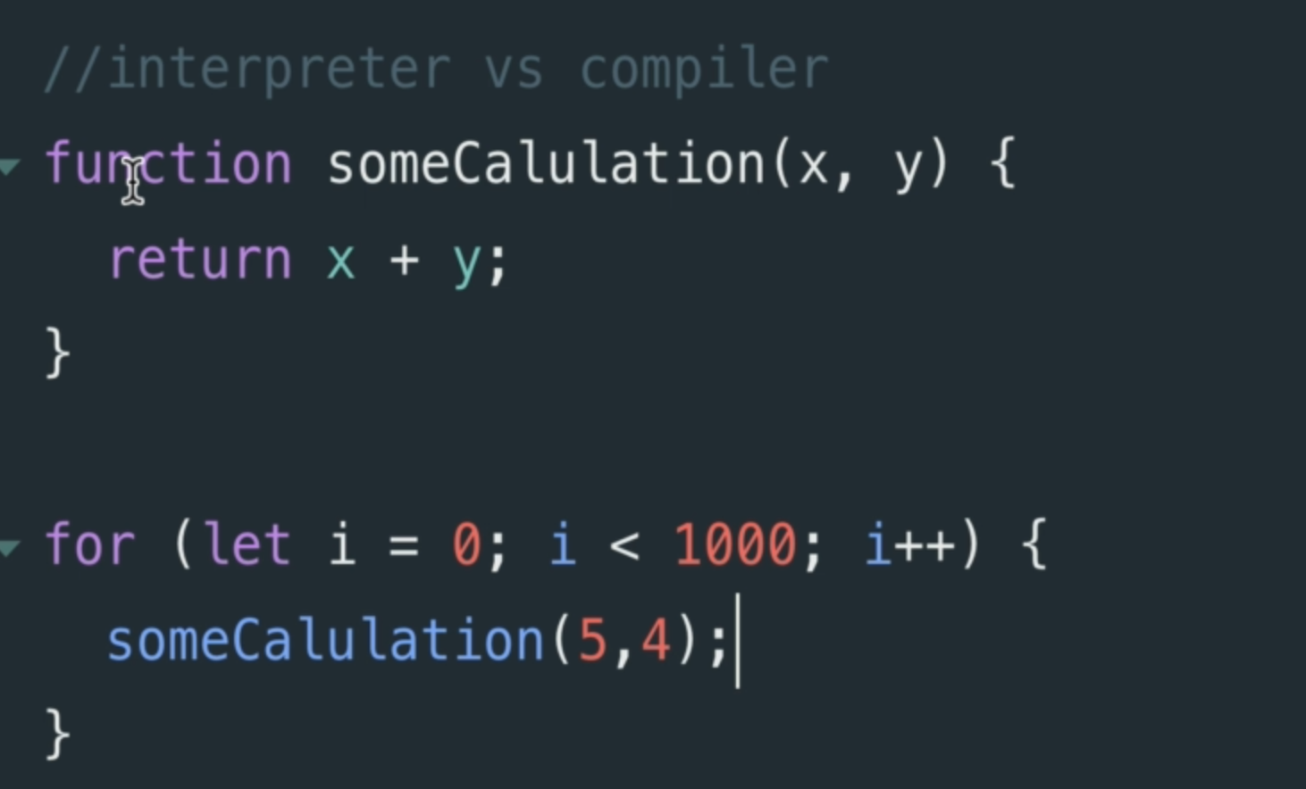

There are 2 ways to run JavaScript, an interpreter or a compiler.

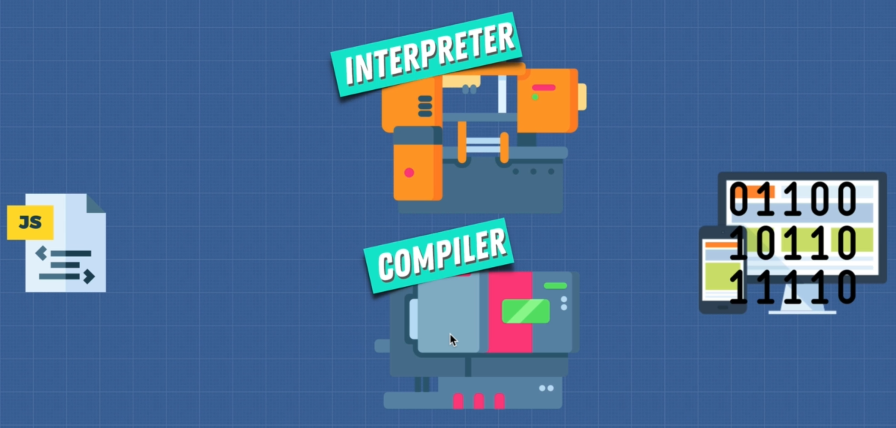

8. Inside the V8 Engine

V8 engine uses JIT compiler which is a combination of interpreter and compiler

AST: abstract syntax tree

Profiler: it is also called a monitors and watches.

Monitors and Watches it makes note on how we can optimise this code such as how many times it is being run. What types are used and how we can possibly optimize this.

Using this Profiler as the code is running through our interpreter which tells our browser what to do if the same lines of code are run a few times, we actually pass off some of this code to the compiler. As the code is running, the interpreter is going to say, here is some code for you to optimise.

The compiler converts the byte code into machine code so it runs faster.

The interpreter allows us to run the code right aways and the compiler and profiler optimises code as we are running.

Note: Byte Code: it is not a native machine code



It depends on the engine we are using and and how we are implementing. Like python can be interpreted or compiled

10. Writing Optimized Code

In order to help the JavaScript Engine we want to be really-2 careful with those on the left functions.

There are 2 main reasons that these left functions/keyword can make JavaScript less optimized.

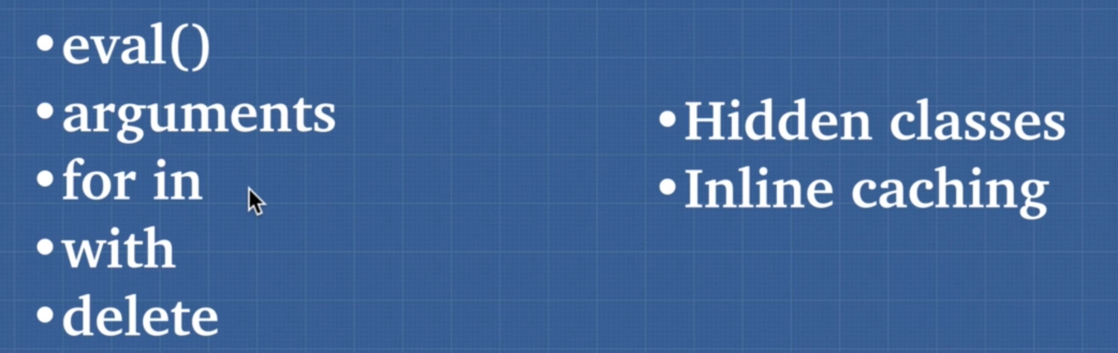

Due to Inline caching done by the compiler, code that executes the same method repeatedly like in the below function, the compiler can optimize this so that whenever the function is looking for user data which has firstname and lastname, it can use something called inline catching where instead of looking up the userData object every time, finding the key and it’s value, it catches (inline catch) so find user converts into simple string “firstname and lastname”

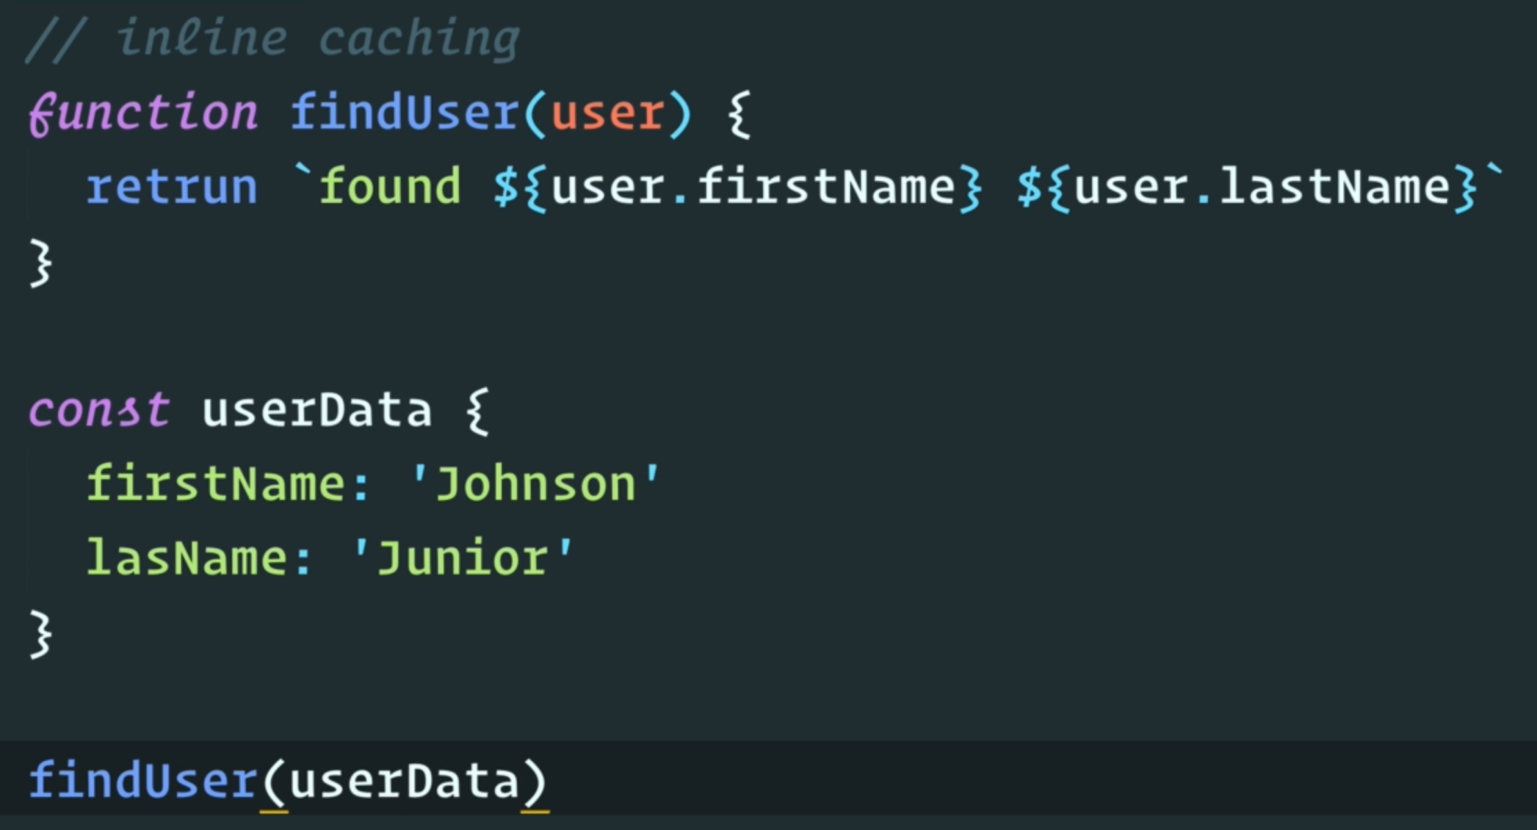

HIdden Classes: “delete keyword” really affects this hidden classes

The below code is actually to make the compiler run slower or de-optimized

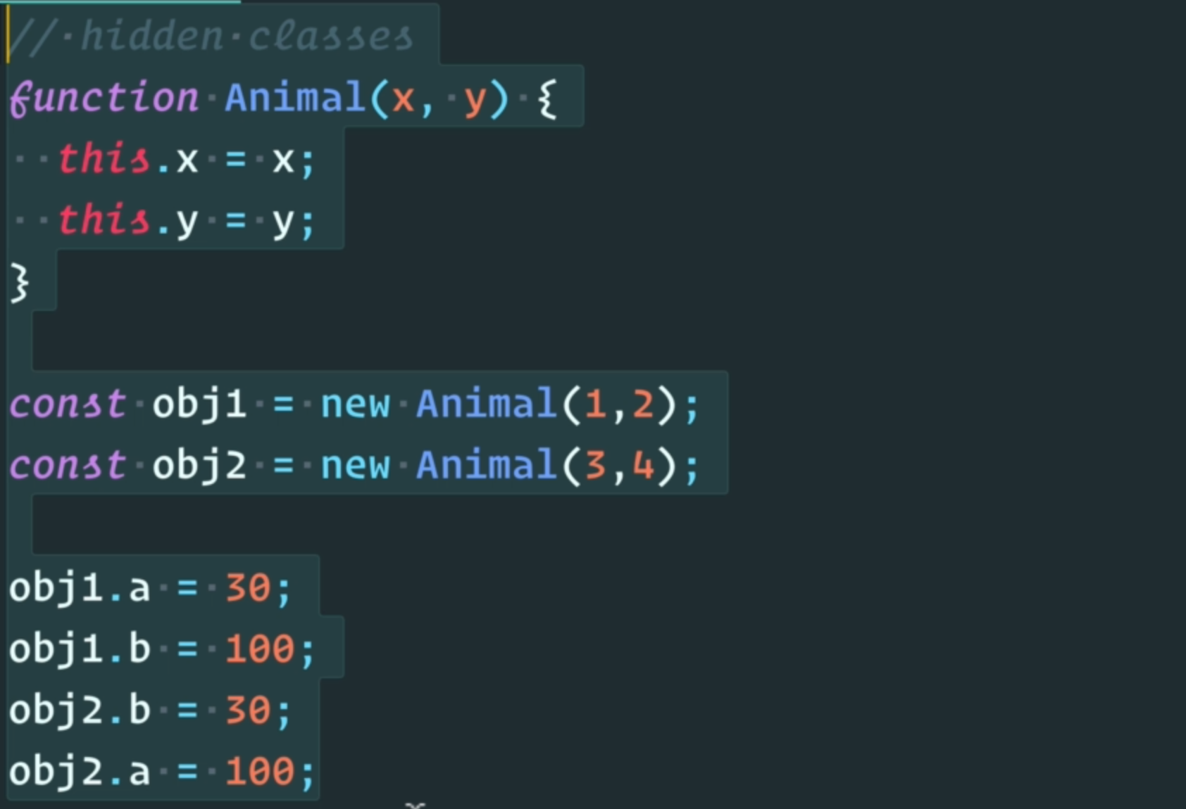

HIdden classes which compiler uses under the hood, but as soon as you start introducing things in different orders it is going to get confused and say they don’t have a shared hidden class they are 2 different things and internally that’s going to slow things down so one thing you want to do in a situation like this is to assign all properties of an object in it’s constructor.

The same problem is with delete keyword

Note: you should write code that is predictable, not only for human, but also for machine.

The more predictable your code is, the better it will be because they will have no surprises.

11. WebAssembly

WebAssembly is a standard executable format so that it runs really-2 fast on browser.

With WebAssembly, we don’t need an interpreter and compiler which JavaScript engine requires to run the code on the browser.

12. Call Stack and Memory Heap

Memory Heap: where the memory allocation happen

Call Stack: where the engine keeps track of where your code is and it’s execution. Call stack stores functions and variables as your code executes.

Simple variable can usually be stored on the stack and object, array and functions are stored on the memory

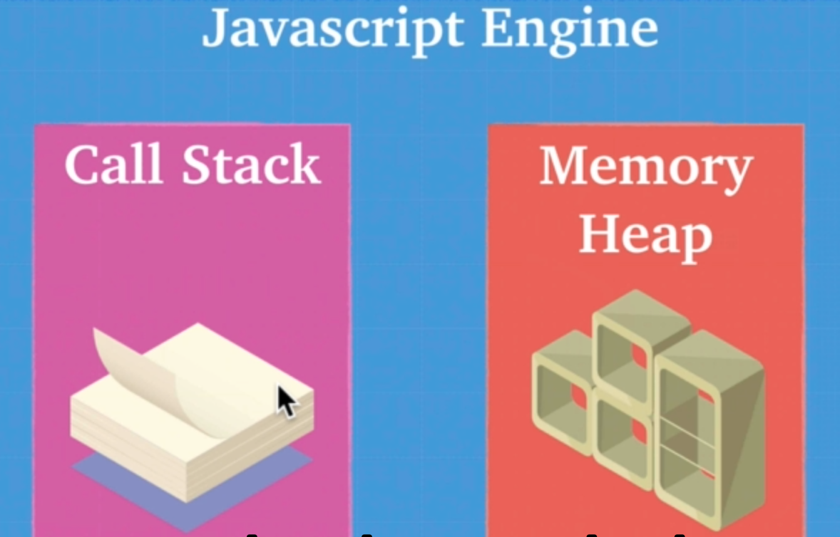

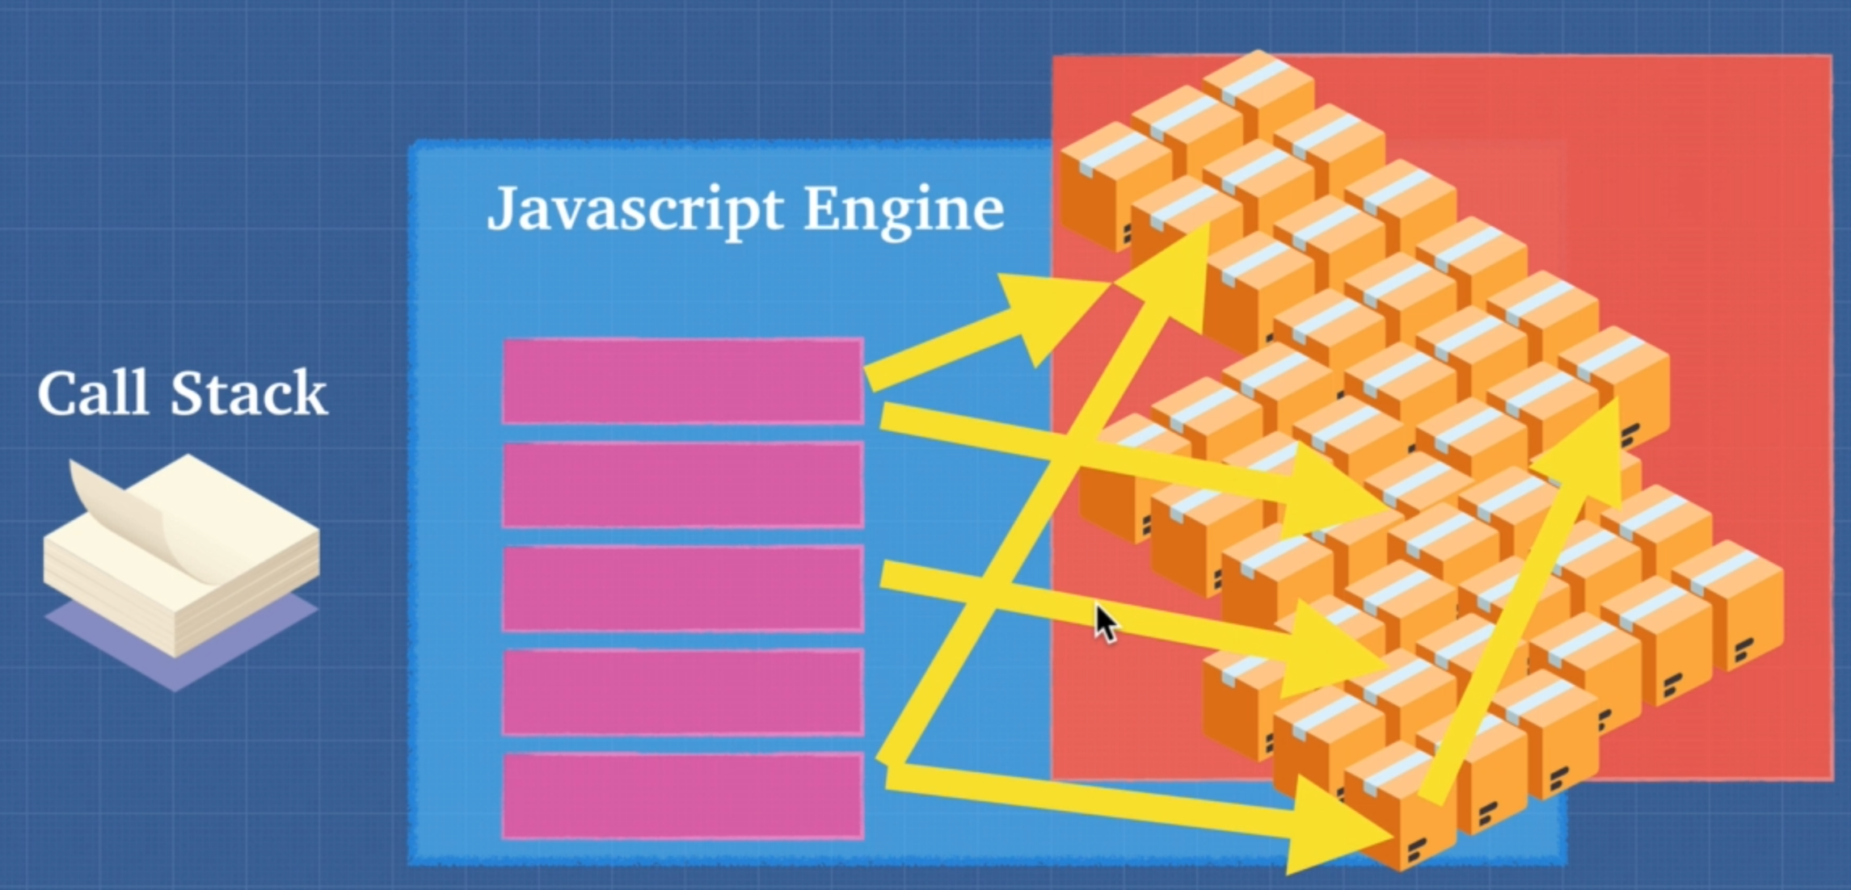

14. Garbage Collection

JavaScript is a garbage collected language. When JavaScript allocate memory to a function, it cleans up memory after function execution.

Javascript garbage collector uses algorithm called “Mark and Sweep”



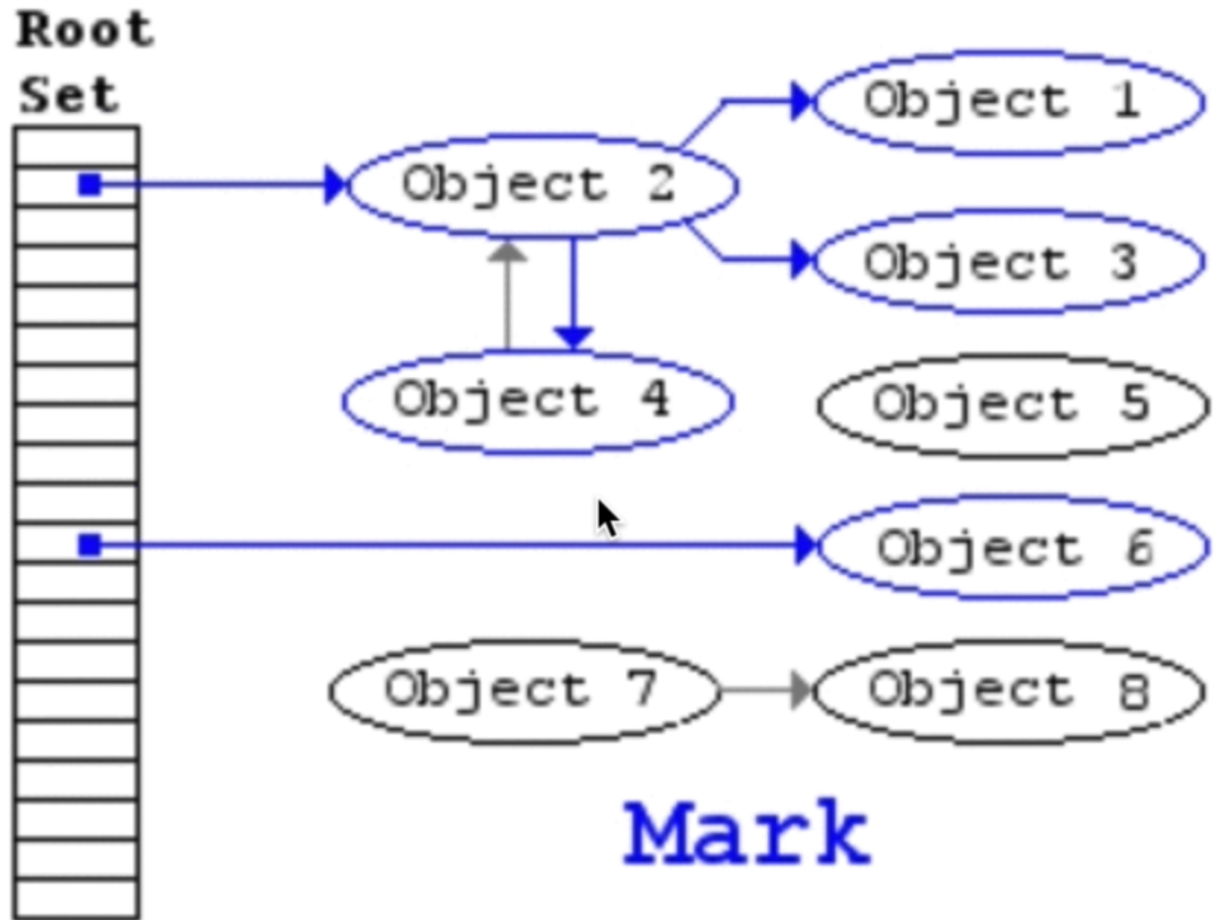

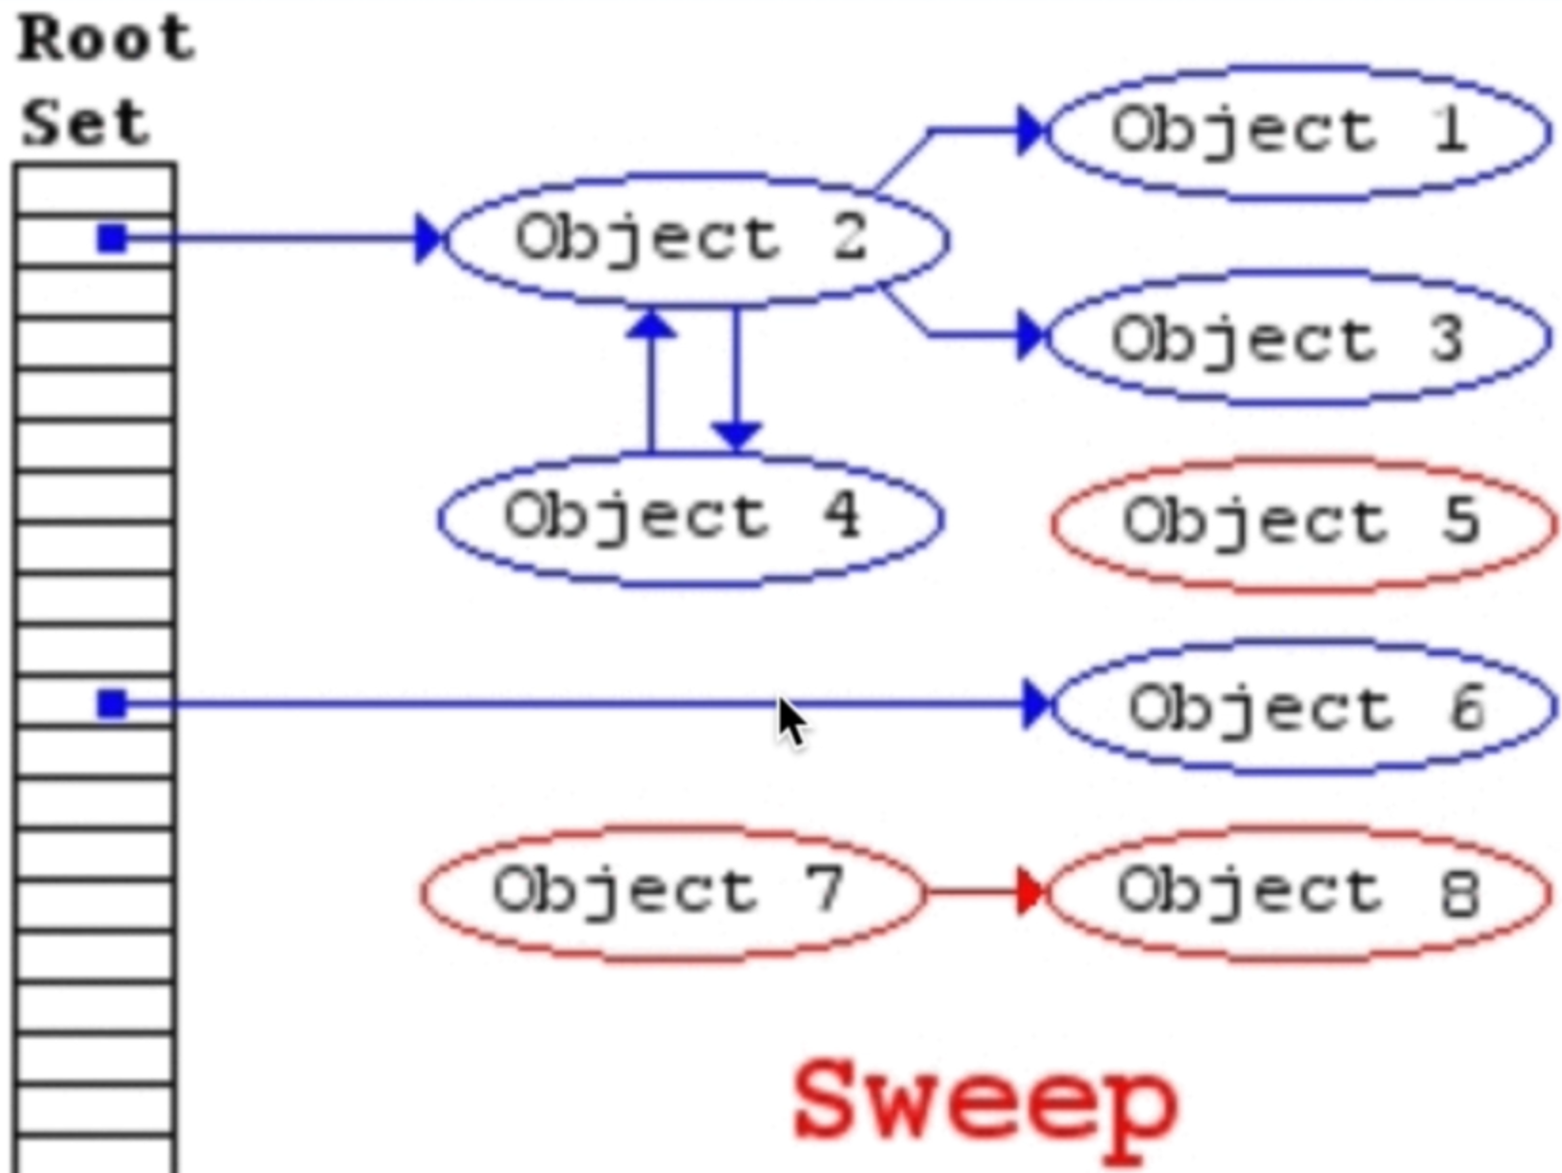

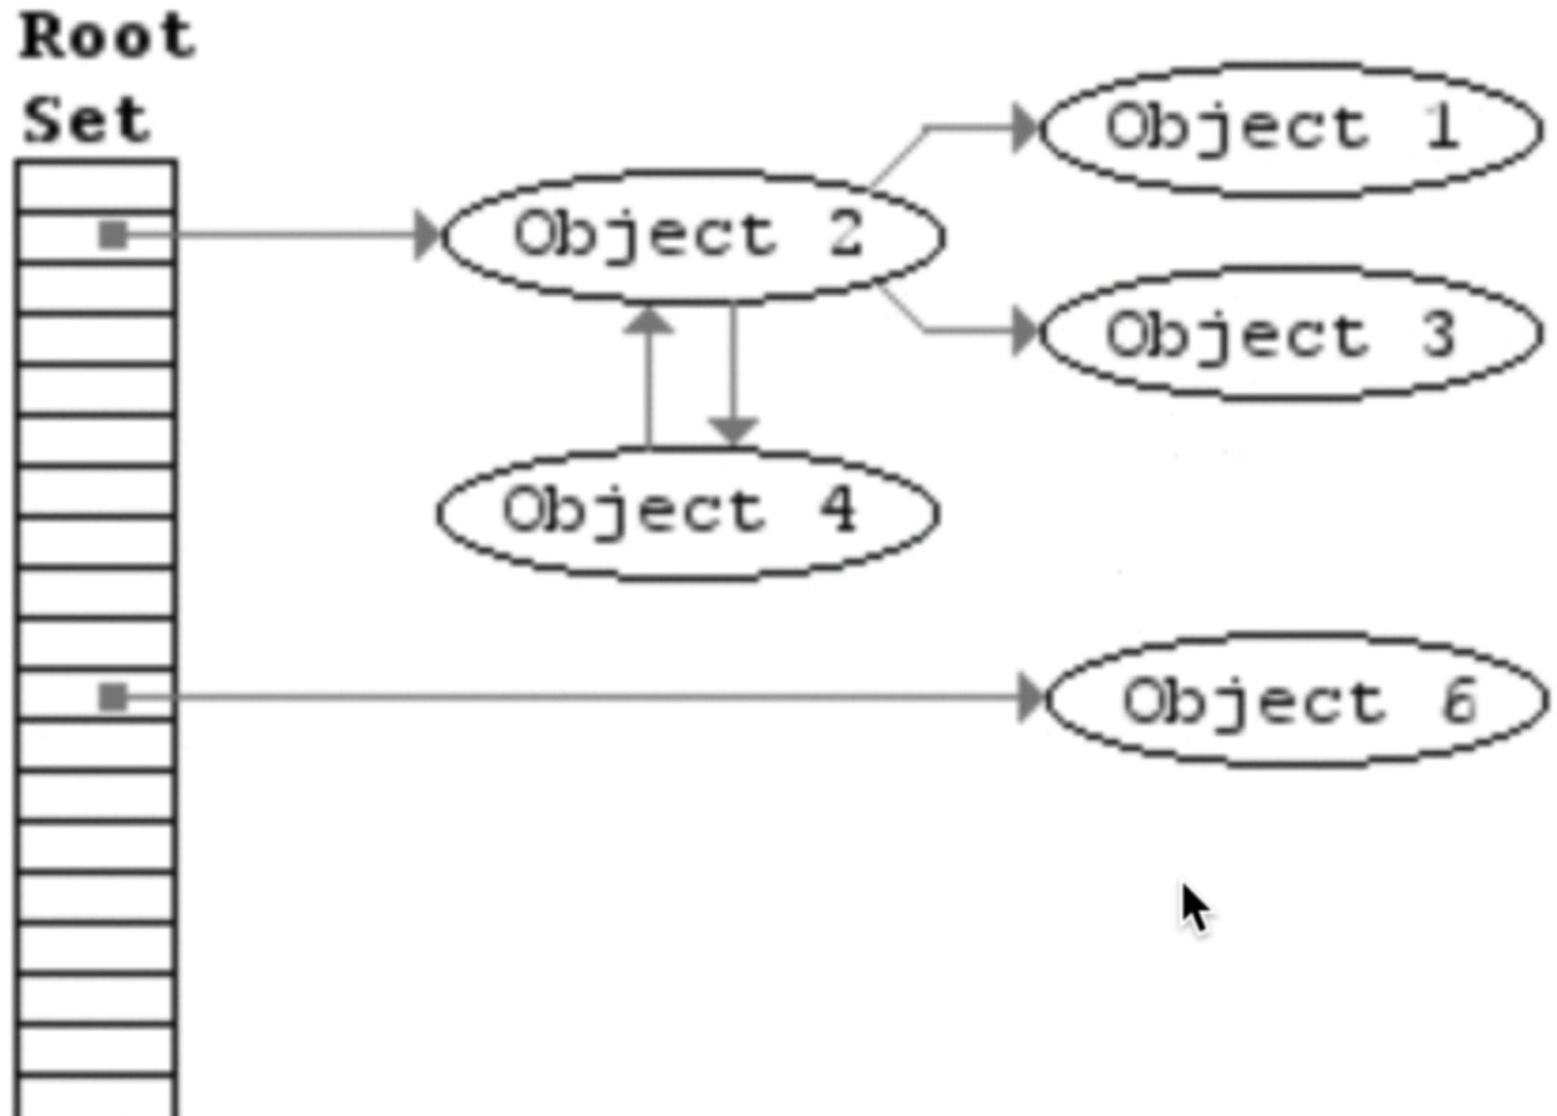

This is the way our garbage collector works. It remove variable and objects which are not in any reference.

15. Memory Leaks

There are 3 ways that you can avoid memory leak

Global variables

Try to limit the number of variables to define on global scope like this

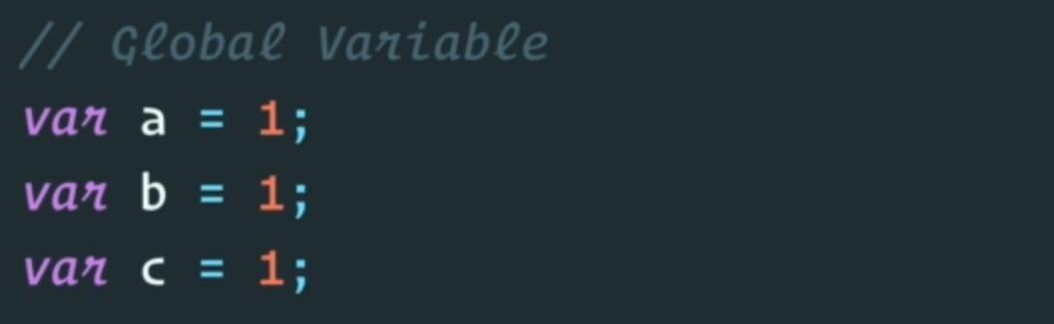

Event Listener

You add event listener and you never remove them when you don’t need them. This is very common memory leak.

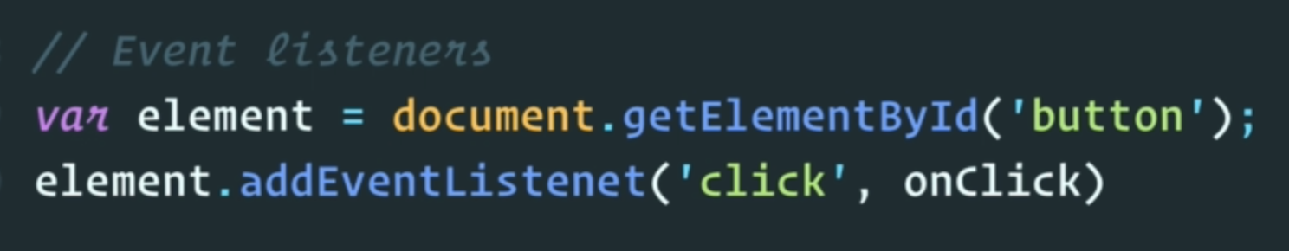

Referencing object inside setInterval()

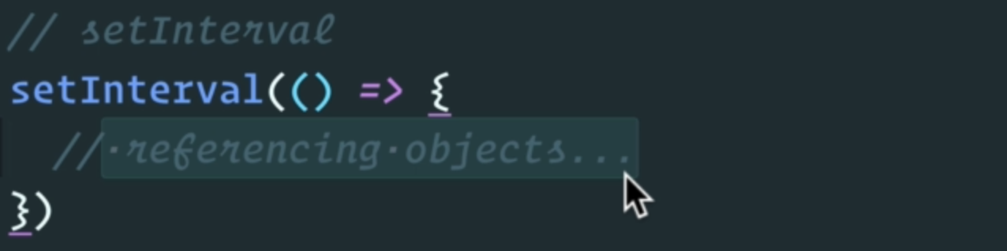

16. Single Threaded

To make sure that JavaScript is single threaded to see that it has single call stack.

Example: I can have with single hand and once I am done chewing then grab next one.



Note: javaScript is synchronous

17. Exercise Issue With Single Thread

With single threaded synchronous code that JavaScript engine runs, it’s going to make it really difficult if we have long running task.

The example of this is alert() function. It doesn’t allow you to click or scroll until you clear the alert()

Most of the time never use JavaScript engine which is synchronous. We have JavaScript runtime which other APIs to handle asynchronous operations.

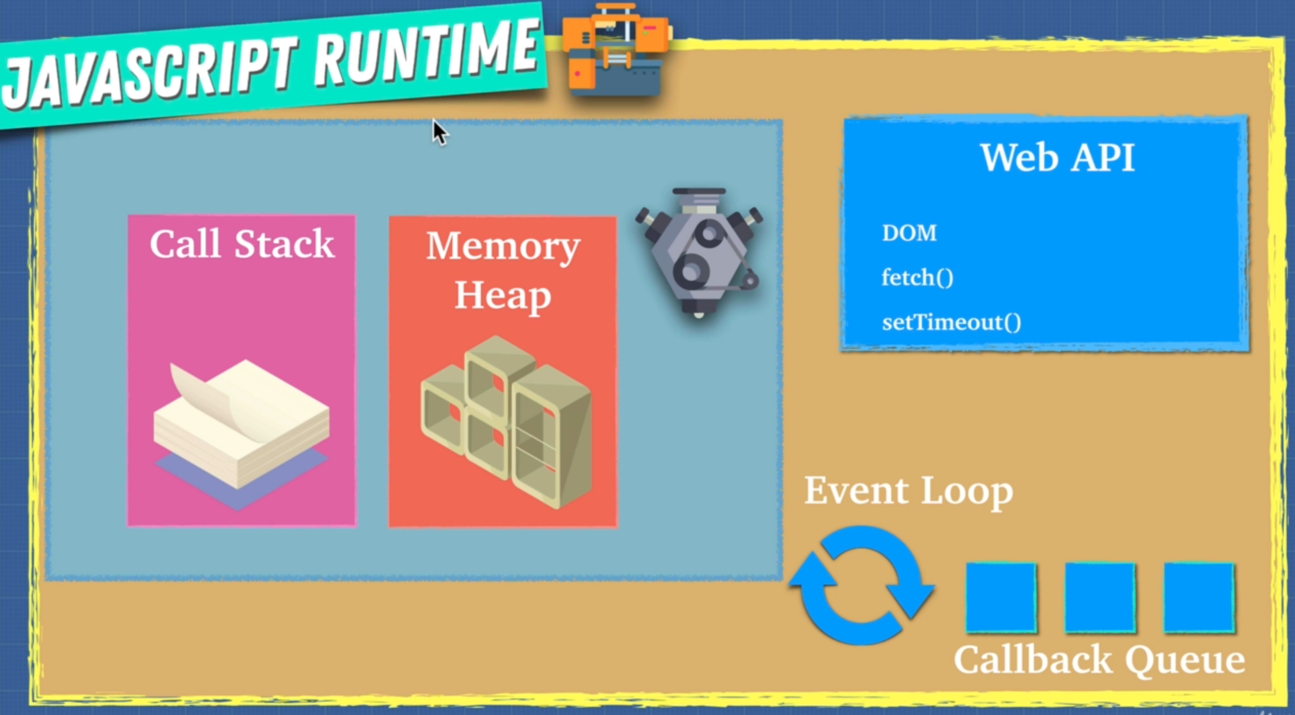

18. Javascript Runtime

Web API comes with the browser. All browsers have JavaScript runtime which have webAPI

WebAPI: does a lot of things like sending HTTP request, listen to DOM events, delay execution something like setTimeout(), it can even be used for caching or database storage on the browser.

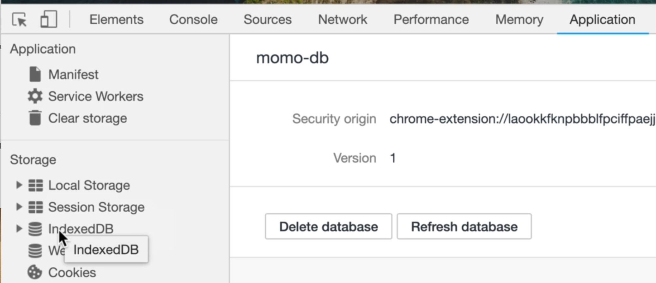

setTimeout and setInterval and many other functions and features are provided by WebAPI, they are not part of JavaScript.

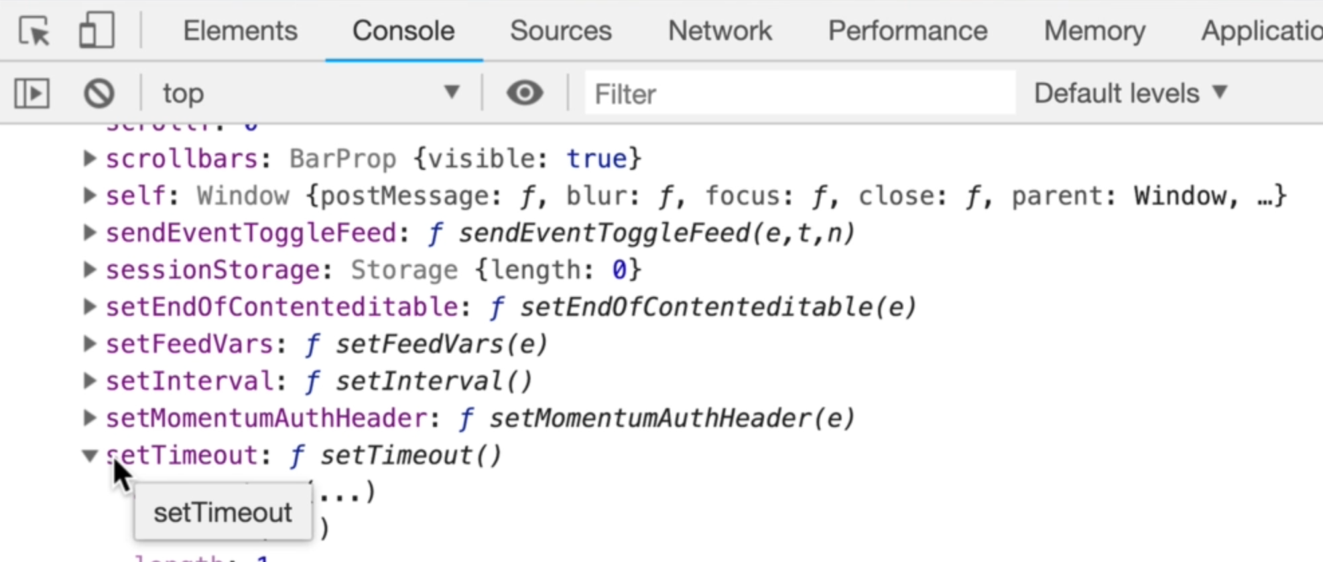

Browsers underneath the hood use low level programming languages like C++ to perform the above mentioned operations in the background.

Note: WebAPI is asynchronous

Once WebAPI done it’s work, it sends that off to callback Queue and once the JavaScript call stack is empty, the event loop takes the first callback from the callback queue and pushes that on to JavaScript stack and there javaScript engine runs it.

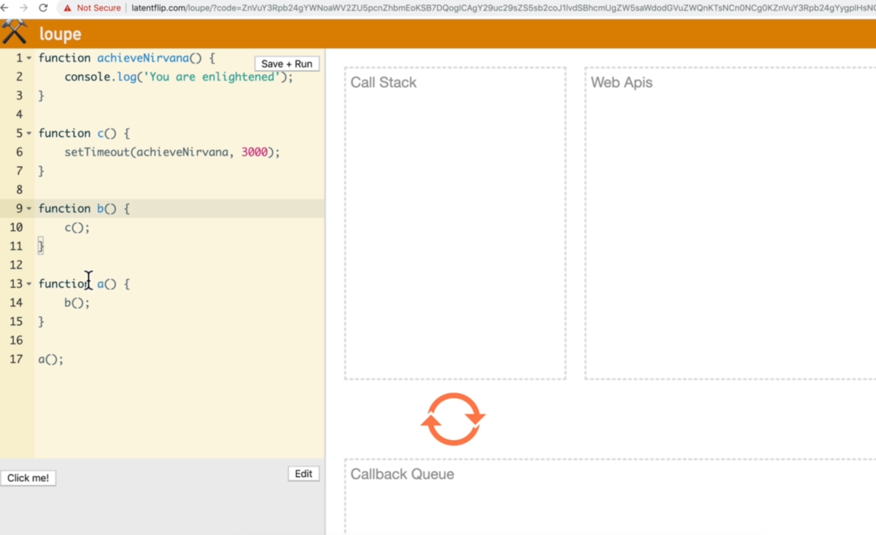

19. Node.js

Is Nodejs a programming language? => No

is nodejs a javaScript engine? => No

is nodejs a runtime? => Yes

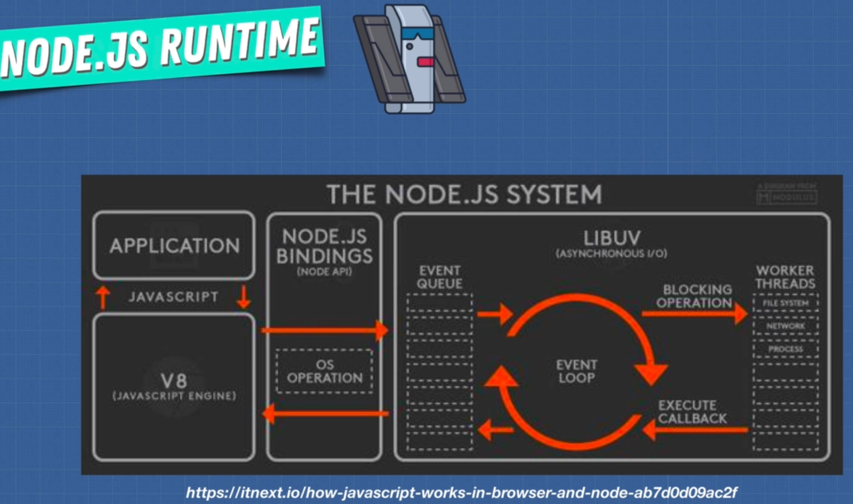

**3. Javascript Foundation II**

2. Execution Context

JavaScript Engine creates these 2 objects

1. Global object (window)
2. “this” Object

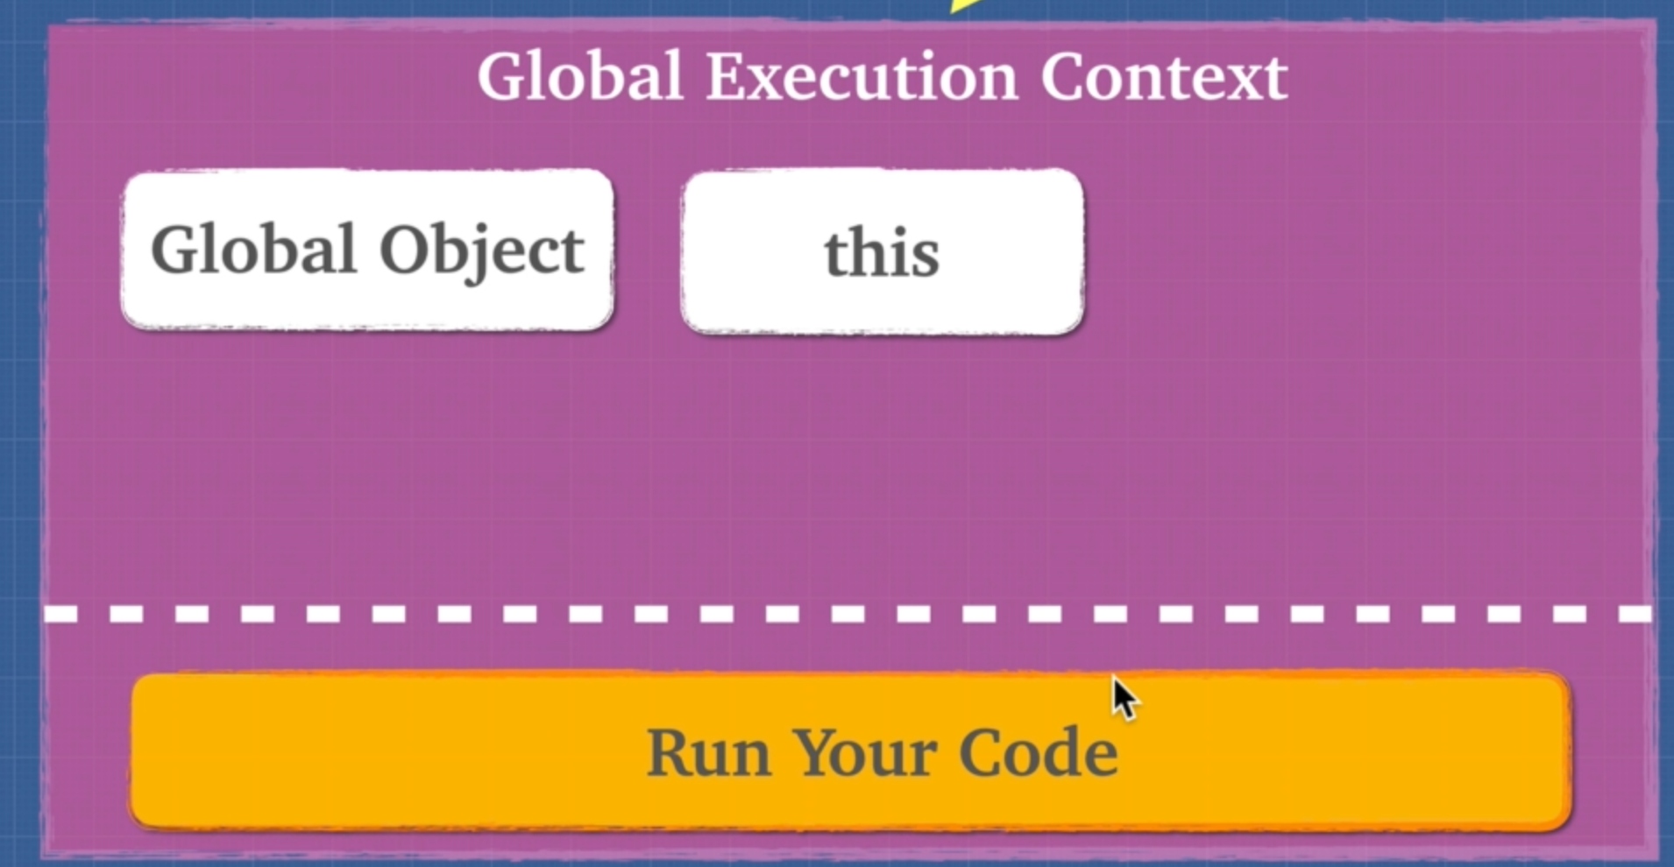

3. Lexical Environment

Lexical: it check where the code is at compile time

Lexical scope/Environment is where you write code

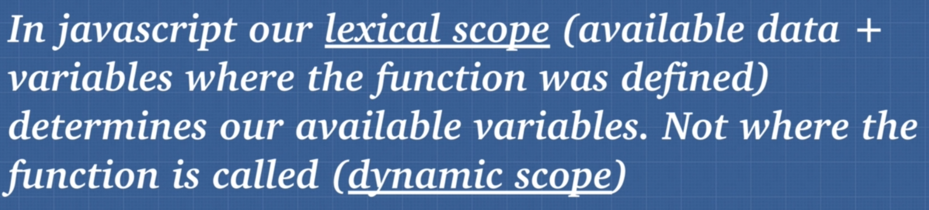

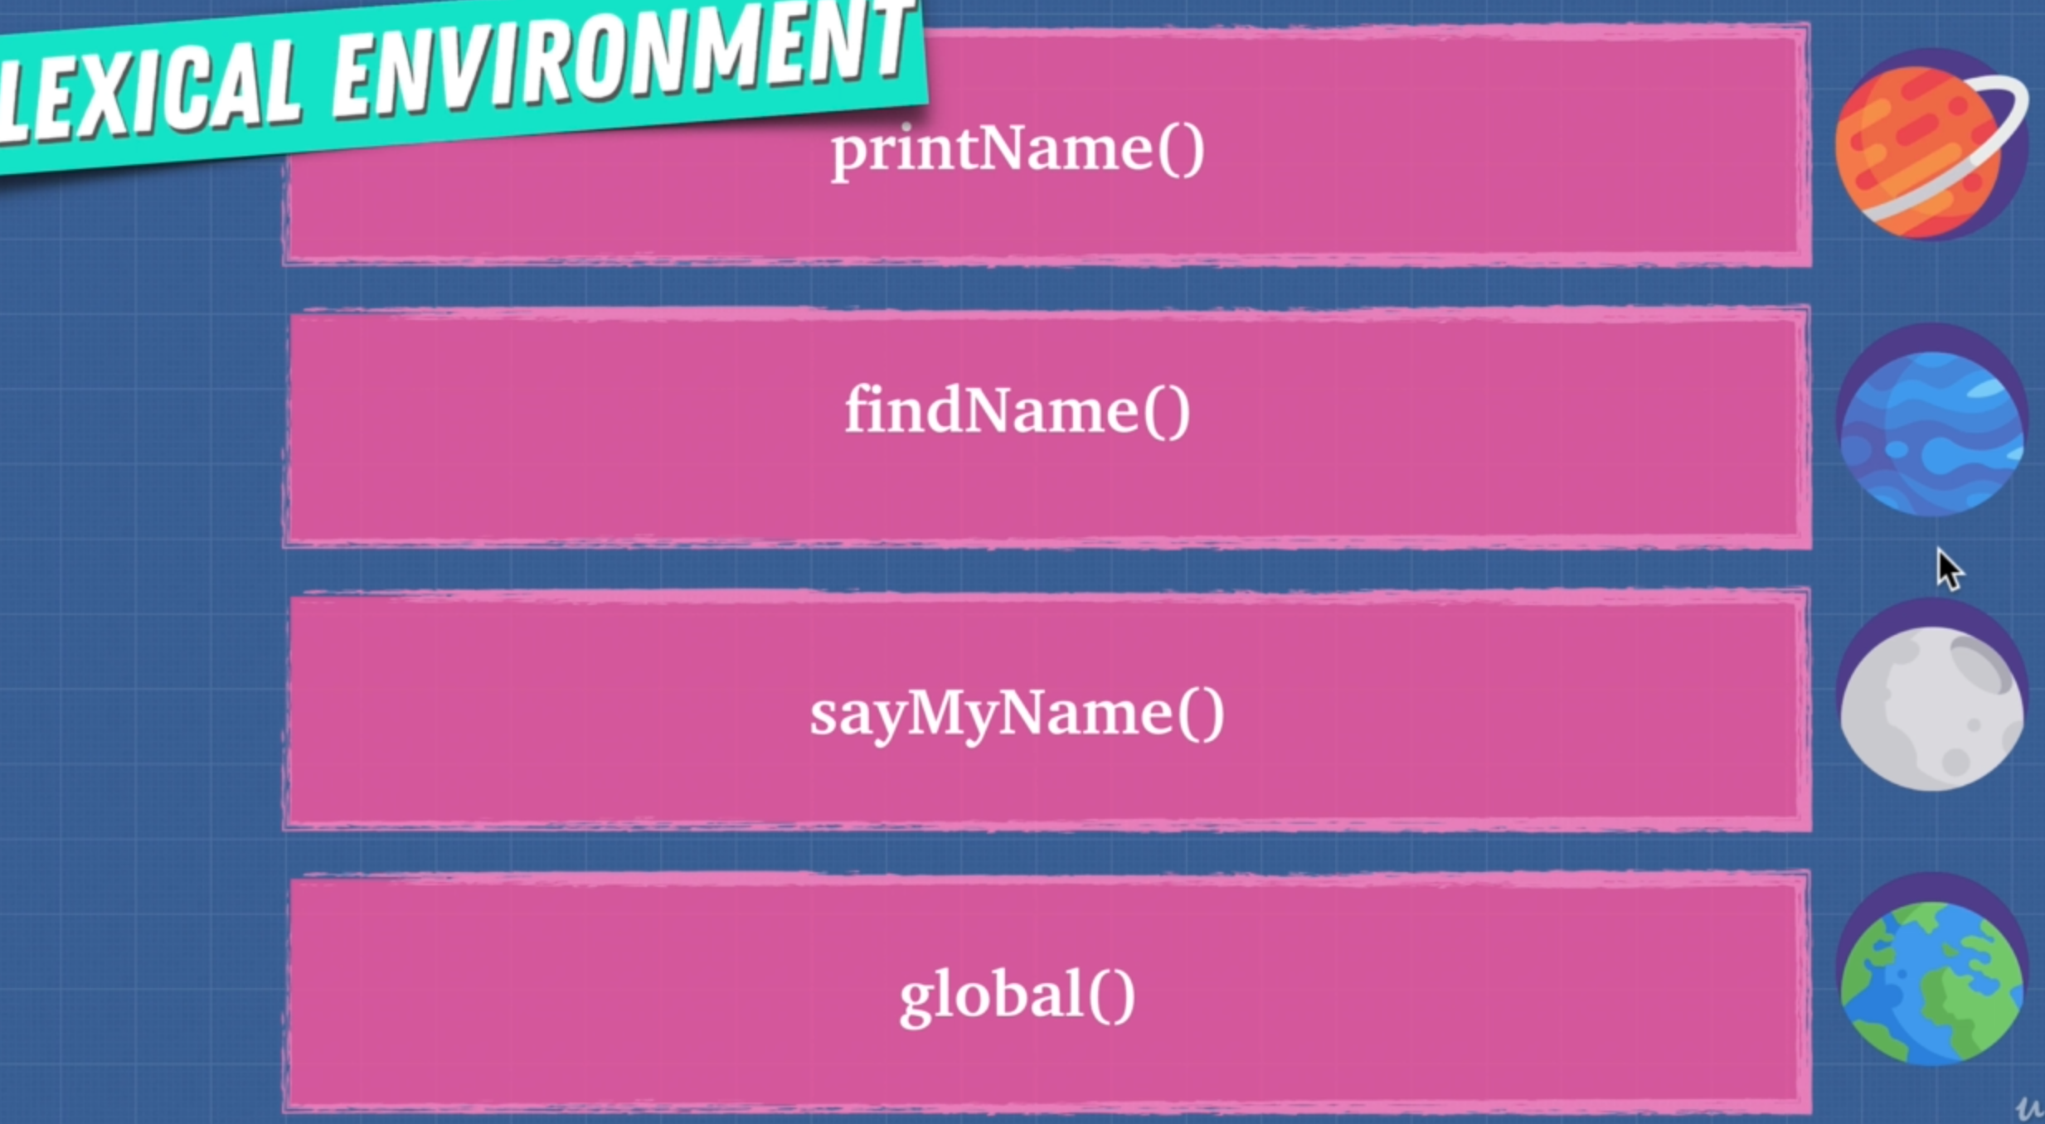

4. Hoisting

Hoisting is the behaviour of moving the variables or function declarations to the top of their respective environment during the compilation phase.

Note: variables are partially hoisted, but functions are fully hoisted

Partially hoisted means it moves the variable up with value as undefined.

Note: iffi() function, it does not hoist

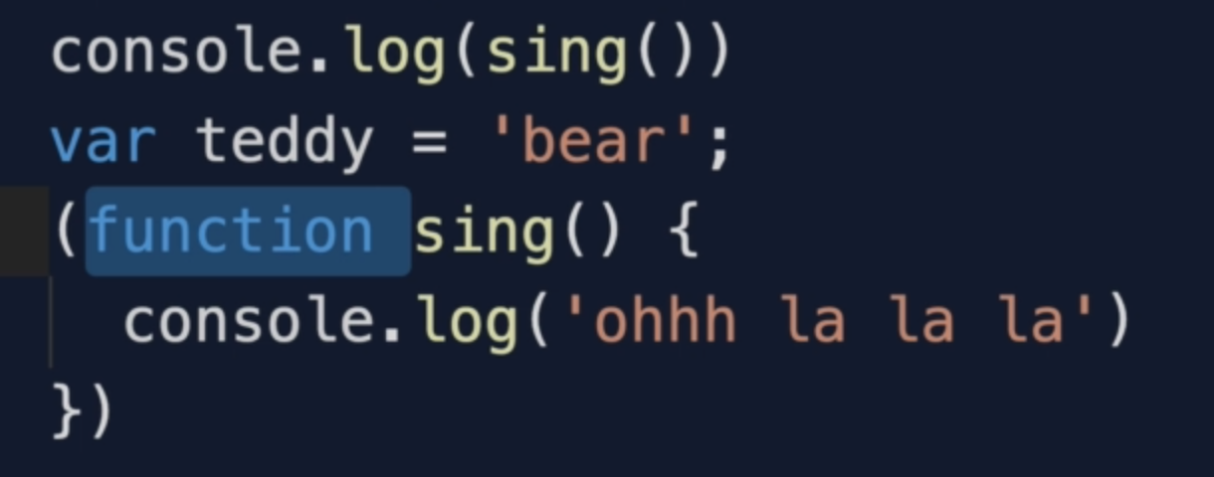

The above code will give you reference error as iffi functions do not hoist.

Note: LET and CONST do not hoist either.

Example: teddy did not hoist as we used LET instead of VAR.

Only VAR and FUNCTIONS hoist.

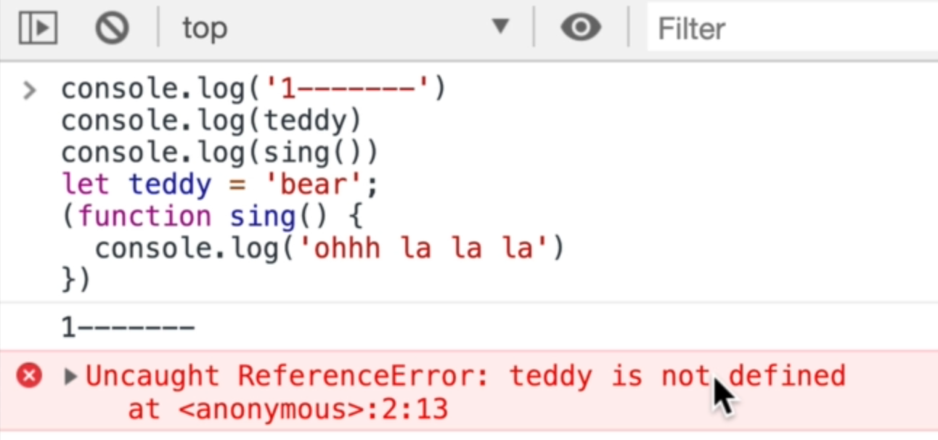

Note: function expression doesn’t hoist, but only the variable in which we are adding function expression. At the time of compile, only the function expression variable hoist so if we call it before it’s declaration, it will give reference error.

Example:

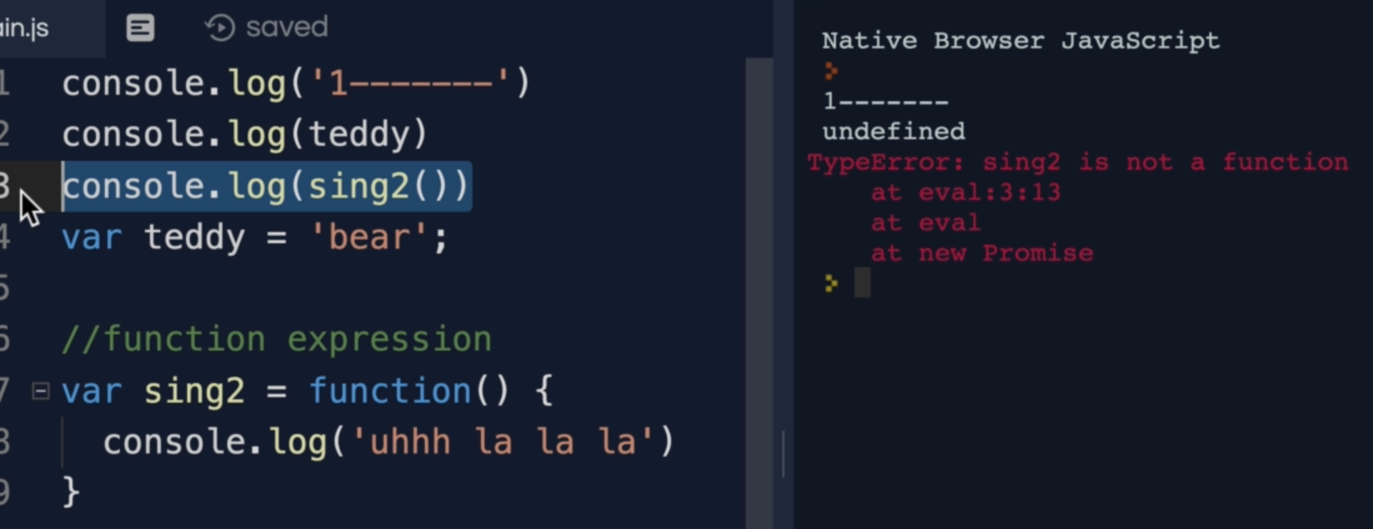

In the creation / compile phase we have global, this and hoisting

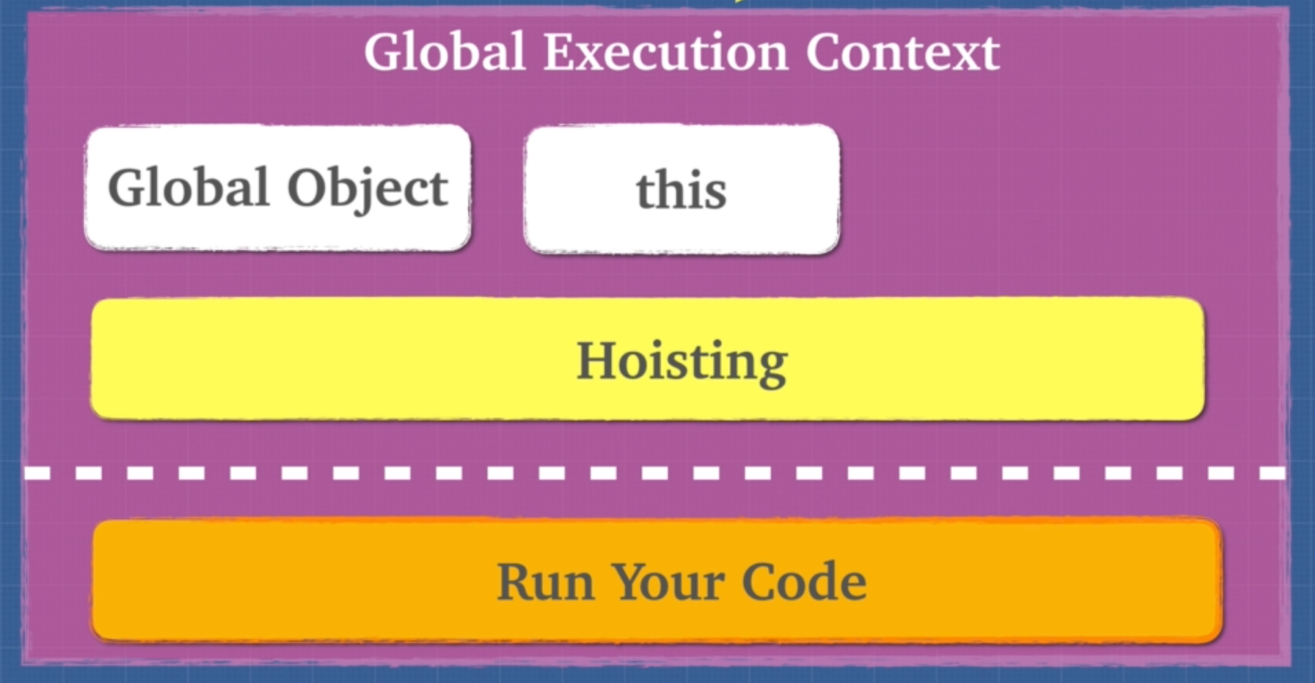

5. Exercise Hoisting  
6. Exercise Hoisting 2

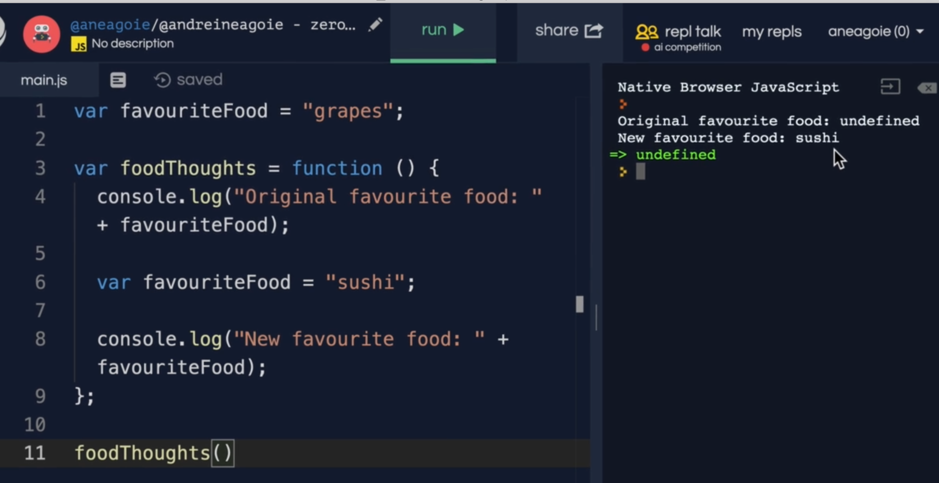

Why favorite food it undefine, well the reason is that every function has a lexical scope

In the function during creation phase while hoisting, it makes “favouriteFood” undefined and in execution phase it adds value, but before adding value we used that variable so it is showing undefined.

We shown what happened to “favouriteFood” variable in hoisting phase so it is logging undefined.

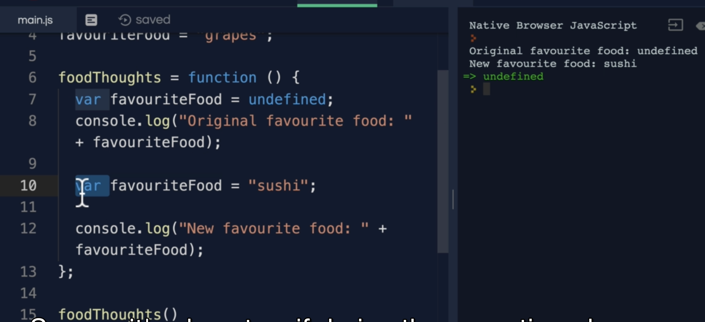

8. Function Invocation

When a function is invoked we create a new execution context and we get “this” keyword

and arguments.

9. arguments Keyword

Compiler doesn’t optimize code if you use “arguments” in a function, you can instead use spread operator to get all the argument passed to a function like this.

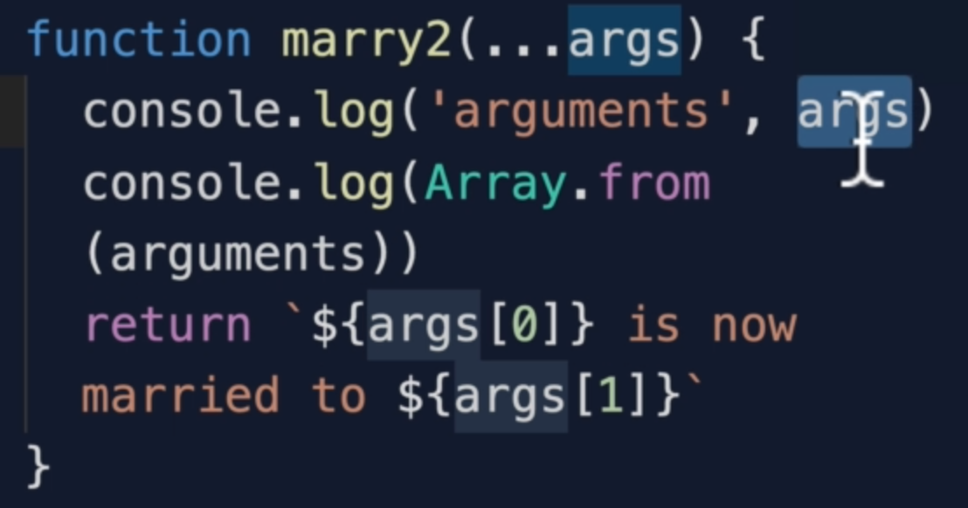

10. Variable Environment

11. Scope Chain

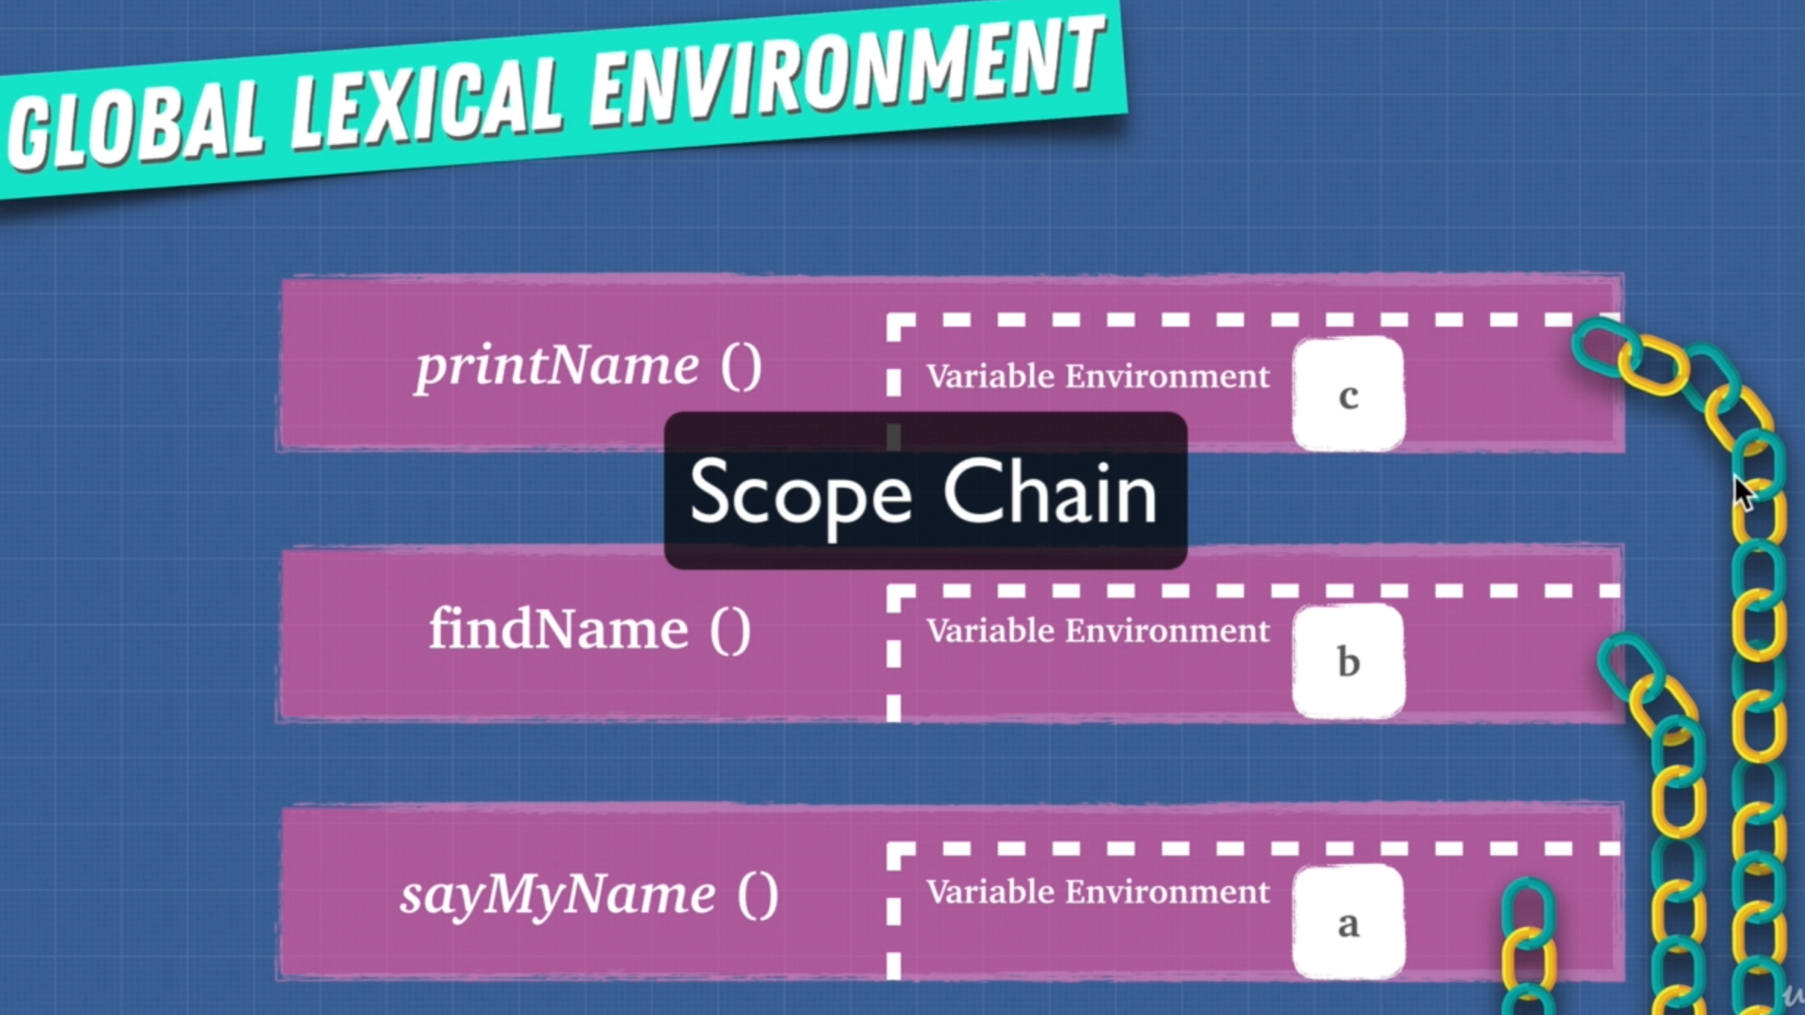

Scope chain links and gives us access to variables that are in our parent environment

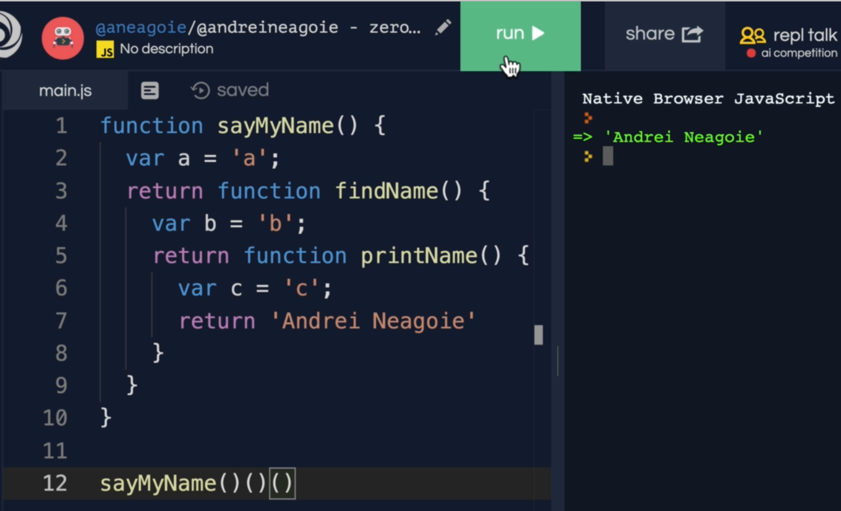

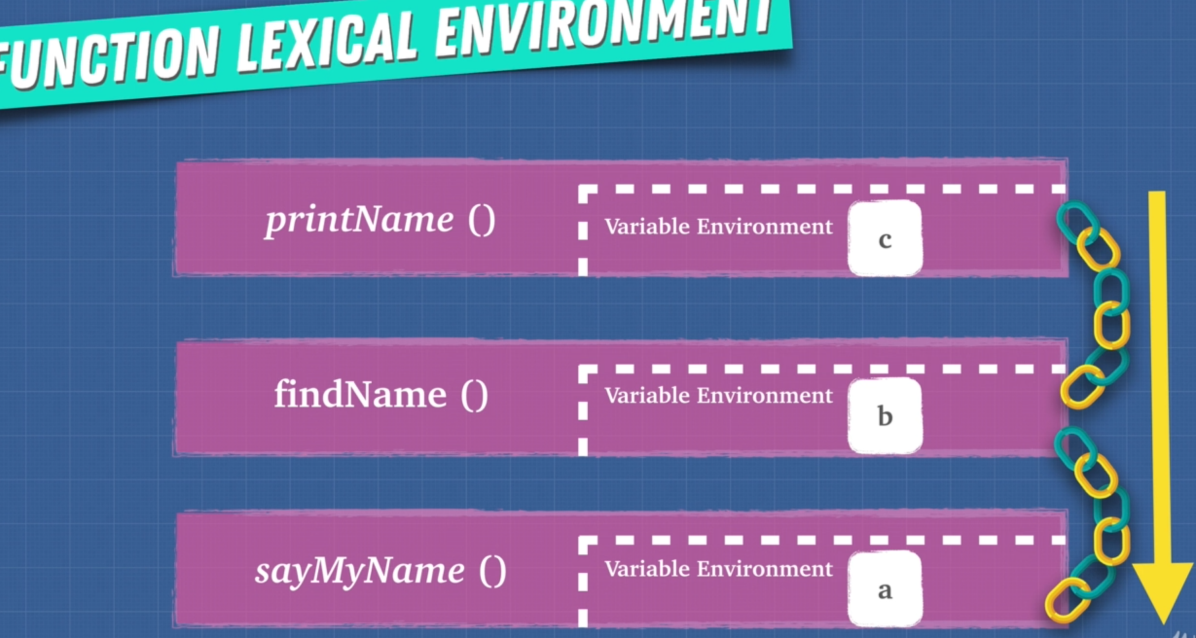

eval() and with() change the scope chain which confuses the compiler and hence doesn’t optimize code.

12. [[scope]]

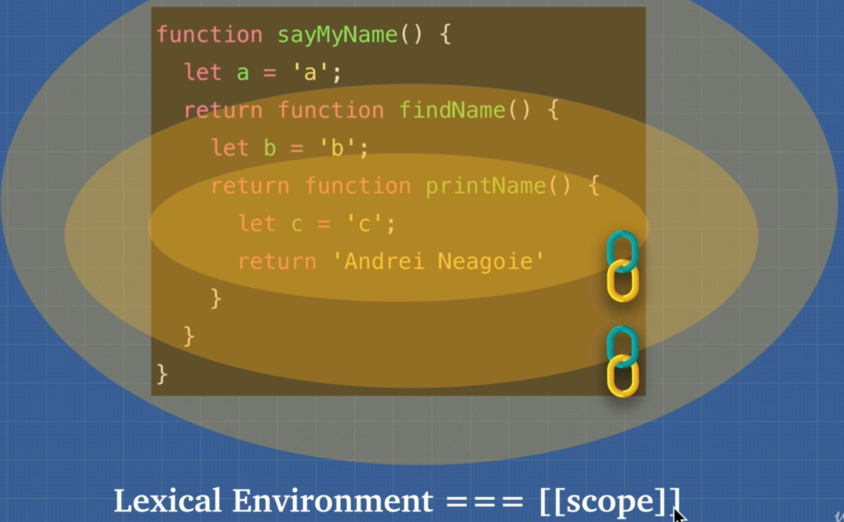

Every function has scops as shown below

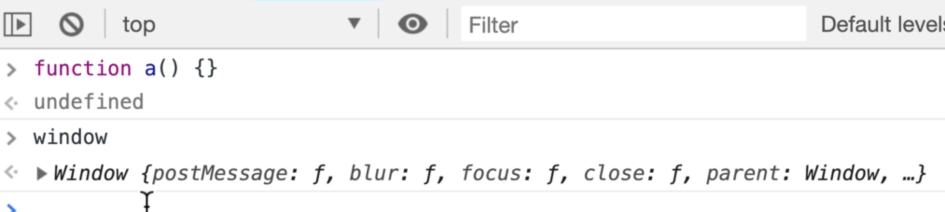

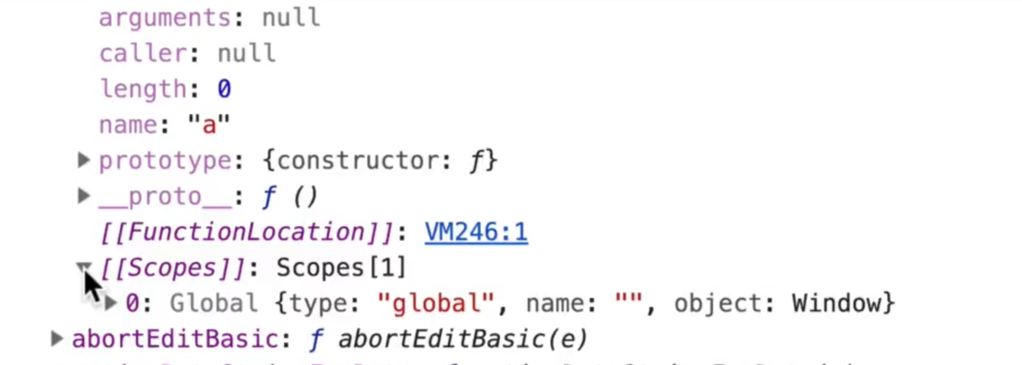

13. Exercise JS is Weird

“Use strict” : prevents javascript to do unpredictable weird things

Function expression even with name cannot be access on global scope like this

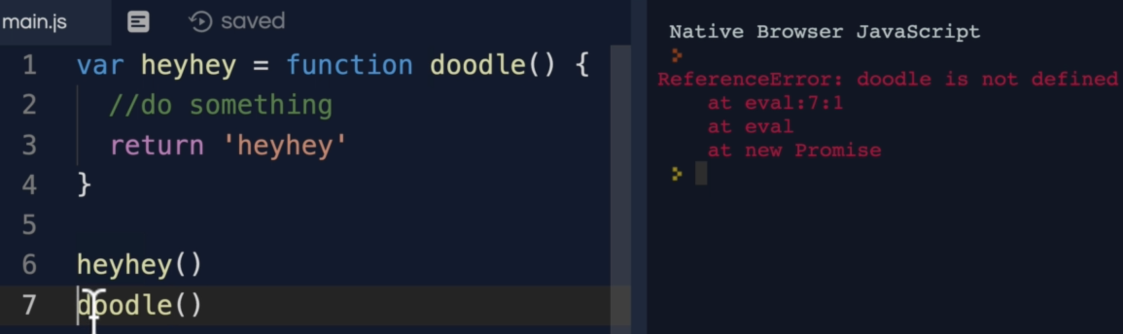

14. Function Scope vs Block Scope

LET and CONST are both **block scope keywords**

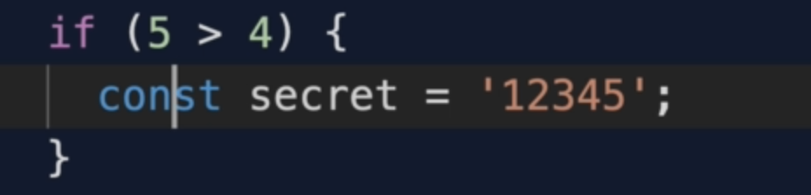

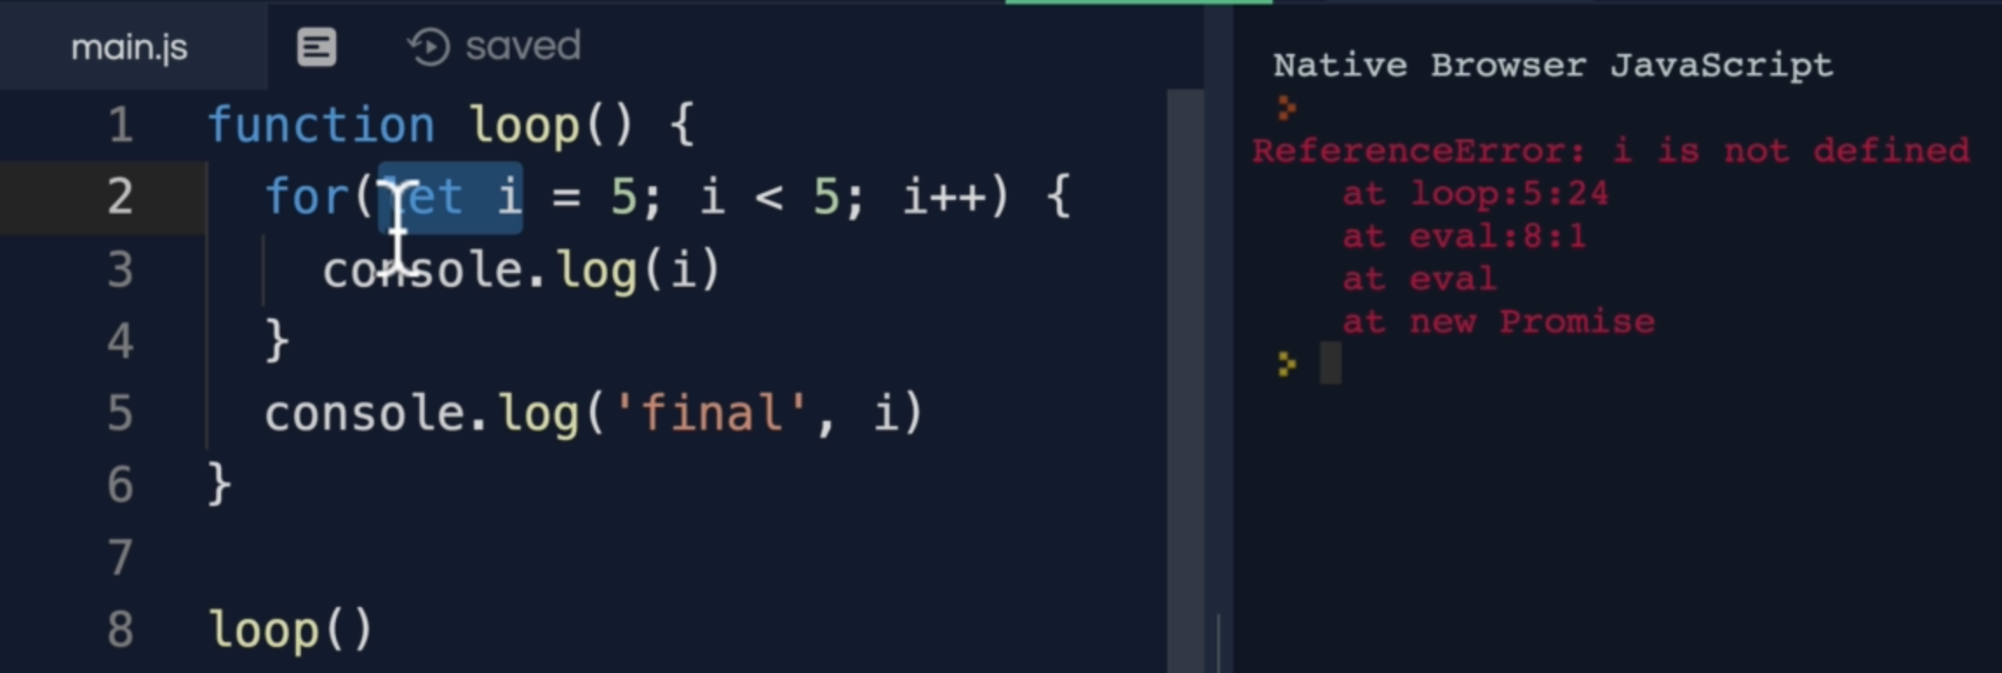

Note: The variable **i** still in memory, but engine doesn’t allow to use it outside of its scope.

16. Global Variables

All the script tags inside HTML combine to one execution context.

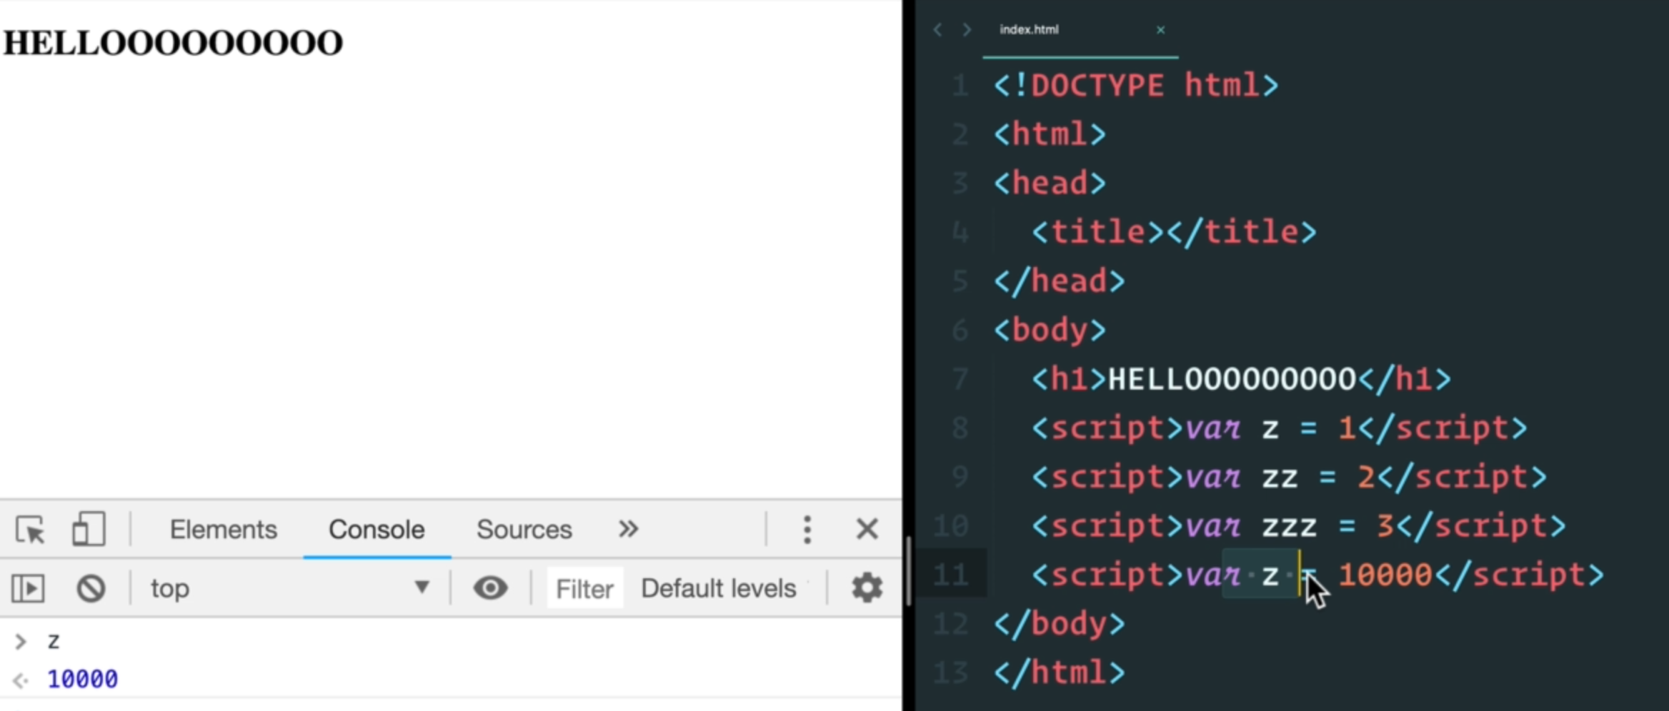

The solution to the above is to use Module system which creates a new scope.

17. IIFE

It creates a new execution context.

There are 2 ways we can write IIFE function

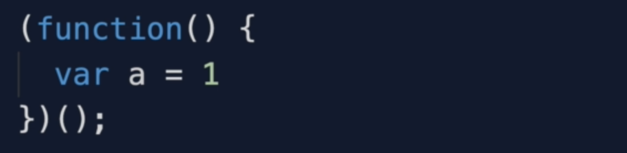

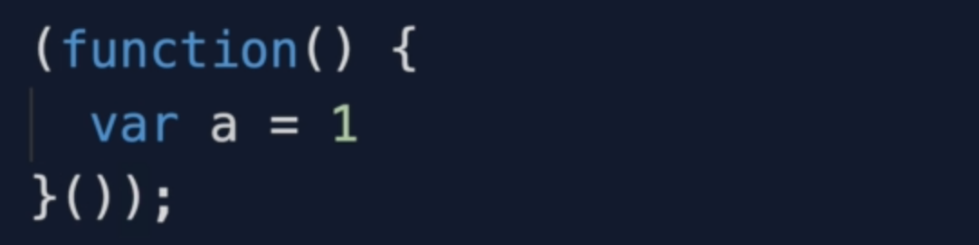

18. this Keyword

19. Exercise Dynamic Scope vs Lexical Scope



“use strict” was added to JavaScript as a way for us to avoid the common mistakes that can happen with JavaScript.

This is a cleaner way of writing function inside an object

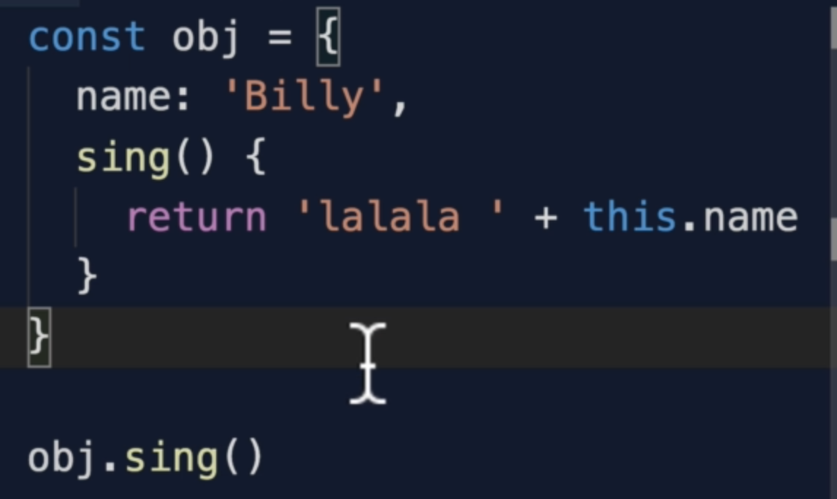

Let’s see why **another() function** in below code is referring to **window object**

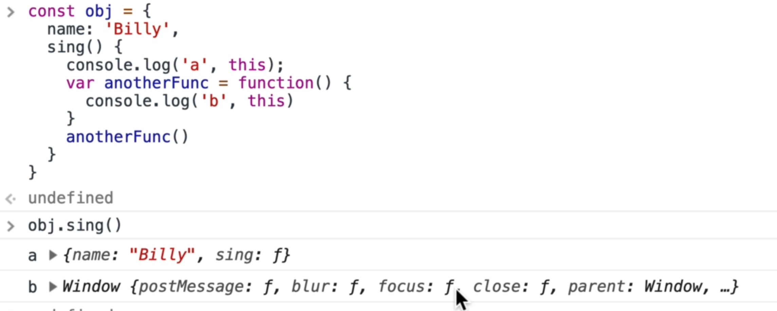

It doesn’t matter where “this” written, the matter is where it is called. “Obj” did not call another function, the sing() function did. In javaScript “this” default to the window object.

There is a foot-note to above statement because everything in JavaScript is actually lexically scoped (how you write it determines what we have available) except “this” keyword.

“This” keyword is dynamically scoped that is it doesn’t matter where it is written, it matters how the function is called.

To avoid the above problem we can use ES6 arrow function. Arrow functions are lexically bound. Arrow function has lexical “this” behaviour

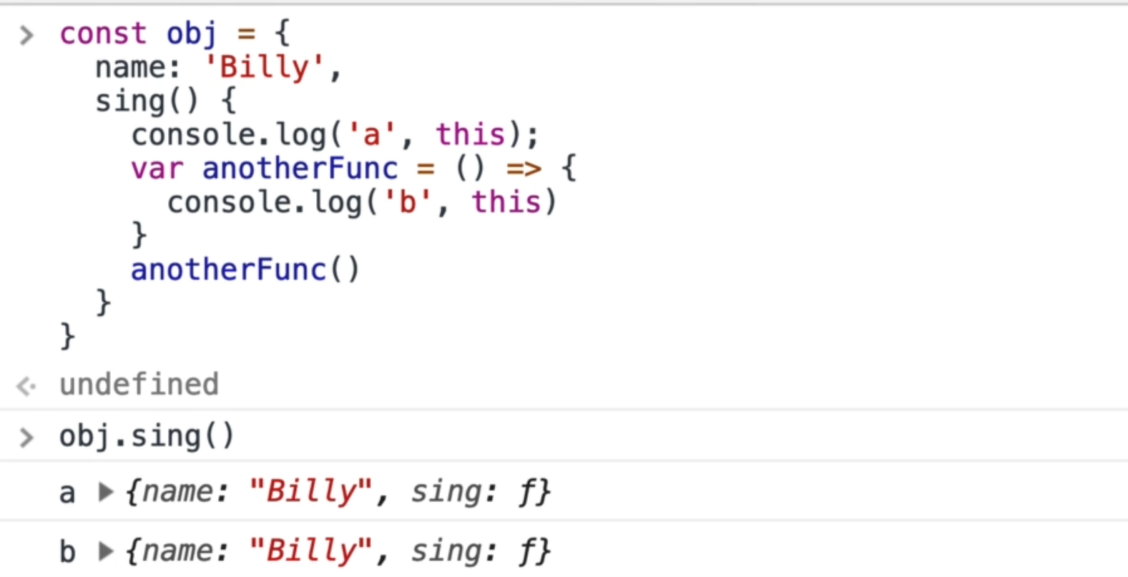

Another way we can solve above problem is to use “bind()”

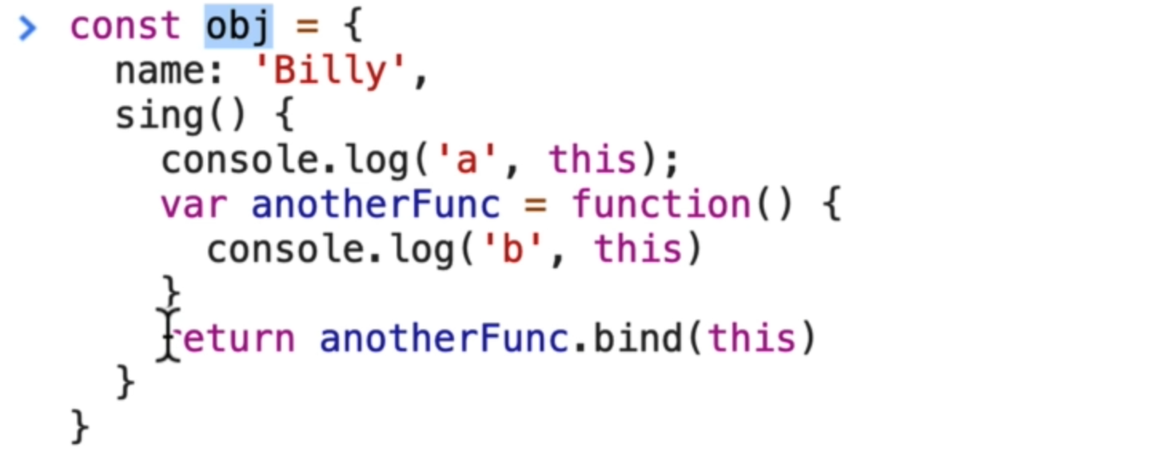

We can also use “self” as a reference of “this”

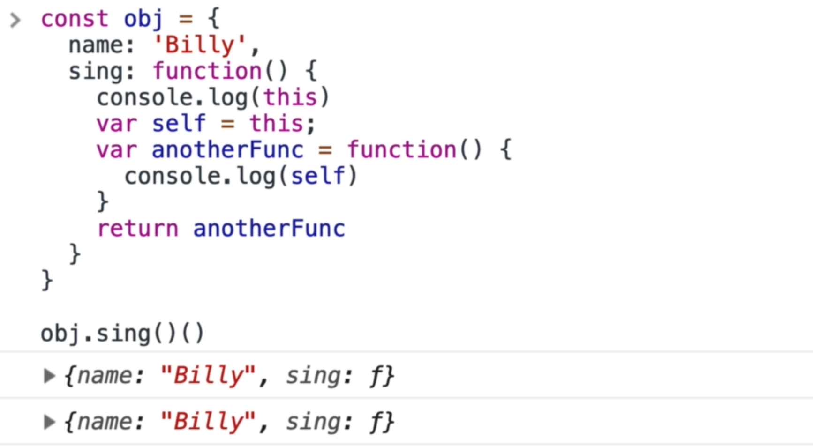

20. call(), apply(), bind()

Call and apply both invoke function like in given examples

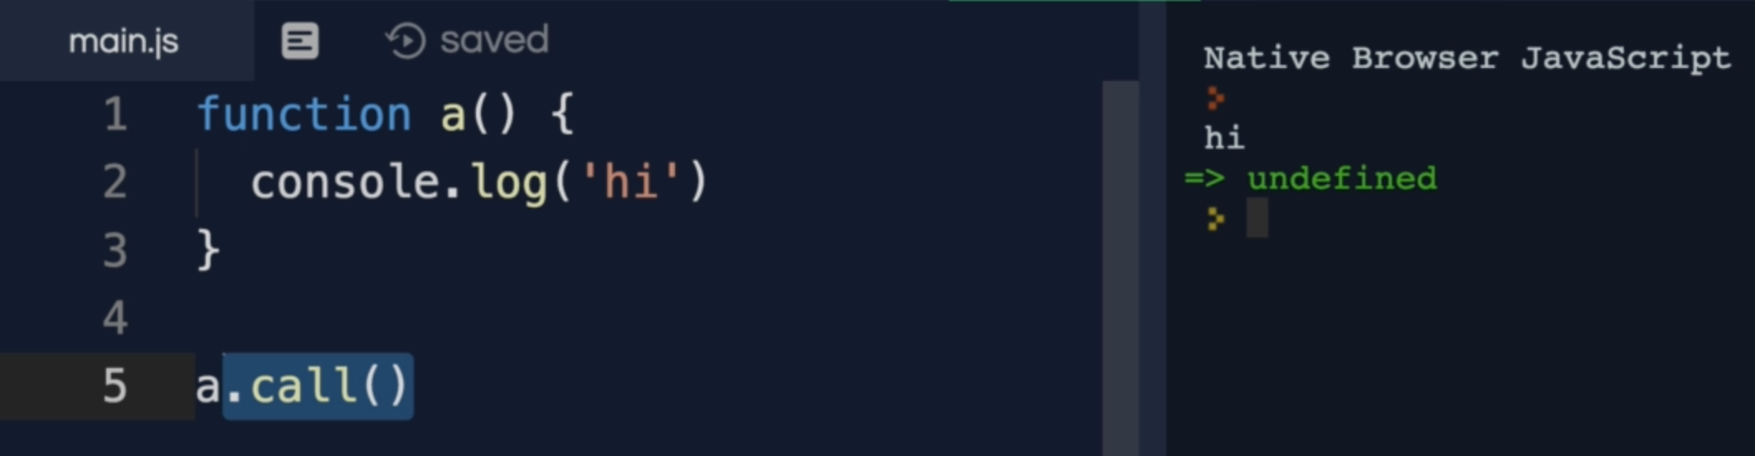

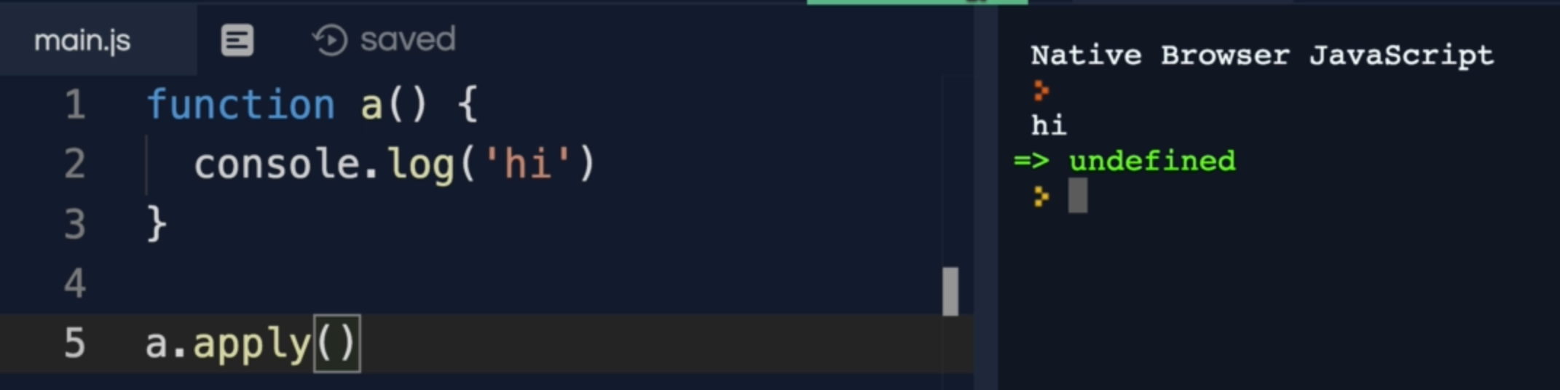

We can also use these bind/apply for borrowing other helper function which reduces the redundancy.

Example:

**wizard.heal.call(archer)**

Here is the meaning of the above line

Call heal() function, but instead of using “wizard”, use “archer” object

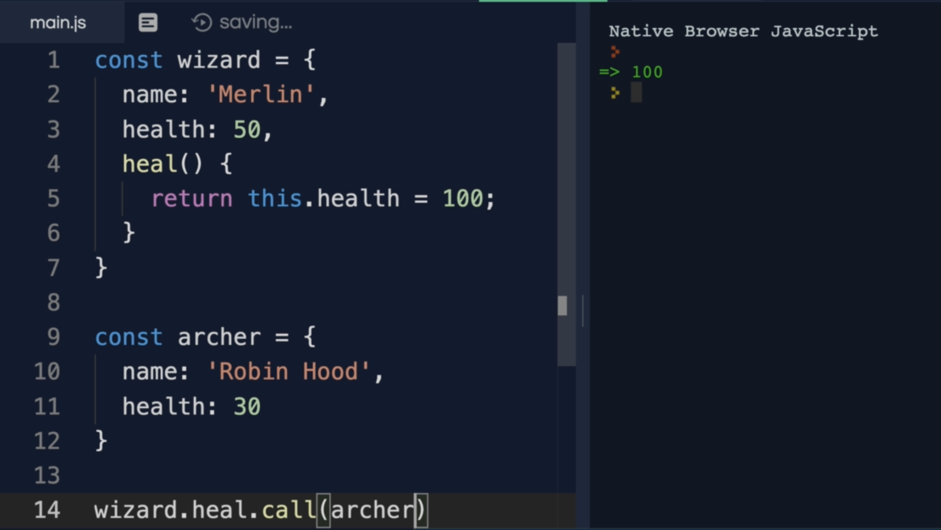

This is the way we use these call, and apply methods with params

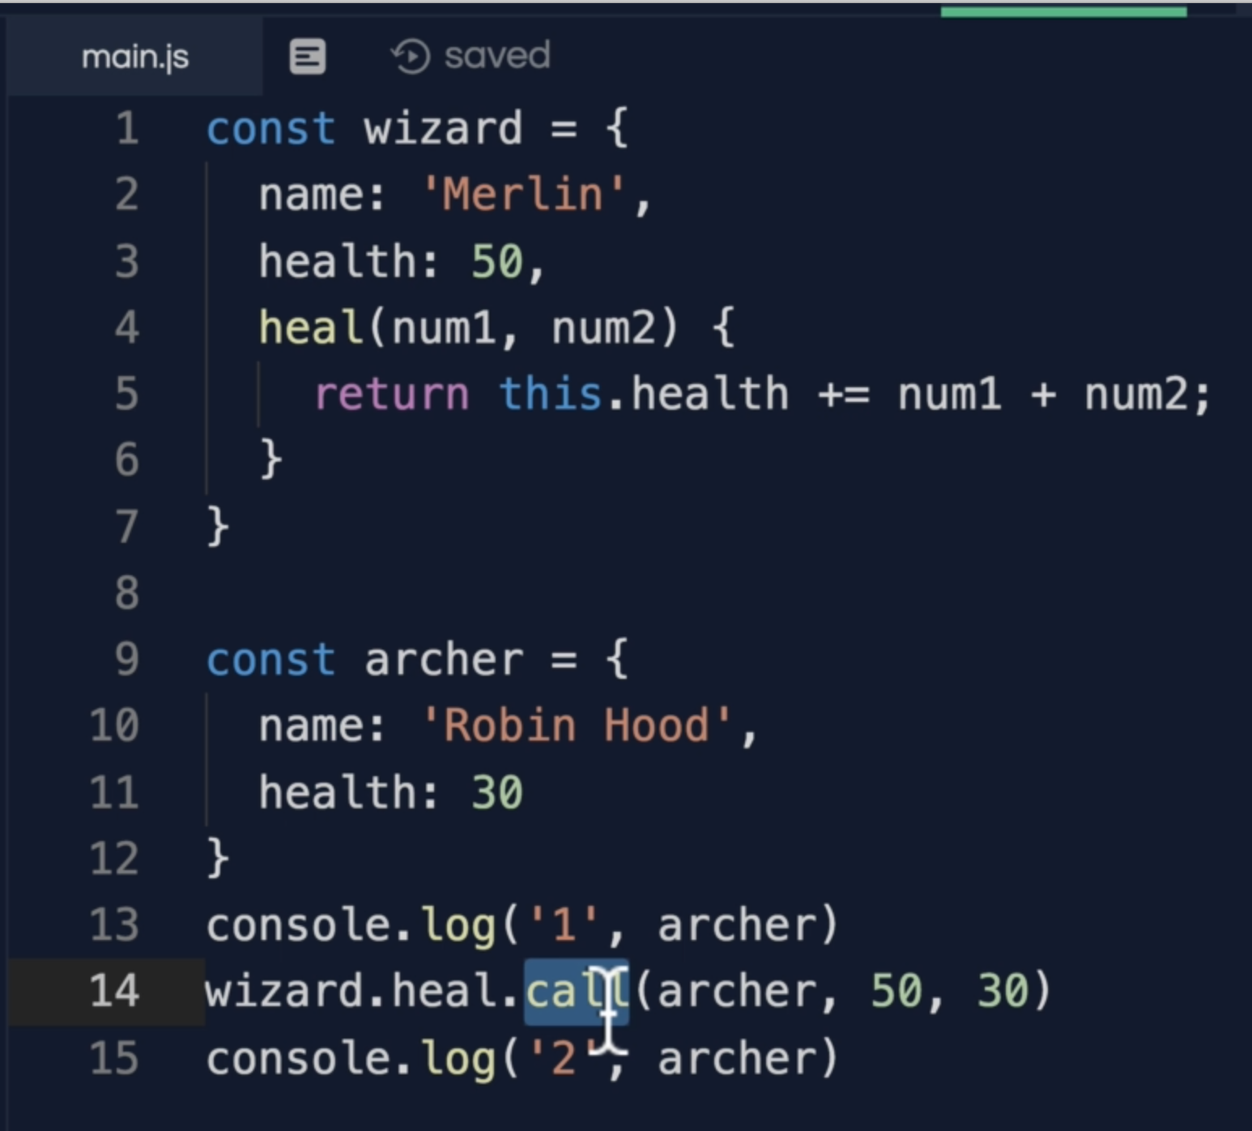

The only difference between call and apply is that apply takes arguments as an array

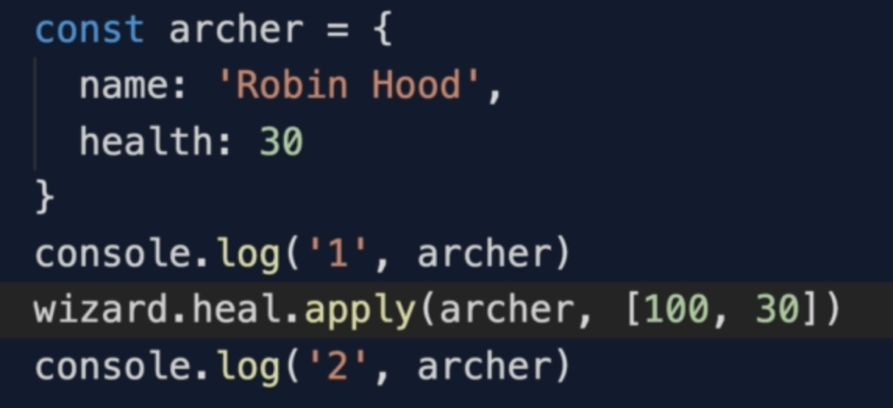

Bind unlike call and apply that immediately runs a function. Bind returns a new function.

Runs.

Bind allows us to store the function for later use.

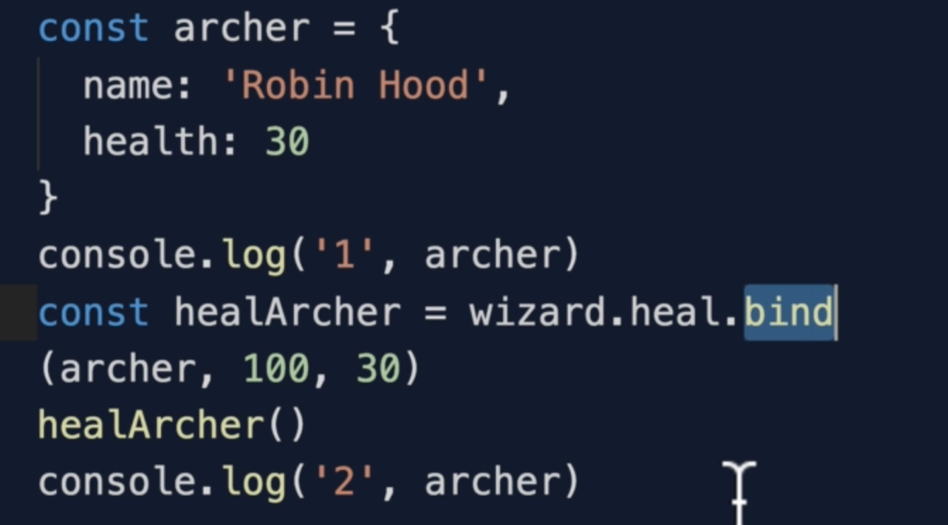

Note: call, and apply are useful for borrowing methods from an object while bind is useful for us to call function later on with a certain context and it is also called function currying

22. bind() and currying

Currying refers to only partially giving a function a parameter

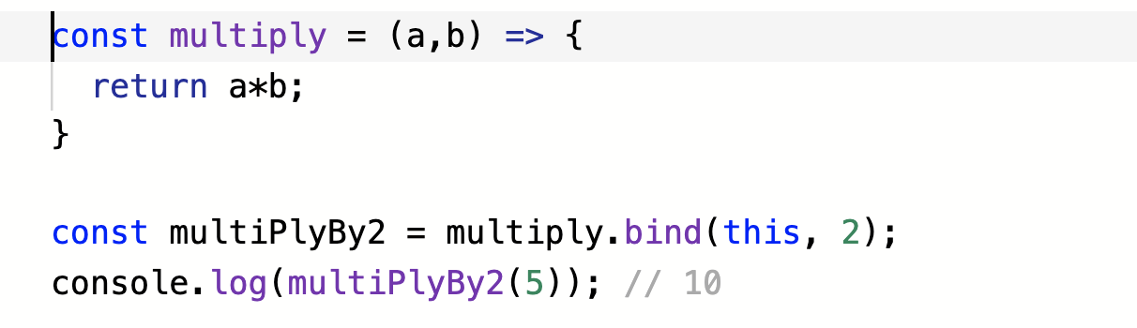

23. Exercise this Keyword

C.

Remember: method inside an object has a function then “this” inside that function refers to window object

D.

Remember: method inside an object has an arrow function then “this” inside that function refers to parent object

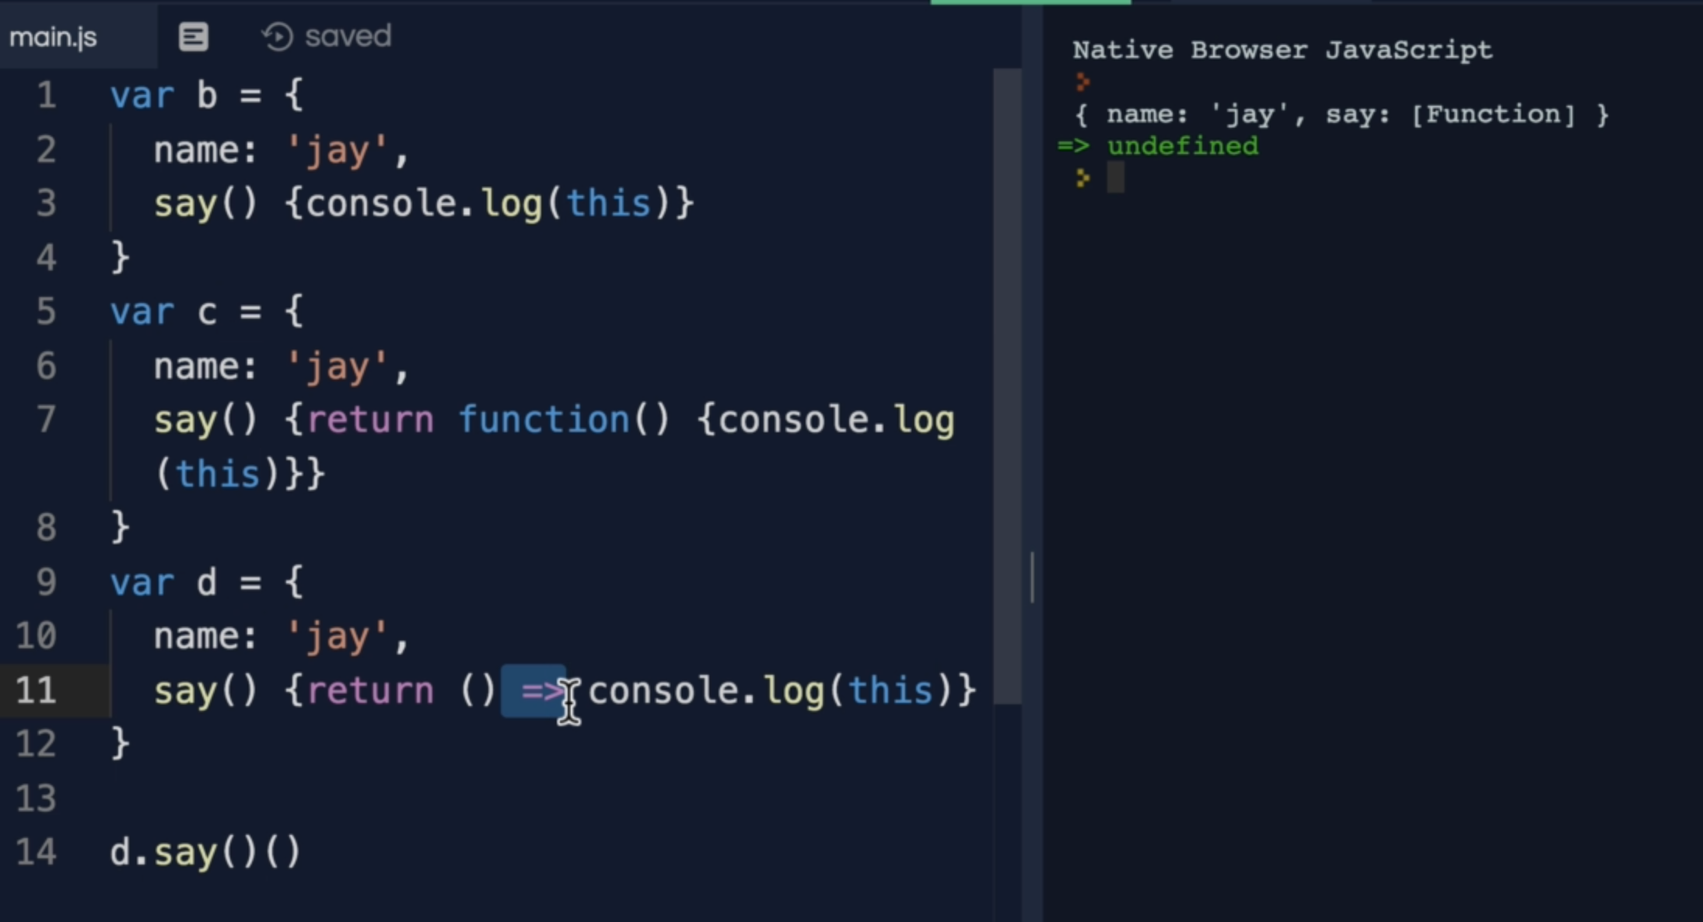

25. Context vs Scope

Scope: it is a function based thing. It means what is the variable access of a function when it is invoked. What is in the variable environment right context.

Context: it is more about object based. It determines the value of “this”

Context is more often determined by how a function is invoked with the value of this keyword and scope refers to the visibility of the variables.

4. Types in JavaScript

2. Javascript Types

undefined: it is absence of definition

null: it is absence of value

Remember: arrays and functions are objects.

Typeof function returns “function”, but underneath the hood, it is an object.

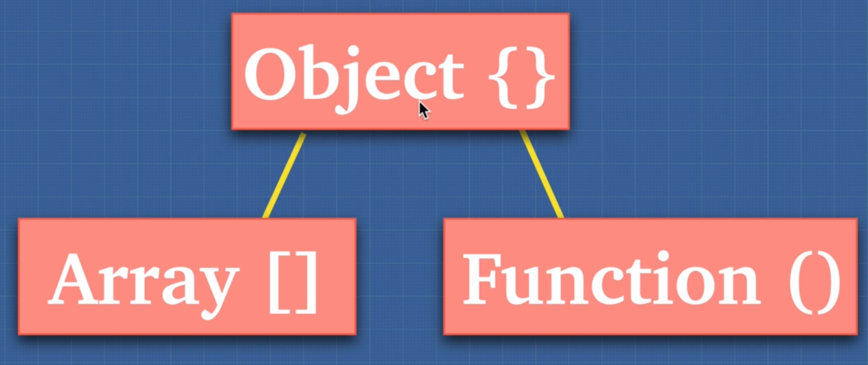

Primitive: it is a data that only represents a single value.

Non-Primitive: doesn’t contain the actual value instead, it contains a reference.

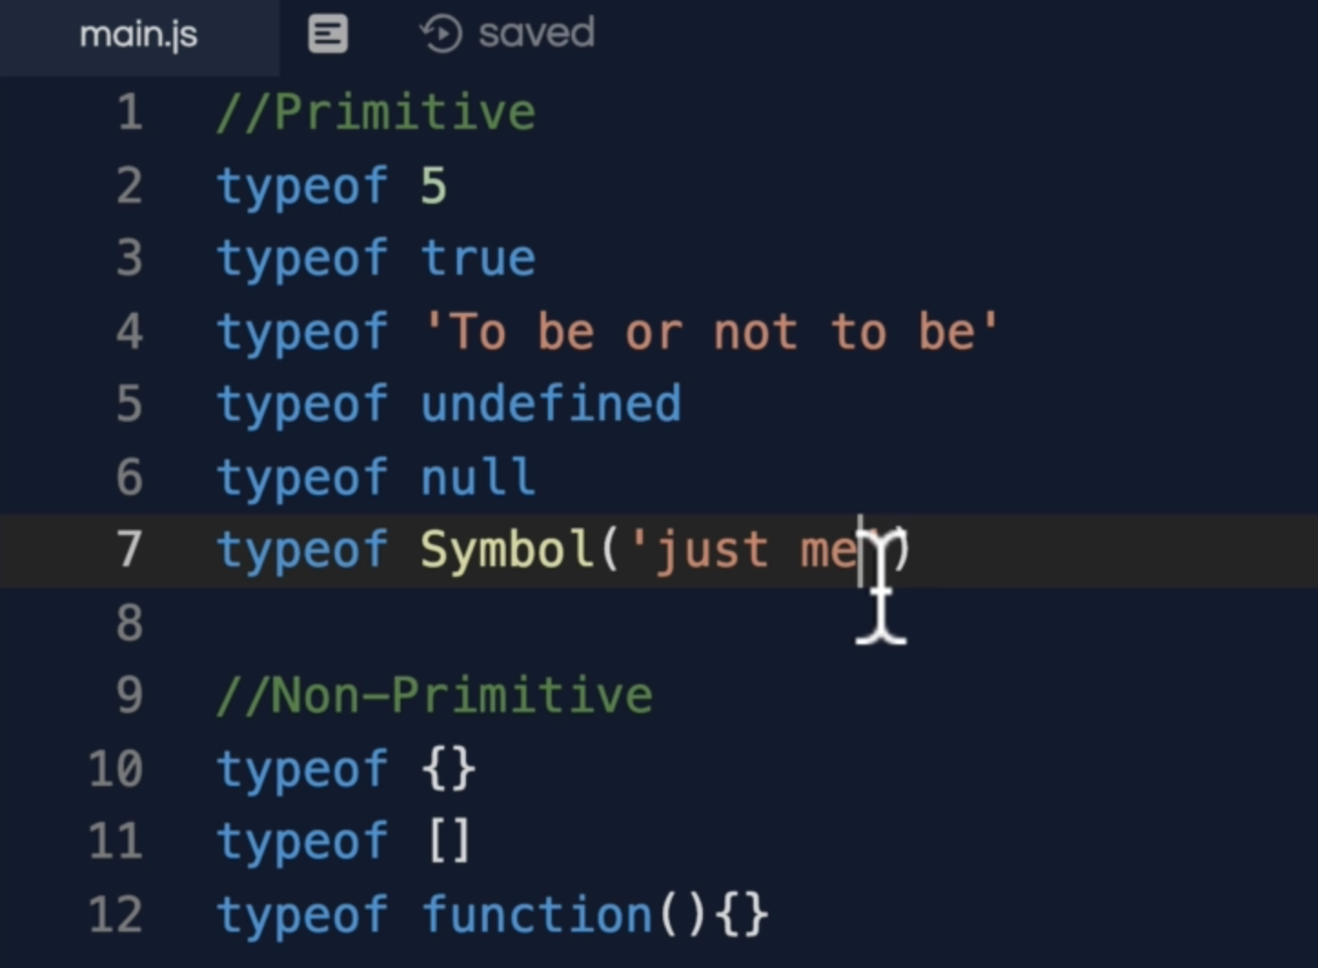

3. Array.isArray()

Arrays in JavaScript are objects. Here is a built-in method to check if the value is an array or not



The other methods to check array and string are

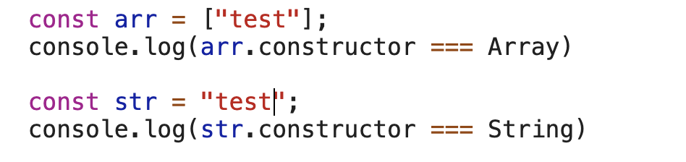





4. Pass By Value vs Pass By Reference

Objects and array both type of Object so both of them are pass by reference and in the below code it will change the value of array where c is pointing to

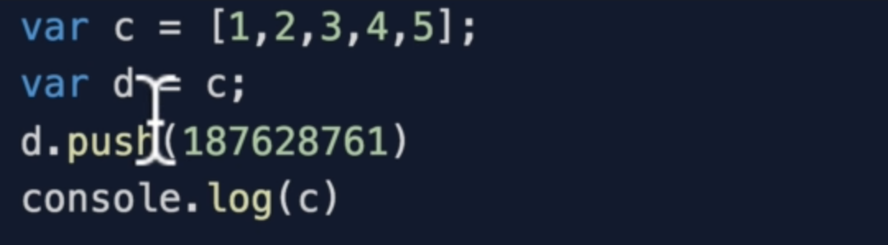

Remember: “Concat method” clones an array. Now value of d will be a new cloned array

Example:

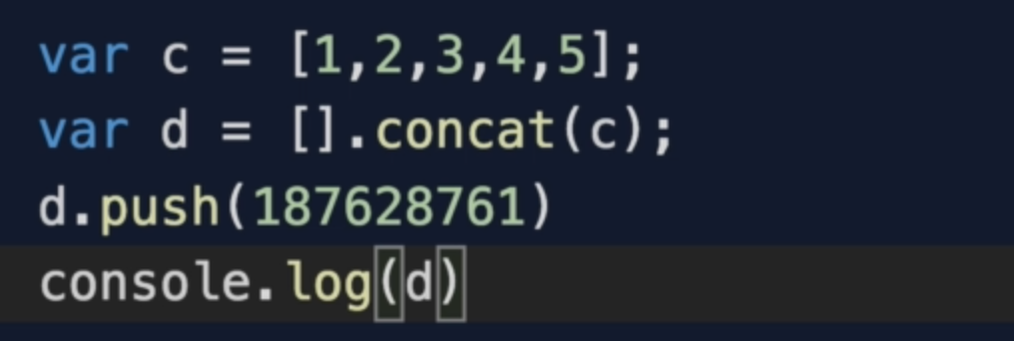

**Shallow Cloning : it clones the first level**

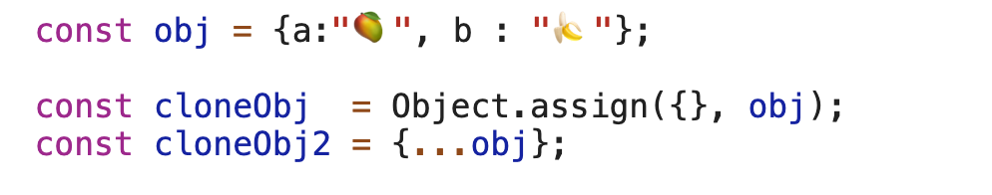

**Deep copy :** it can have some performance implications if the object is extremely deep

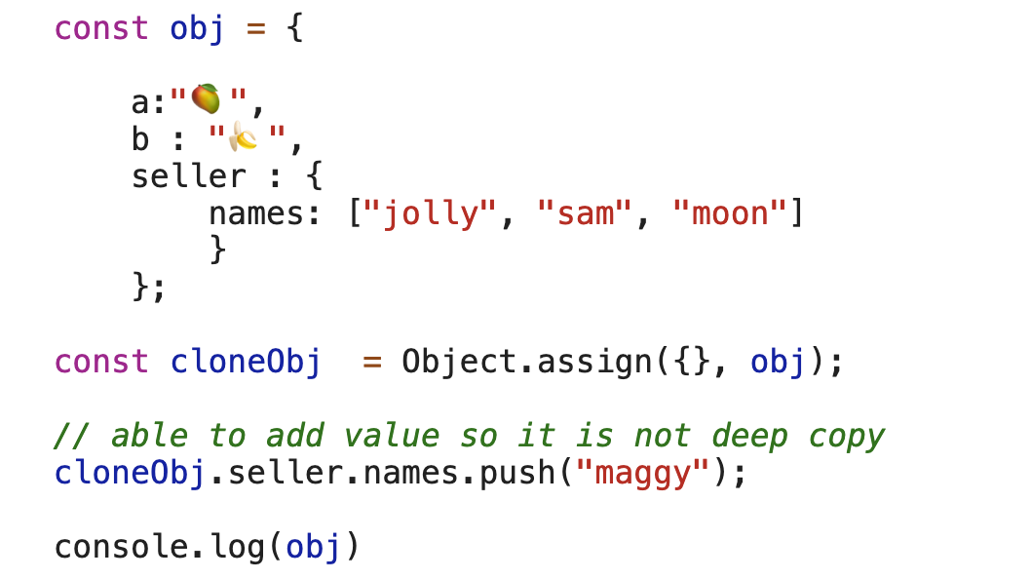

Let’s use another method to make deep copy

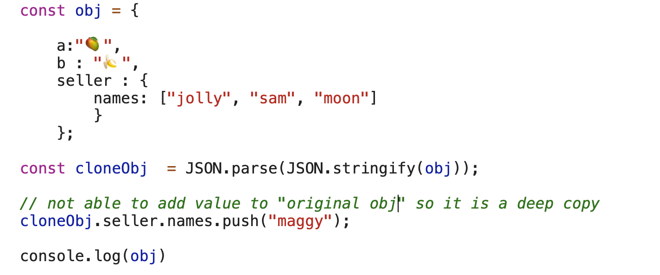

You can see obj’s names array has still 3 values.

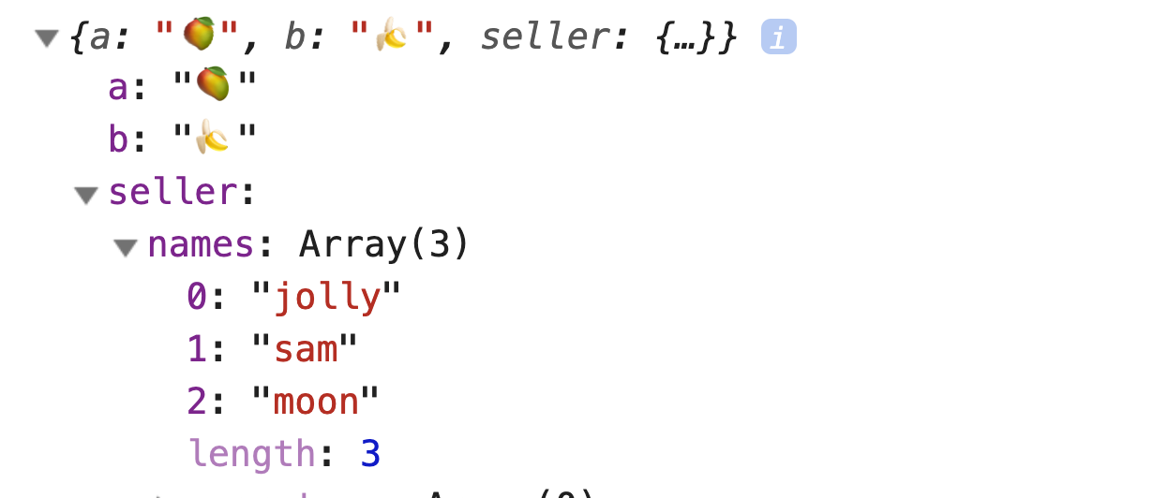

7. Type Coercion

Type coercion means the language converting a certain type to another type.

Type coercion happens in JavaScript when we use double equal sign and if() statement

You can see the actual coercion here

<https://dorey.github.io/JavaScript-Equality-Table/>

In JavaScript, there is a concept of +0, and -0



There is a function called Object.is() which gives you fair result

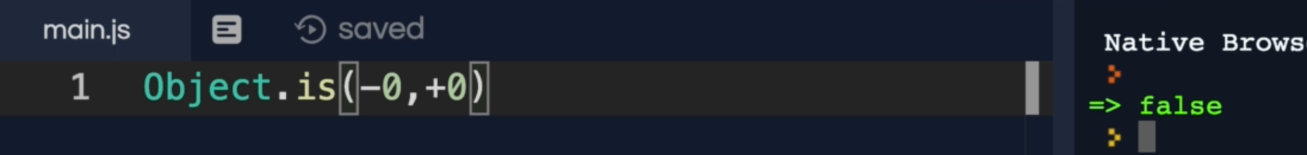



But with Object.is() it will return true



Look on net about type conversion

10. JTS Dynamic vs Static Typing

Static types usually prevents bugs and helps keeping errors from happening

Dynamic type allows you to be more flexible and write software fast

Typescript to behave JavaScript to a static type language

11. JTS Weakly vs Strongly Typed

Weakly typed language allows you to add string with number like this

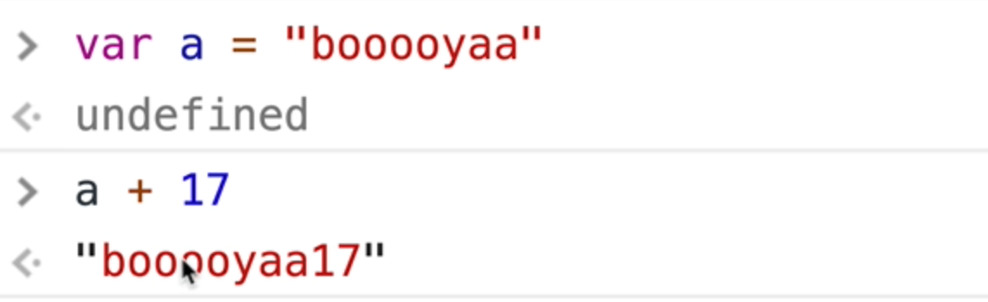

12. JTS Static Typing In JavaScript

Flow is created by Facebook and supports React project, but people are using Typescript even with React Project.

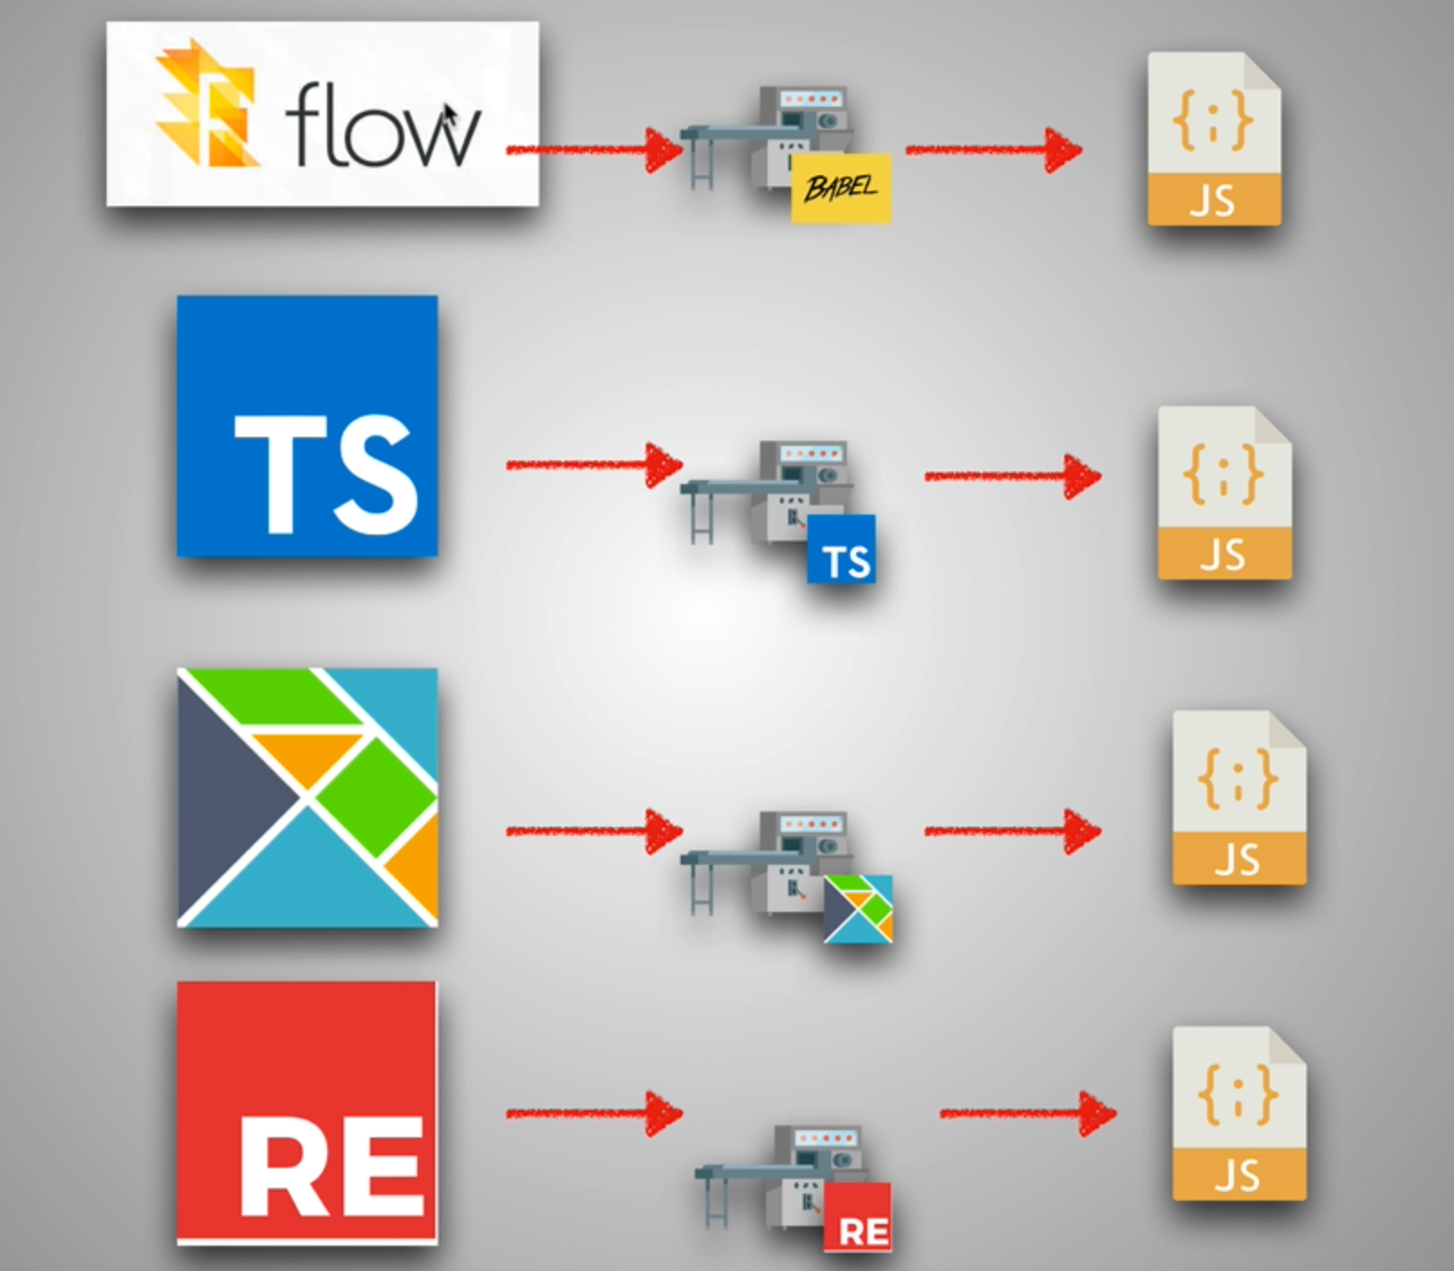

5. The 2 Pillars Closures and Prototypal Inheritance

2. Functions are Objects

When we invoke a function we get 2 parameters automatically “this” and “arguments”.

Function is wrapped with special object which has these properties.

Consider the orange part as a function wrapper

code() => code is the code we write inside the function and () parentheses is that through which we call a function

Name => it is the name of the function

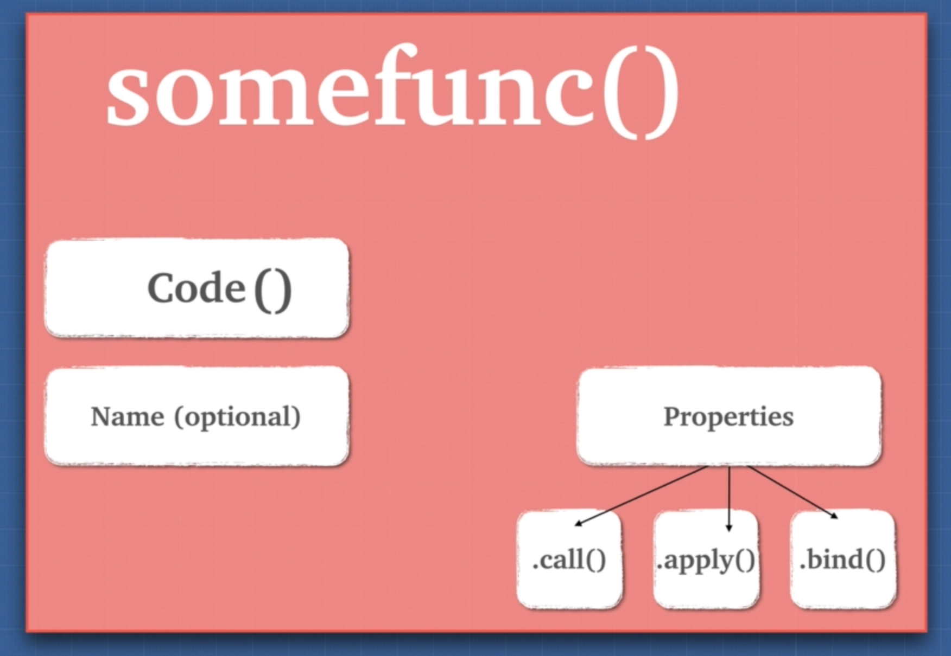

3. First Class Citizens

Function are first class citizens which mean

1. We can assign function to a variable
2. We can pass function as argument
3. We can return function as a value from another function

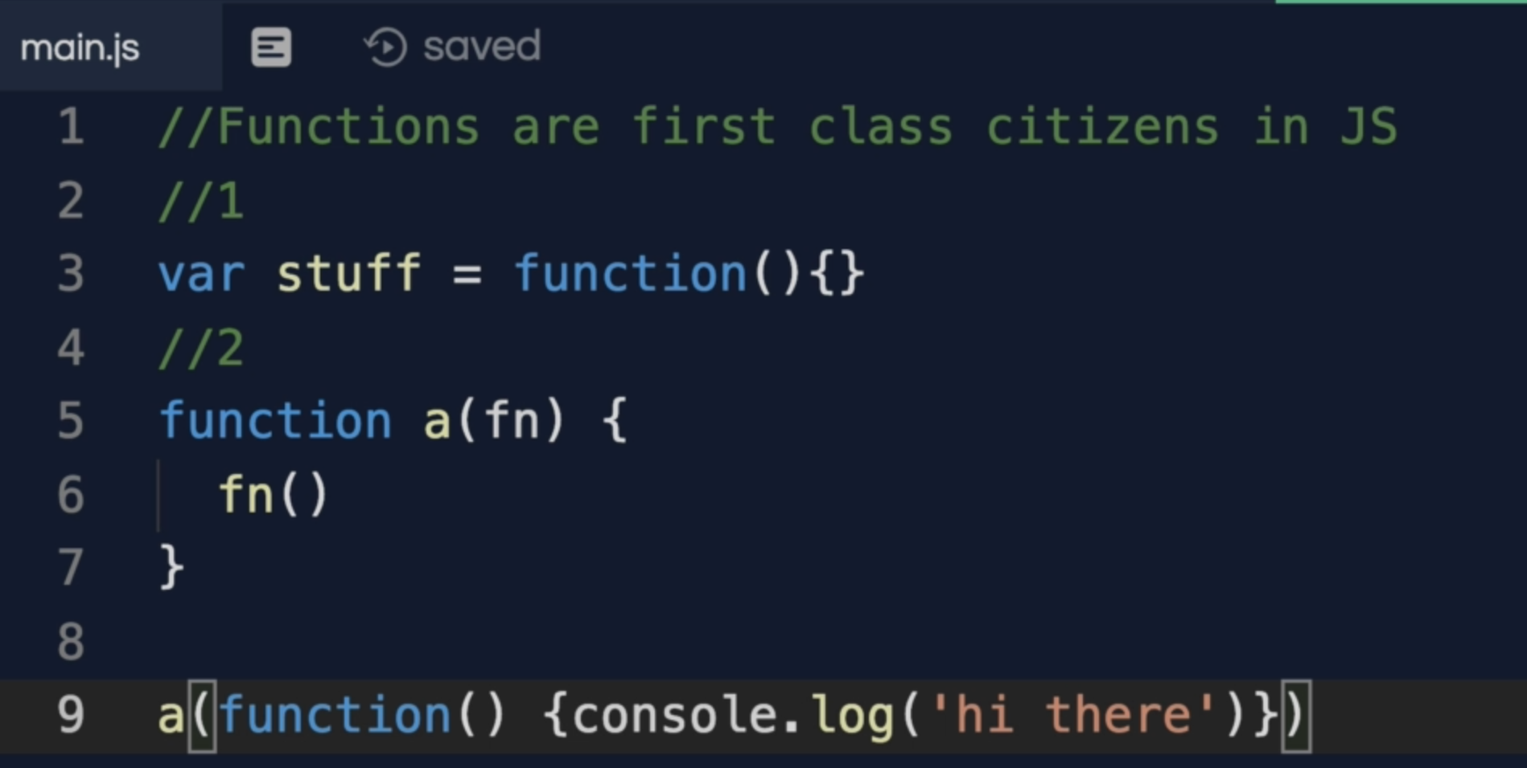

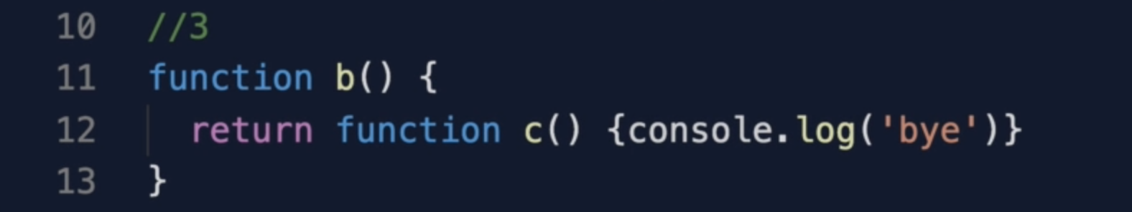

4. Extra Bits Functions

5. Higher Order Functions

Higher order Function is simply a function that can take a function as an argument or a function that returns another function.

Let’s see why HOC is useful?

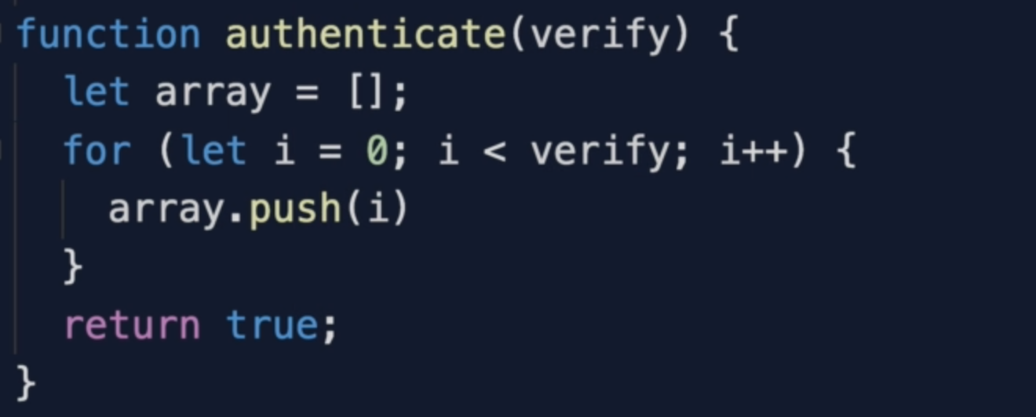

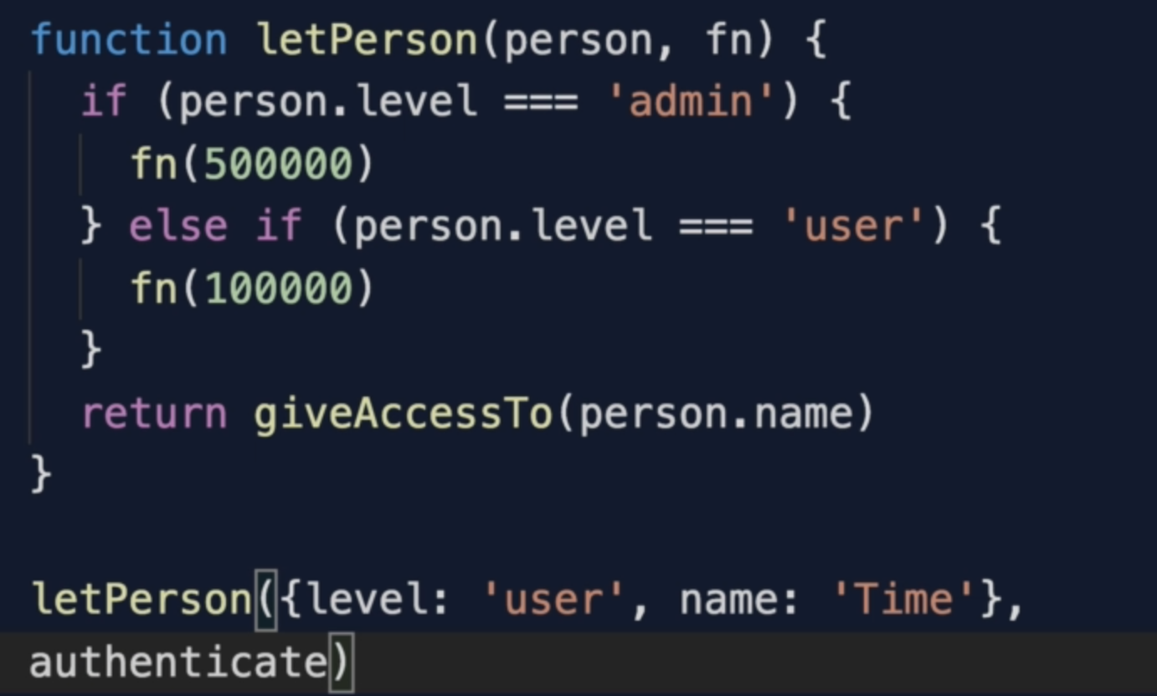

1. Ability to tell the function what to do during invocation.
2. We are able to have little-bit more flexibility.
3. We are able to keep our code dry

6. Exercise Higher Order Functions

Let’s see how to create a generic “multiplyBy” function

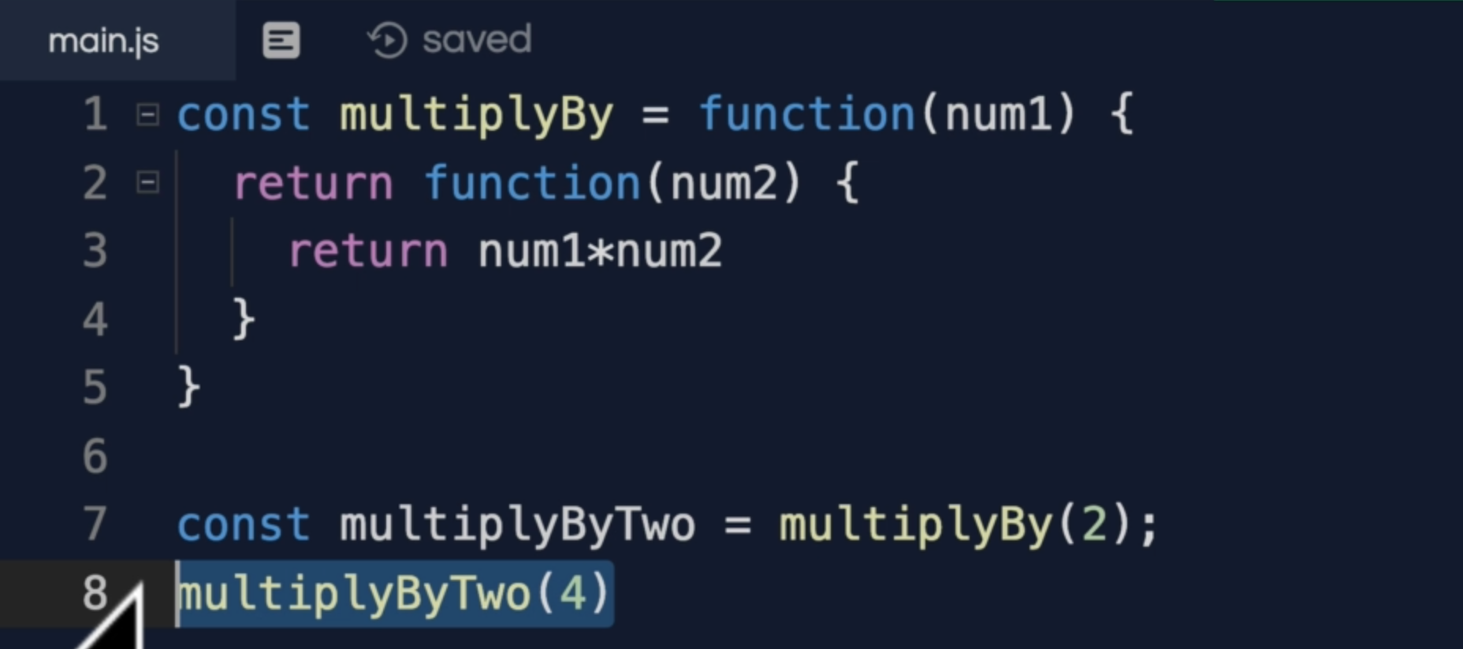

Shorthand arrow function

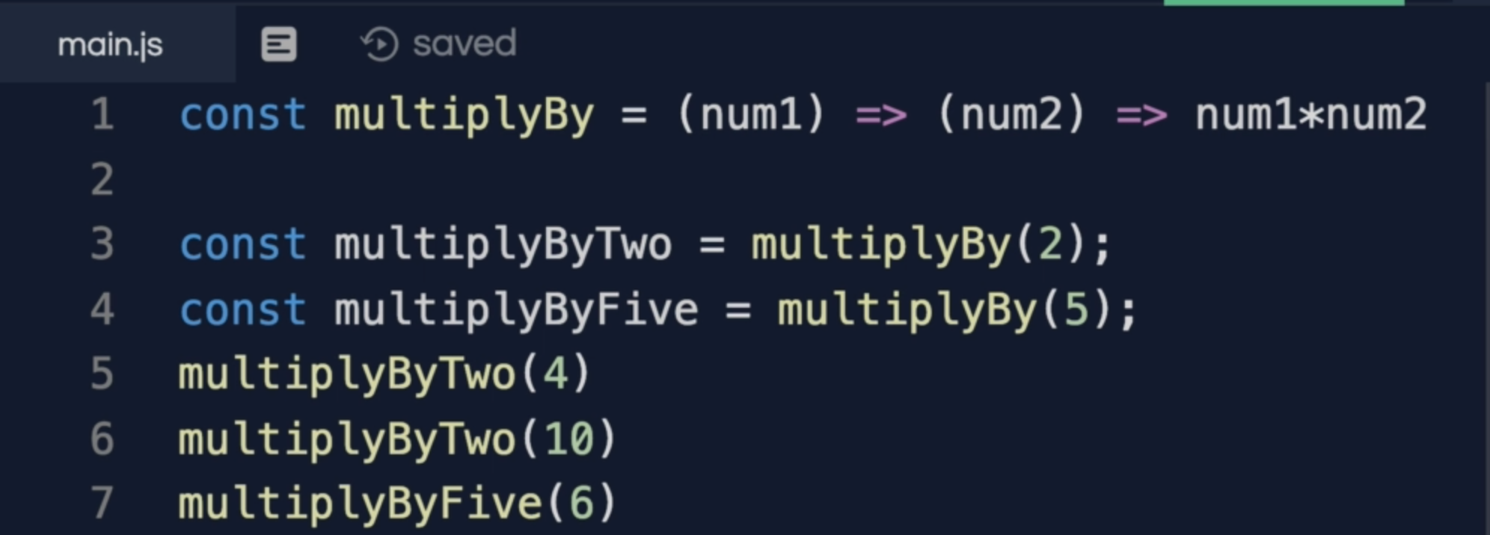

We can also call it like this

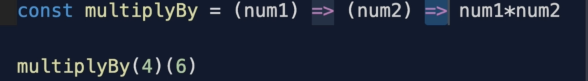

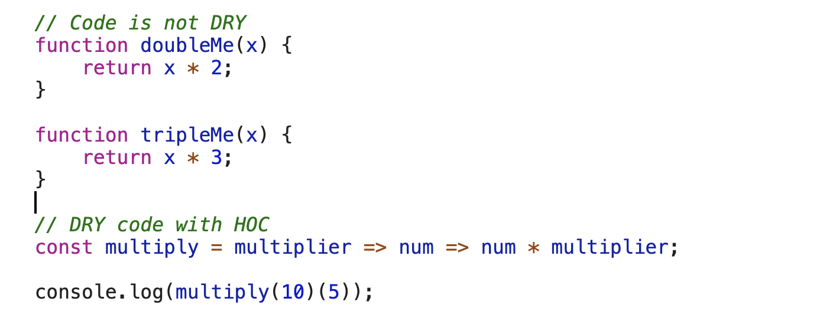

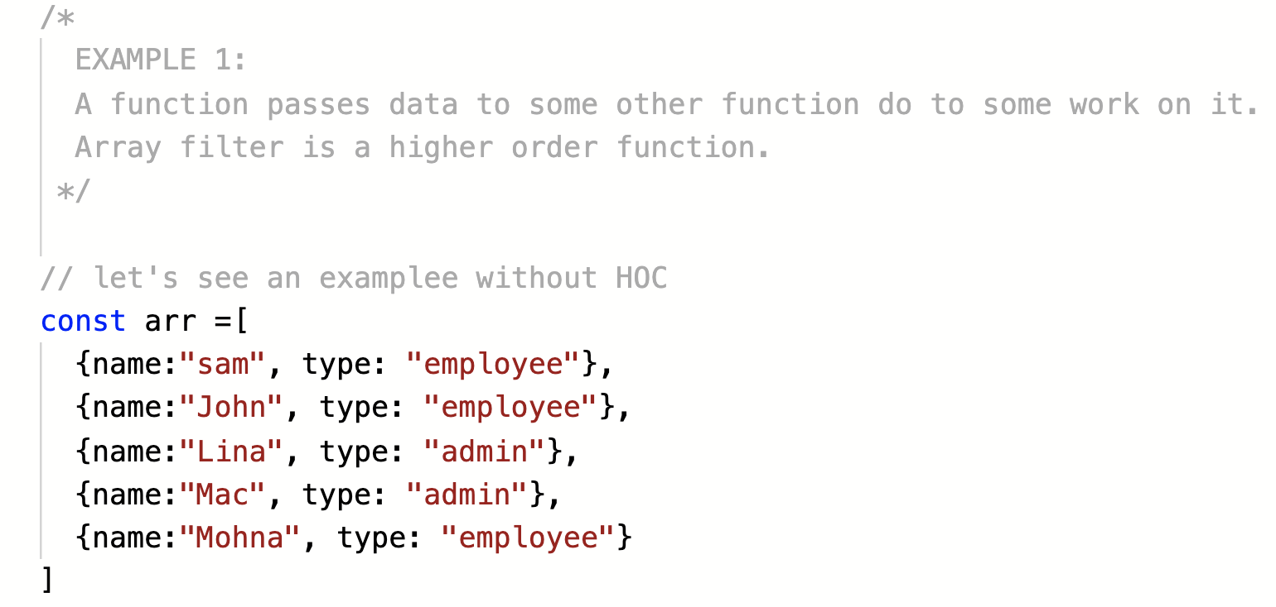

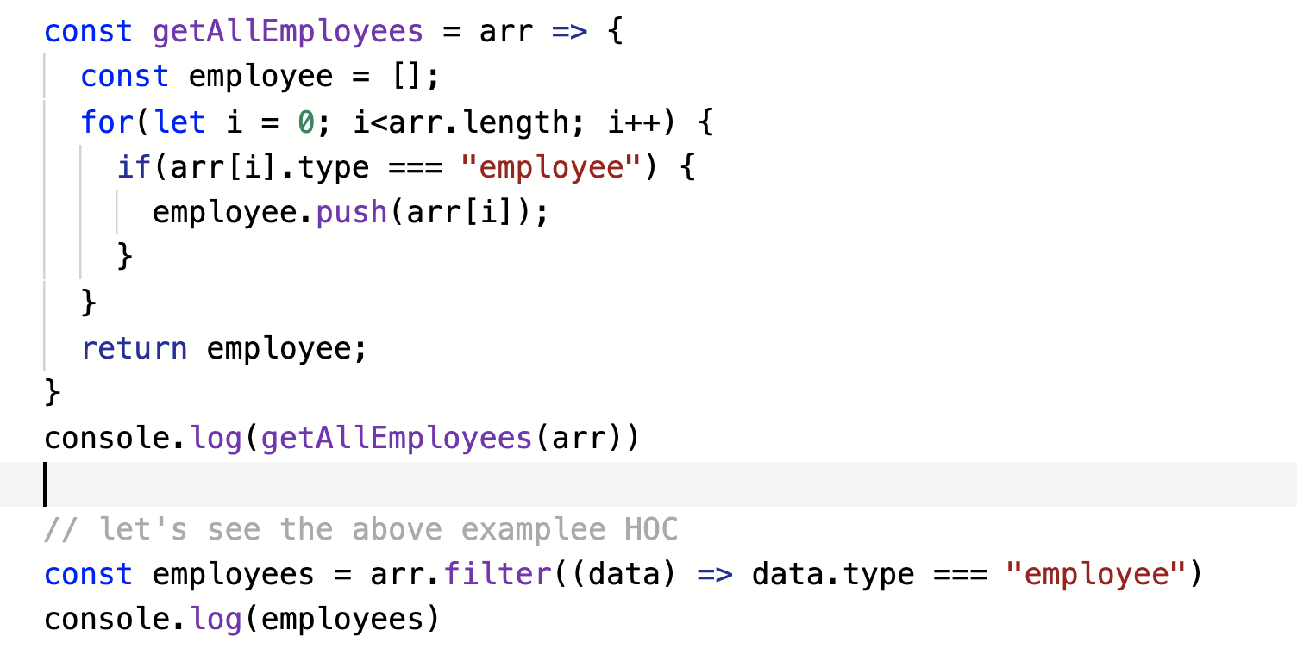

7. Closures

Closure is simply a combination of “Function and Lexical scope”



Closure allows a function to access a variable from an enclosing scope or environment even after it leaves the function in which it was declared.

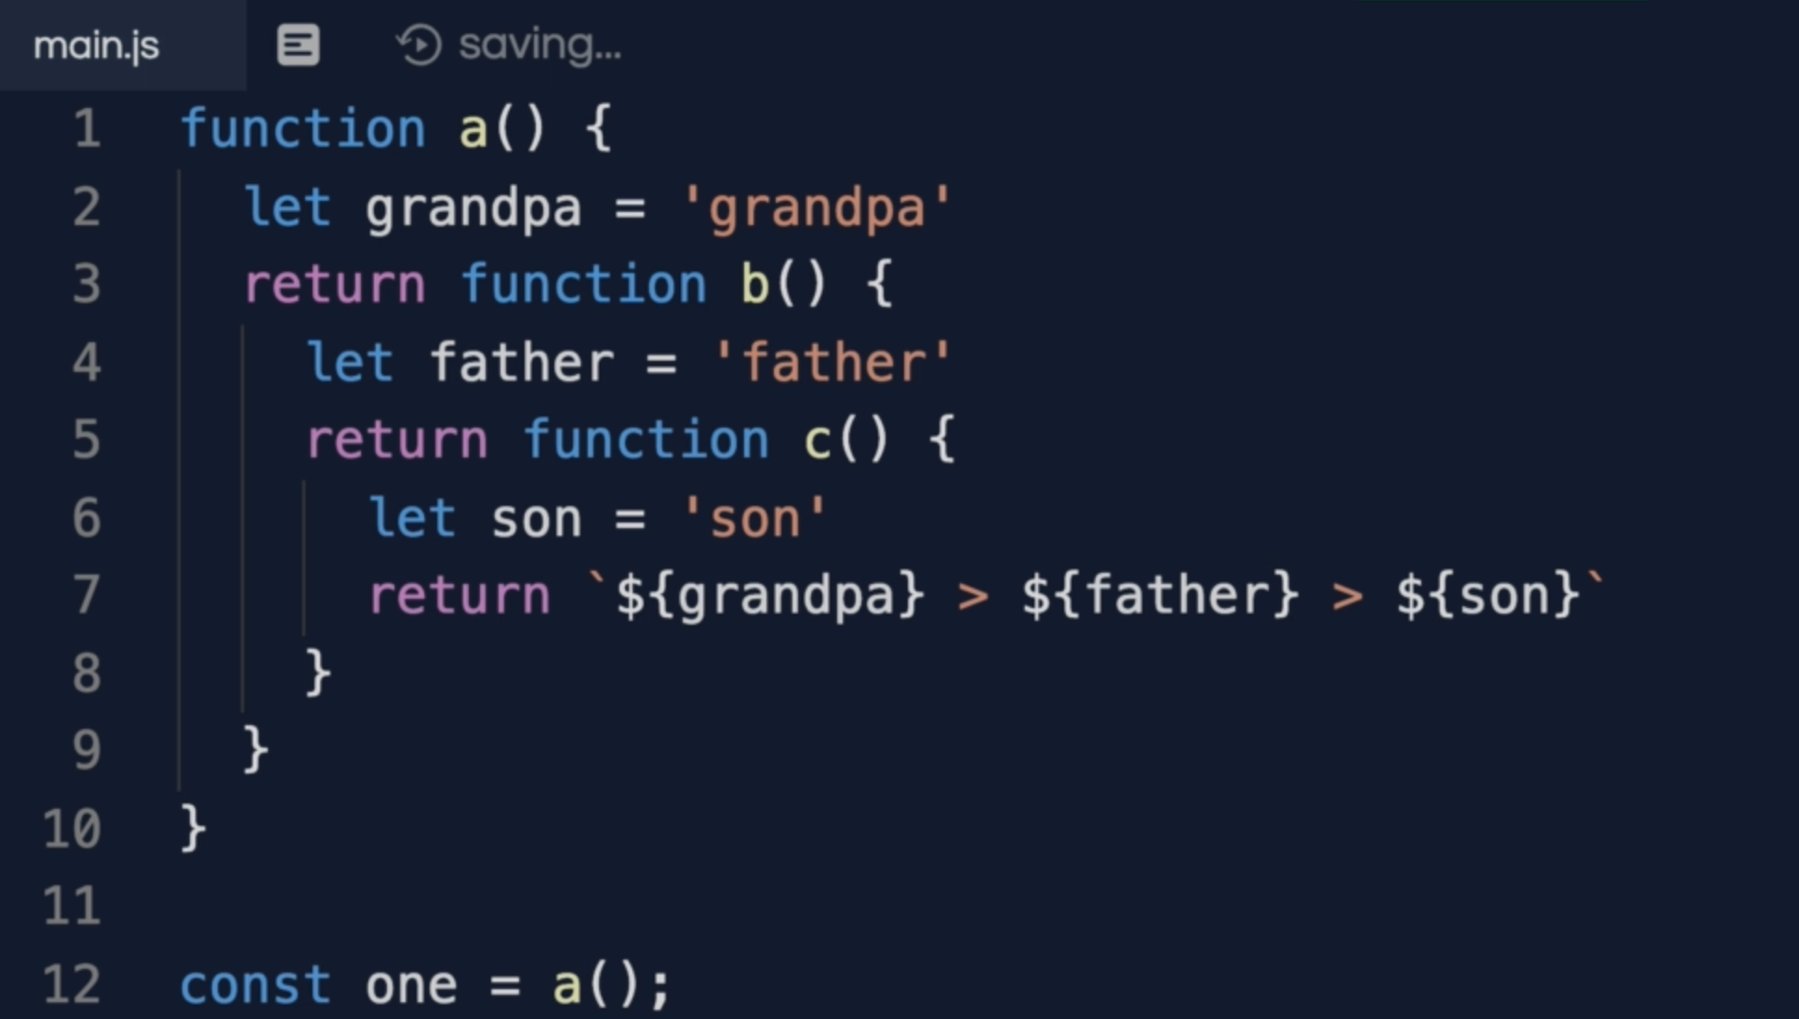

When we run the “**a()** **function”** first, pushed onto the stack and we create a variable environment and this context execution has **“grandpa”** as a variable

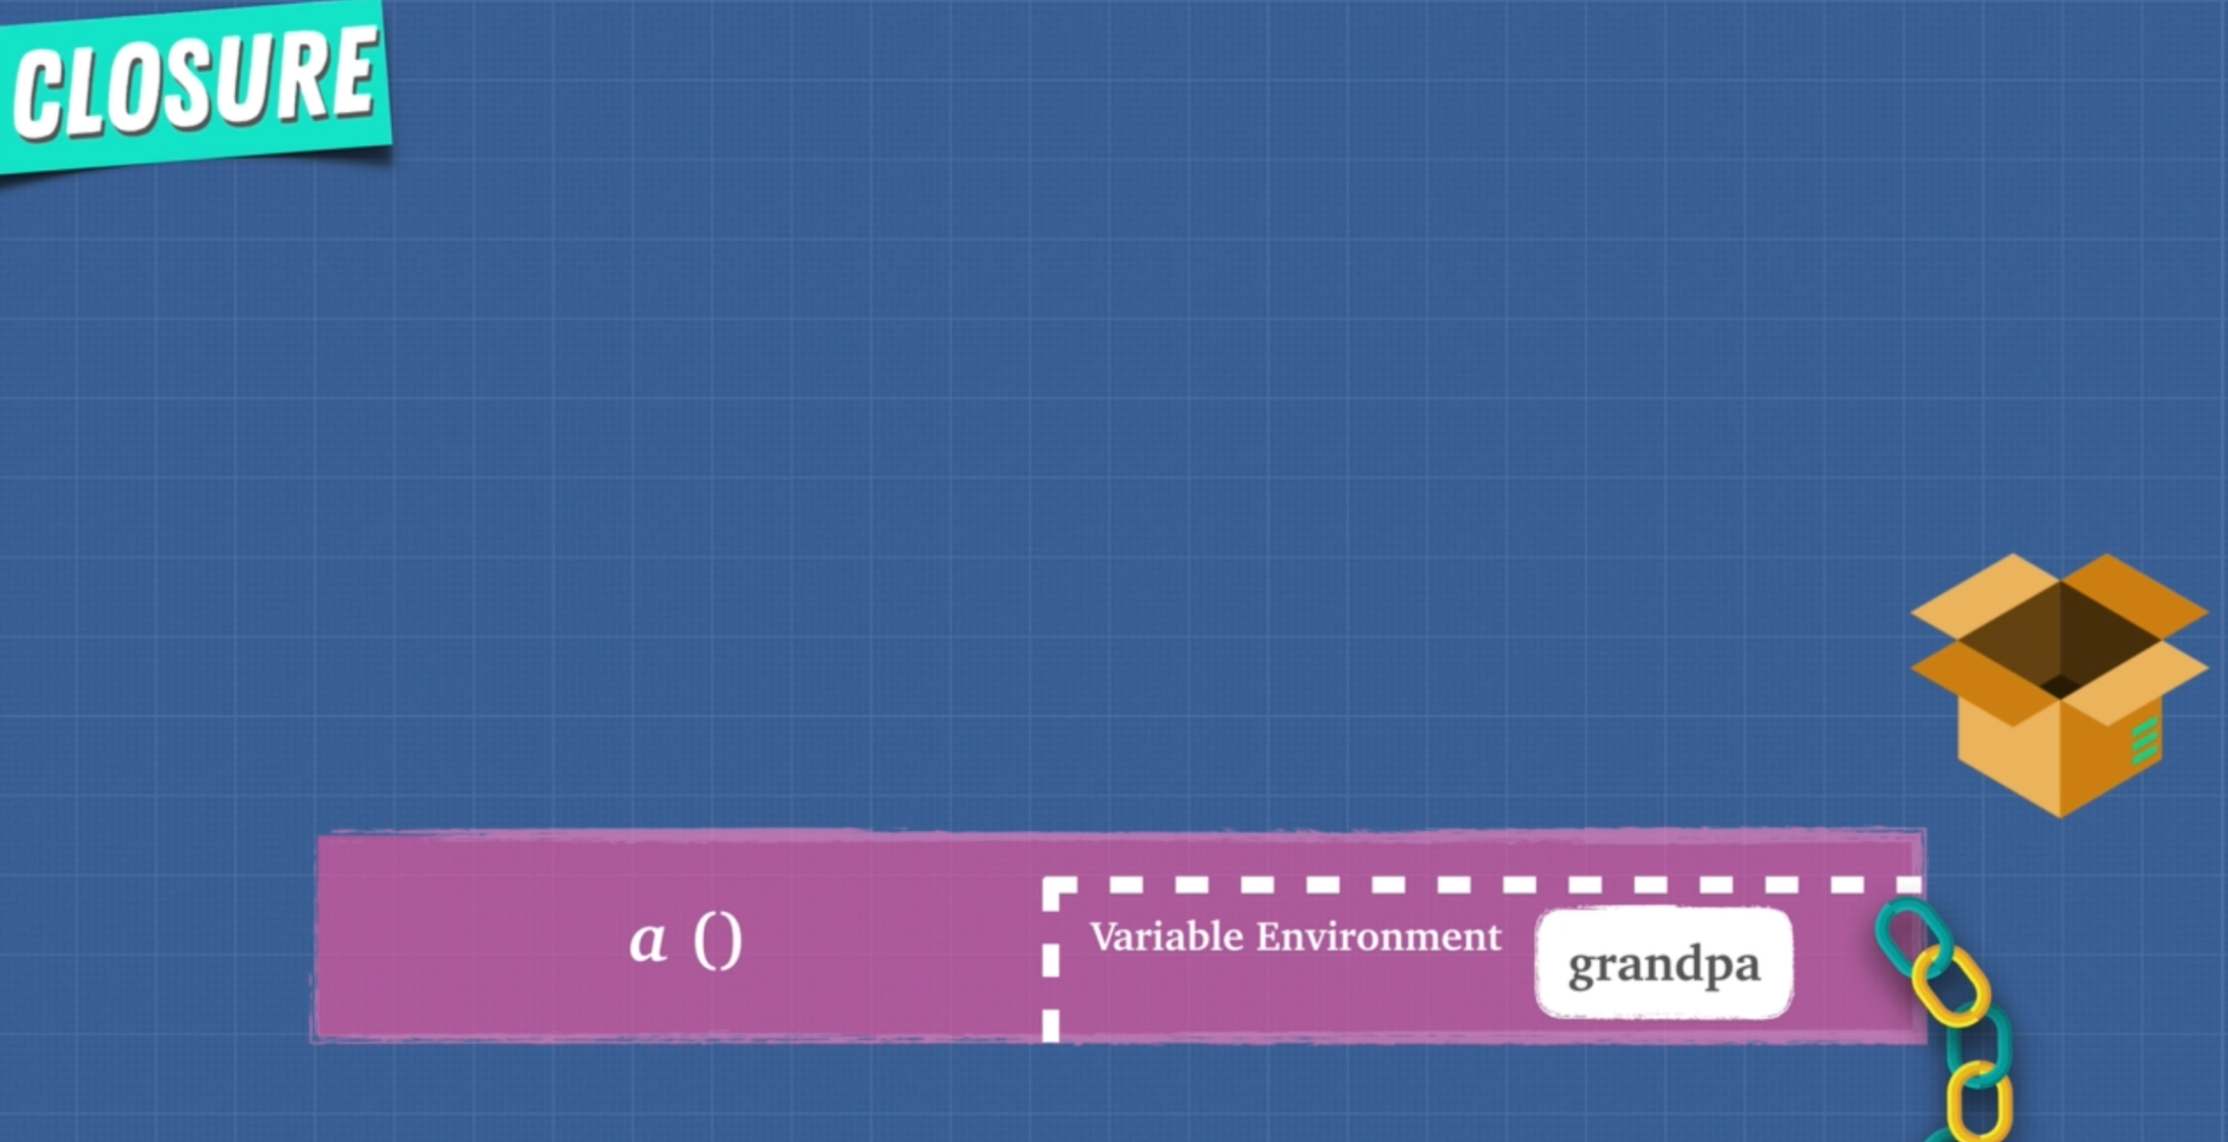

Once the a() function gets executed and removed from the stack, but **“grandpa”** still remains and that is because **“grandpa”** in the above function goes up into the **box** of closure.



This box is where the memory heap is. When garbage collector comes and sees **“grandpa”** in a **special closure box** and says I can’t clean up because something is referencing **“grandpa”**  so the next **b() function** gets called.

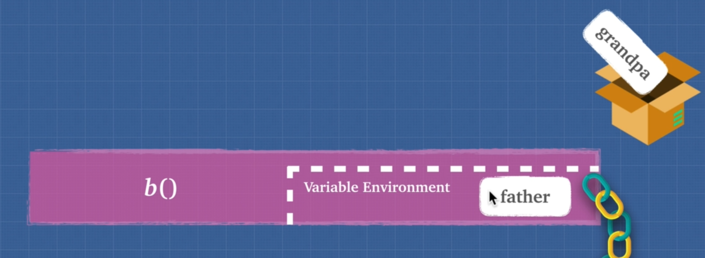

Again it added to the stack and a new variable environment is created and we have **“father”**  there. Once **b() function** gets popped off the stack **“father”** goes to special closure box because it is being referenced by another function inside of it.



then **c() function** gets called

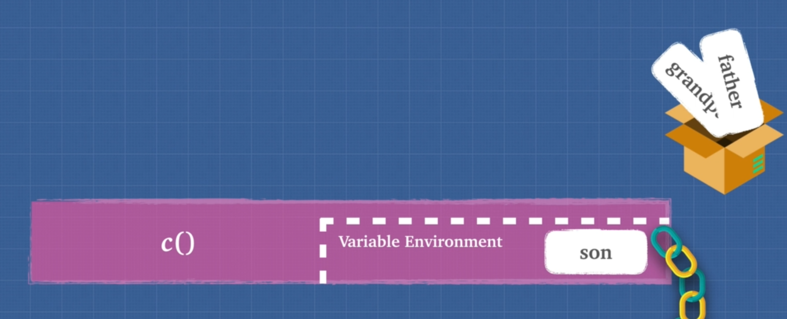

Now when we return **function c()** it **checks** all the variables inside **closure box**

The JavaScript Engine make sure that the function has access to all of the variables outside of the function “**with this above closure box”** function.

Closure is feature of javascript. JavaScript Engine creates a closure when it sees function inside a function.

**Closure** are also called **lexical scoping**. **Lexical** means where it is written. Scoping is what variable we have access to.

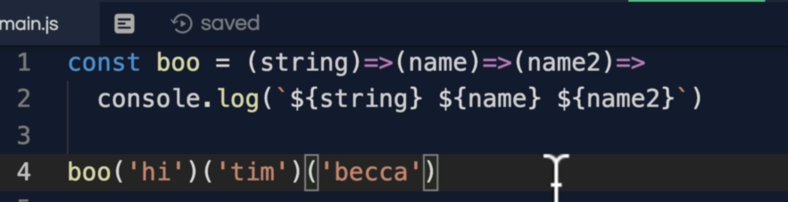

8. Exercise Closures

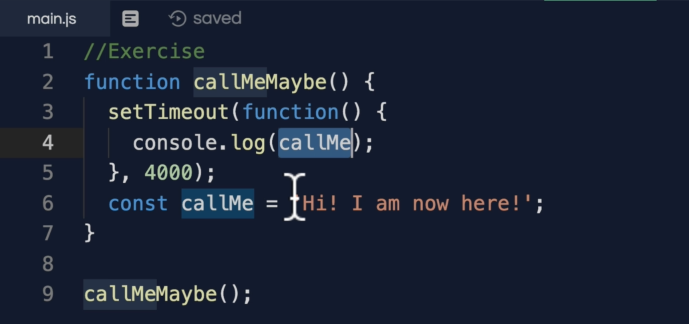

We have a function in setTimeout that is what called a closure which has reference to outer function even the setTimeout is handled by “**webAPI”** and put that into the event queue and once the stack is empty it calls the setTimeout inner function.

**Note:** const does not hoist, but that is available as “callMeMayBe()” executed before setTimeout()

9. Closures and Memory

Closure has 2 main benefits

1. **Memory Efficient**
2. **Encapsulation**

Memory Efficient

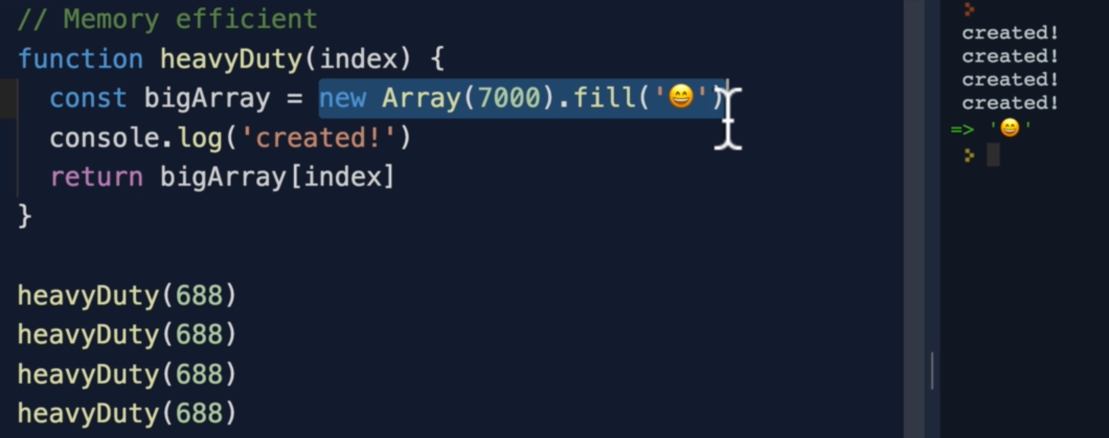

In the above function, it is a heavy duty function. It creates a new array and destroy it every single time we call it so it is taking too much memory.

Wouldn’t it be great if there was a way for us to create this array once and have it memory so that we can access it when we need it because we know it is going to be used a lot.

**REMEMBER:** WE DON’T WANT TO POLLUTE THE GLOBAL ENVIRONMENT

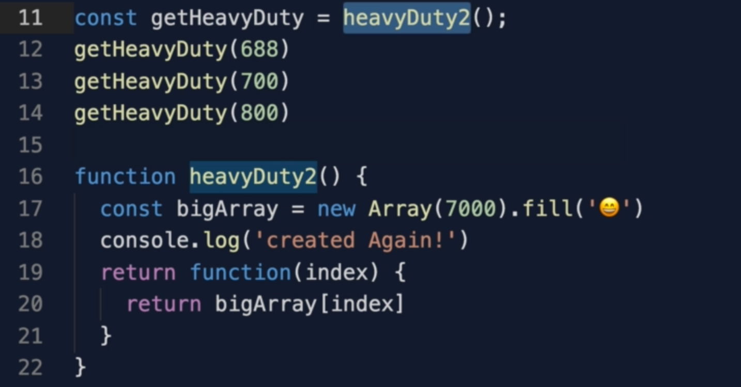

10. Closures and Encapsulation

Using closure we are able to access “**timeWithoutDesctruction**” which we don’t want anybody to touch it. We just want SetInterval() to increment it.

We only allows people to see the pass time by allowing access to passTime()

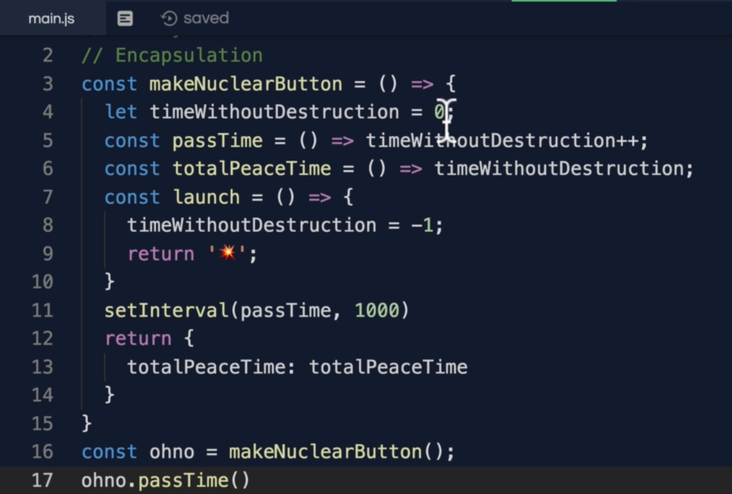

11. Exercise Closures 2

Can you turn this function into a function that can only be called once?

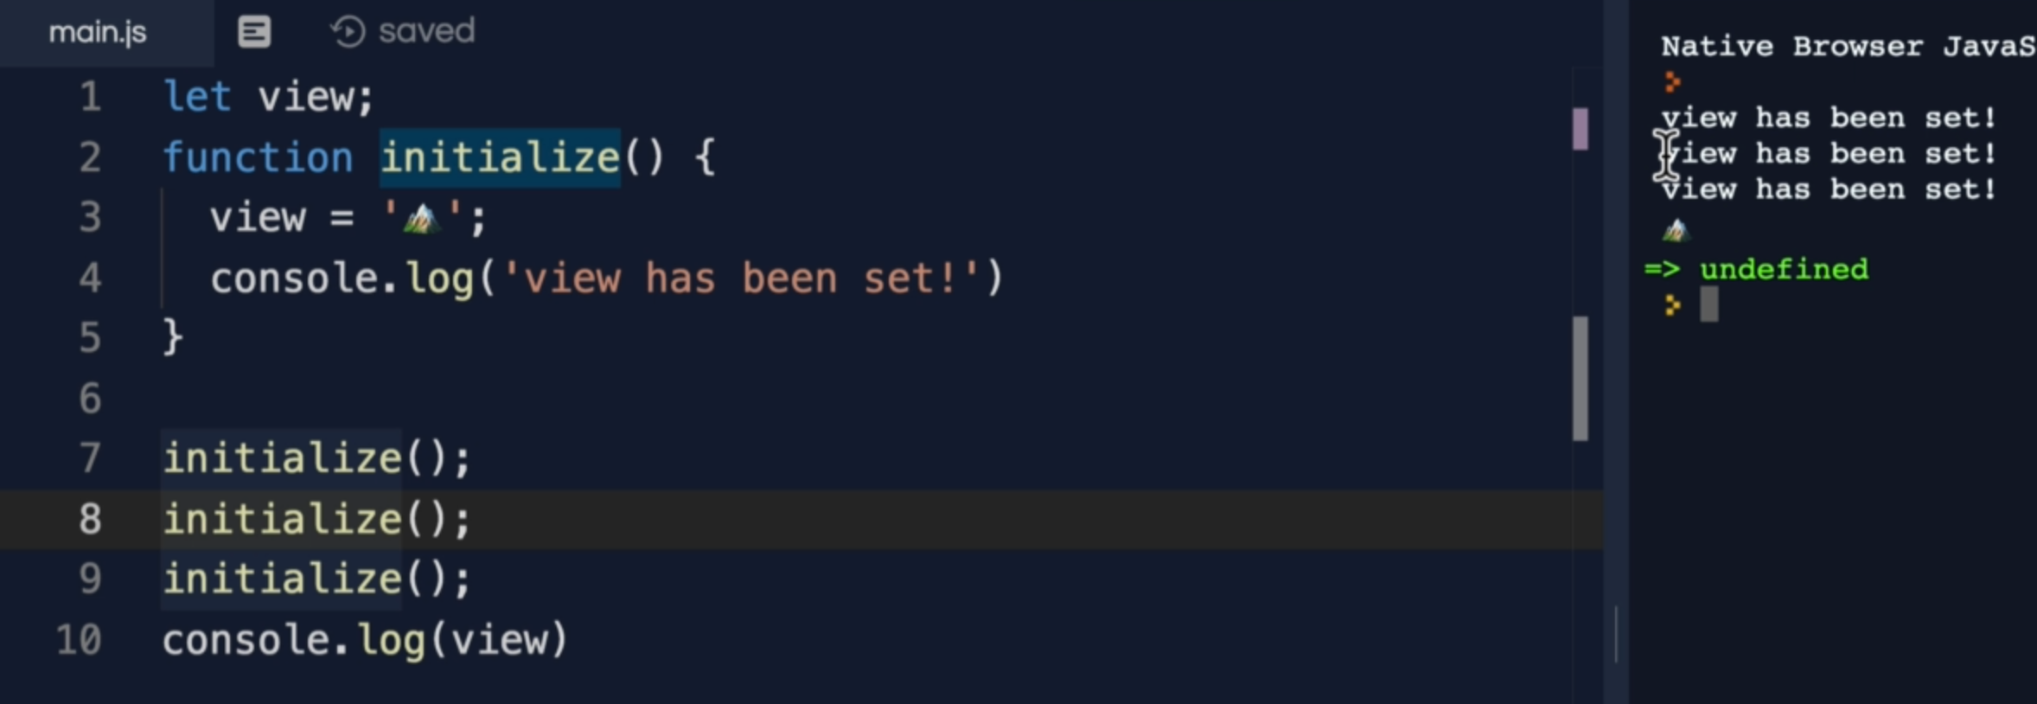

12. Solution Closures 2

We used closure encapsulation approach to make it call once.

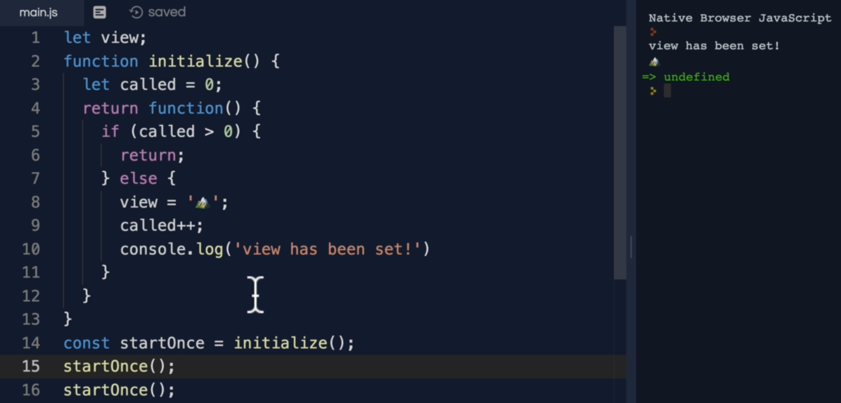

13. Exercise Closures 3

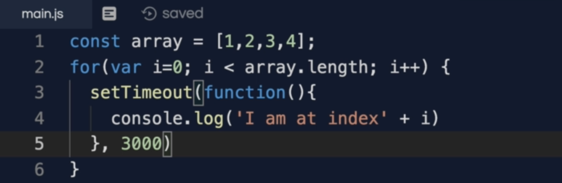

14. Solution Closures 3

“let” keyword creates a scope for “i” where we used it down like this

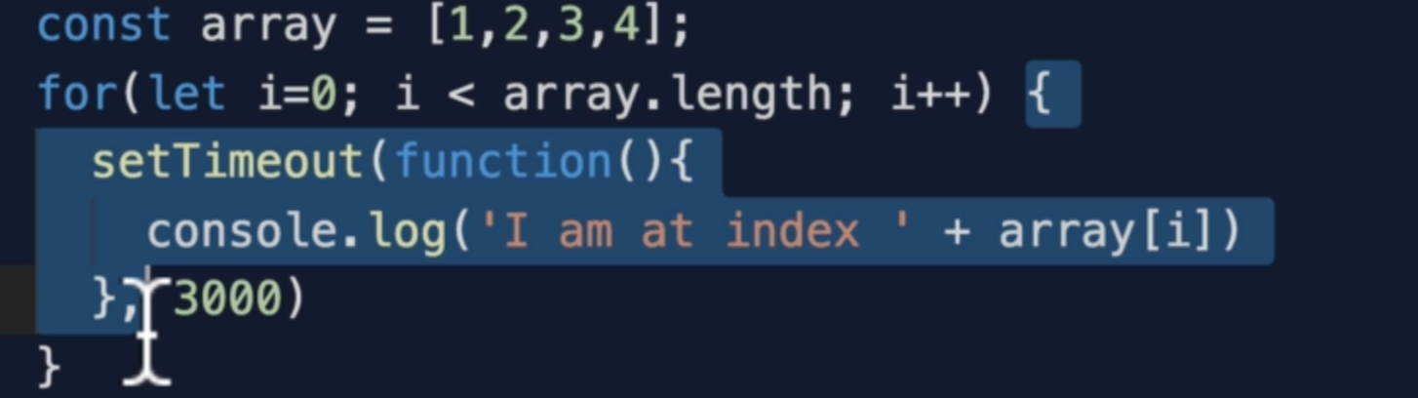

**Another solution**

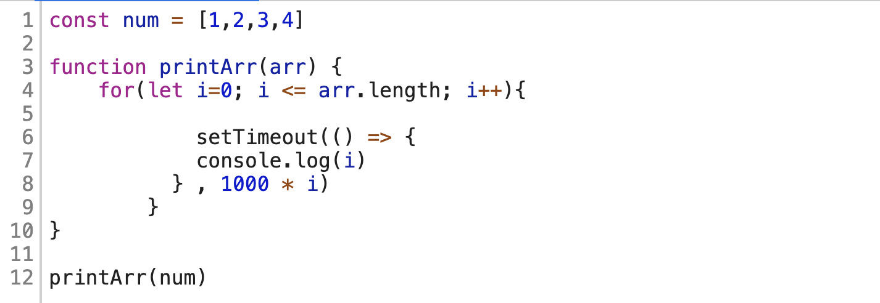

Another solution using IFFI

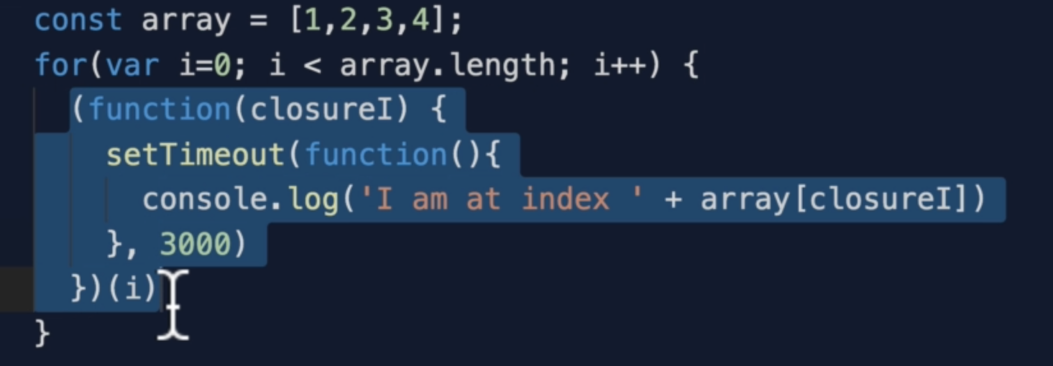

16. Prototypal Inheritance

17. Prototypal Inheritance 2

Arrays and functions are objects and JavaScript uses **Prototypal Inheritance**

The prototype Object is the top Object

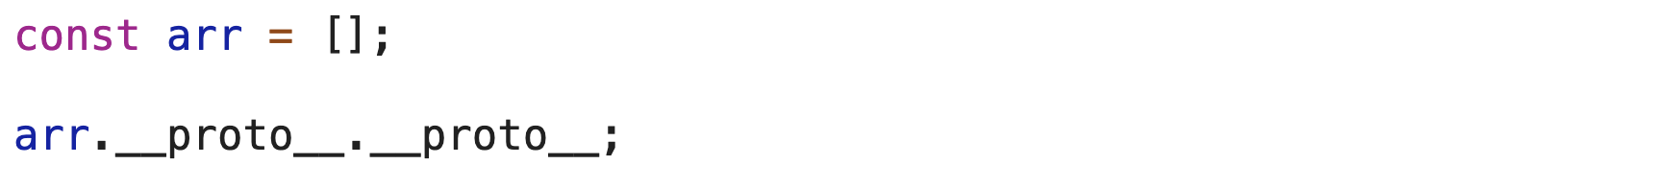

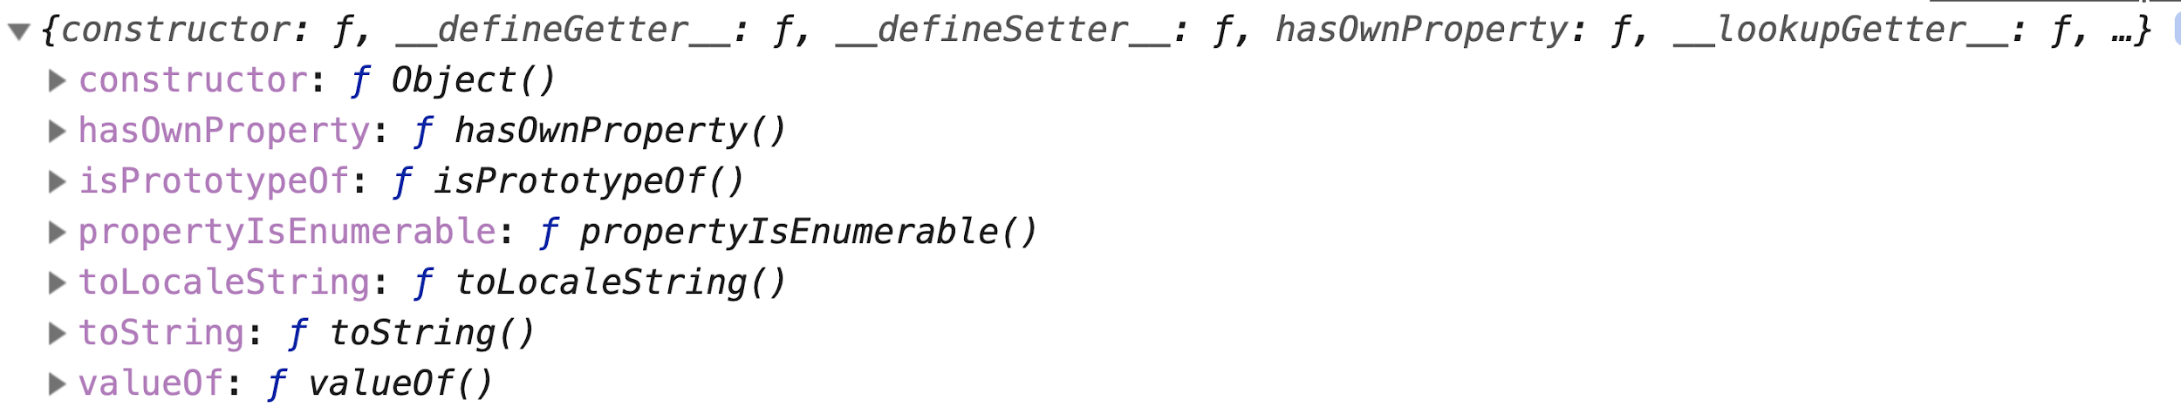

**The prototype of an Array is**

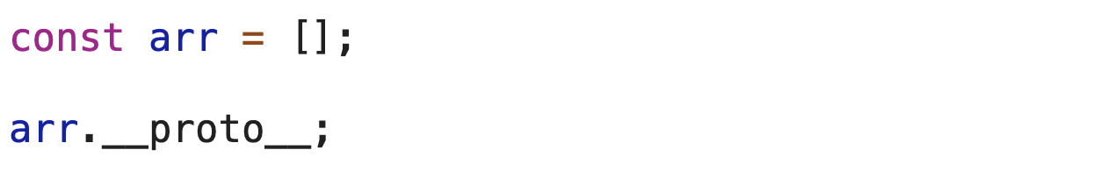

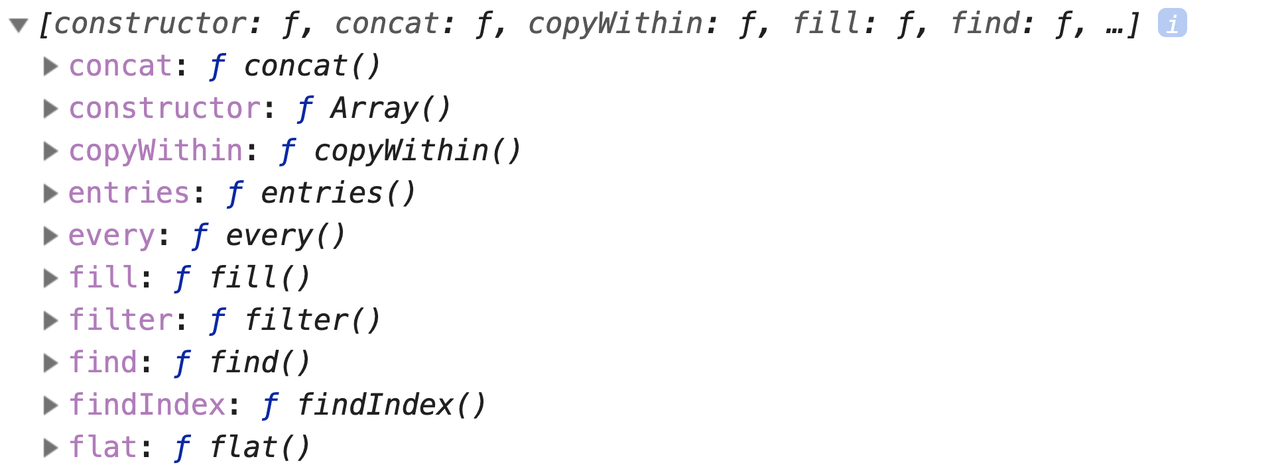

We can make an object prototype of another object

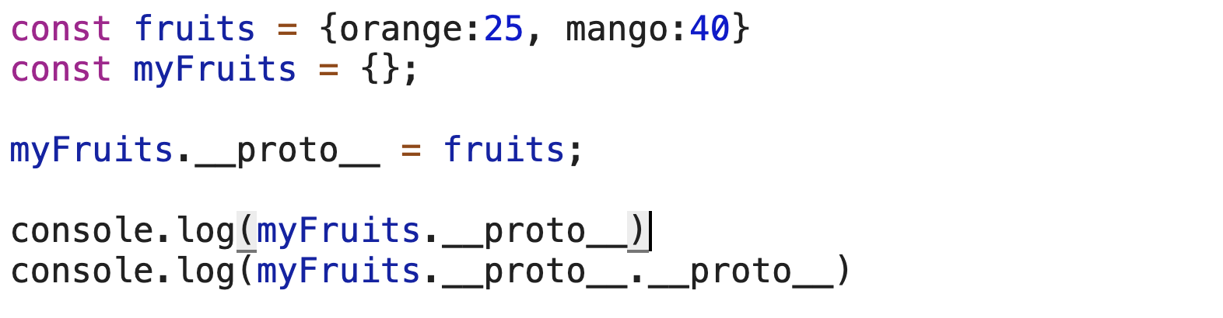



**Array prototype inheritance**

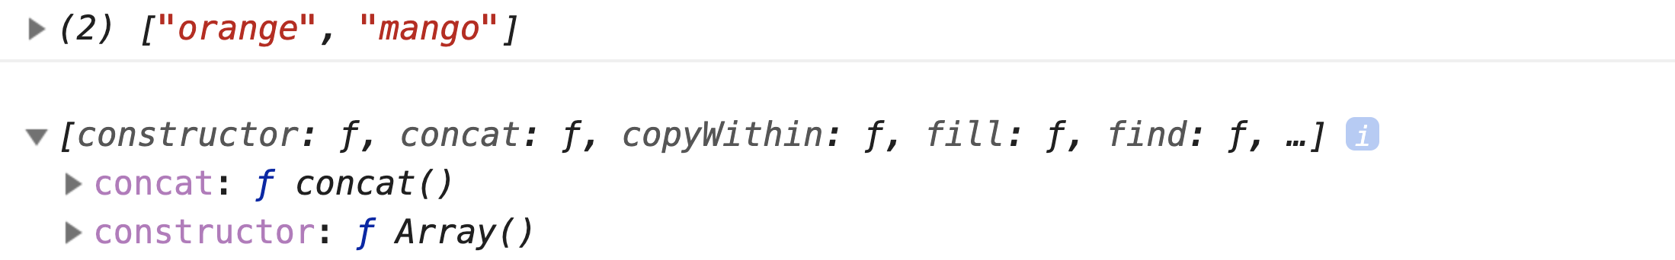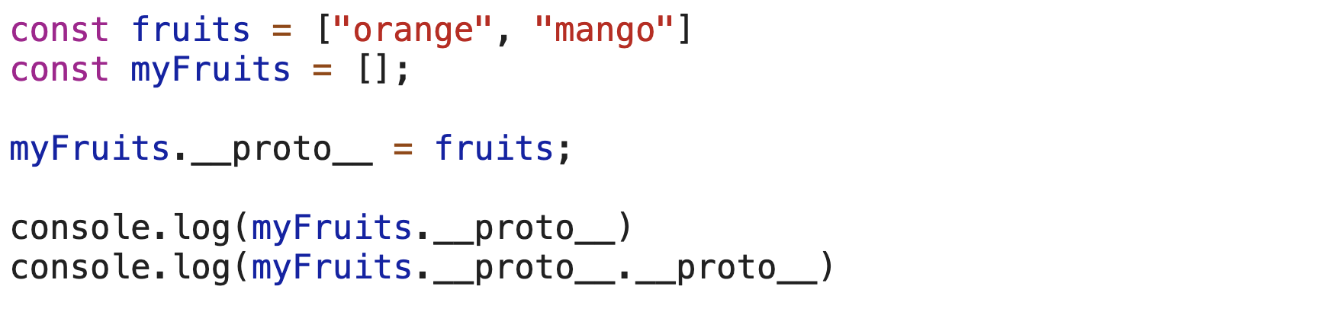

18. Prototypal Inheritance 3

If you loop an object, it will print all the properties it has, but if the object has custom inheritance __proto__. it will also print that.

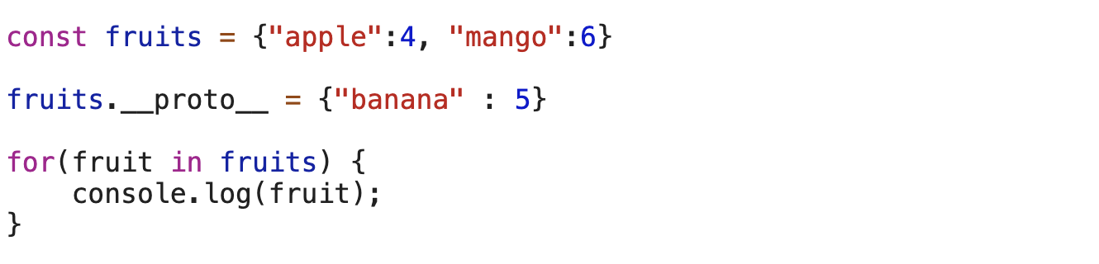

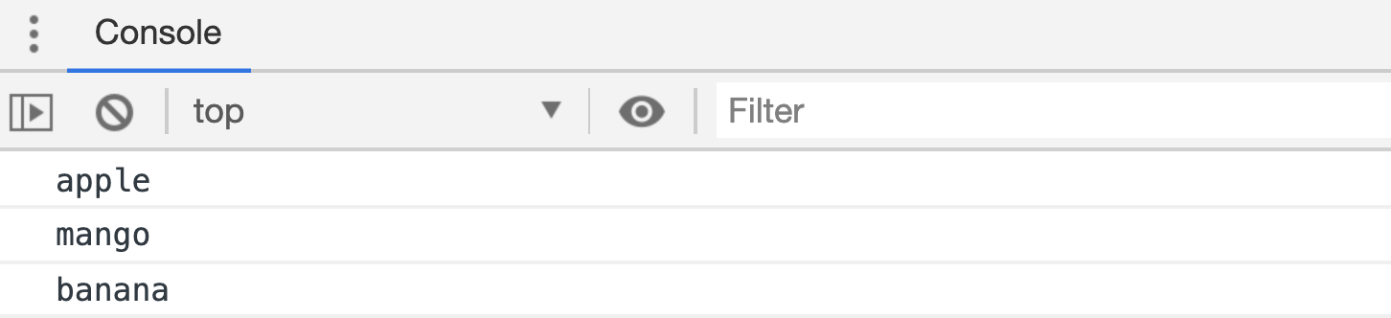

**Warning:** We should never assign the prototype chain manually like

**fruits.__proto__ = {banana: 5}** It will mess up our compiler very badly and that causes a performance issue



**Note:** whenever the JavaScript Engine doesn’t find anything in the prototype chain, we get undefined.

19. Prototypal Inheritance 4





**Both __proto__ and prototype are equal in this way**





20. Prototypal Inheritance 5

We should never assign __proto__ value manually like this

__proto__ =

The correct way to do this is use **Object.create()**

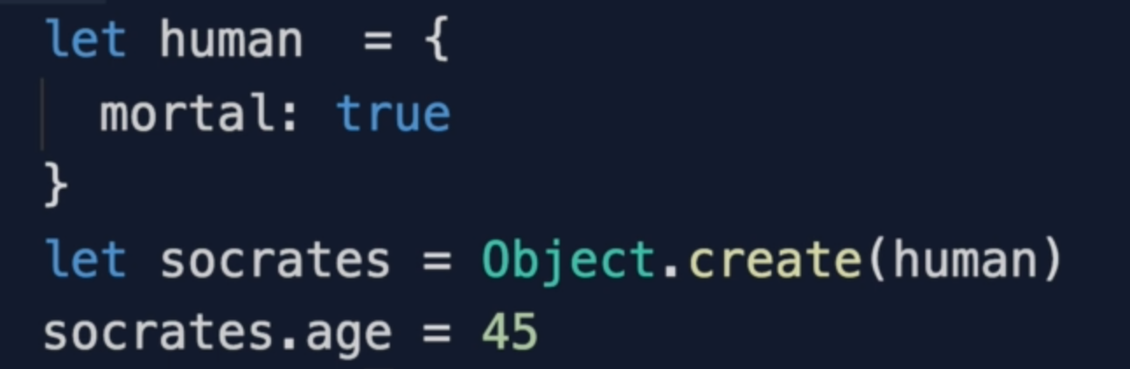

21. Prototypal Inheritance 6

“Object” is the object constructor so we get Function as Object type, but if we create our own object then that will be typeof object.



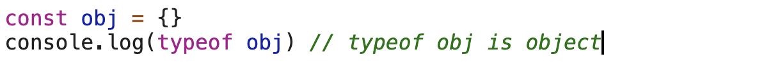

22. Exercise Prototypal Inheritance

Adding a custom function to Date object



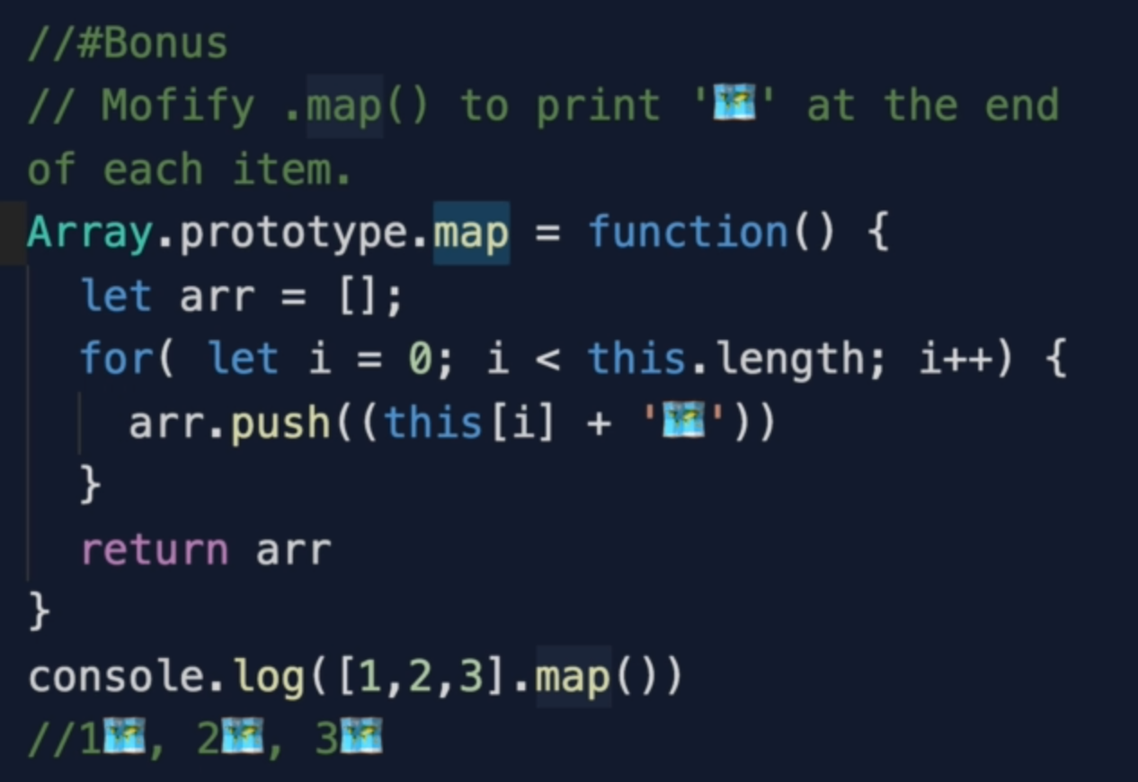

6. Object Oriented Programming

1. Section Overview

2. OOP and FP

OOP says bringing together the data and it’s behaviour in a single location called an object

Functional programming says data and behaviour are distinctly different things and should be kept separate for clarity.

3. OOP Introduction

4. OOP1 Factory Functions

Factory function acts like a factory. It creates objects for us.

In the above code we are copying all the data to memory. Let’s if we need to create 1000s object then all the functions and variables will be copied to memory.

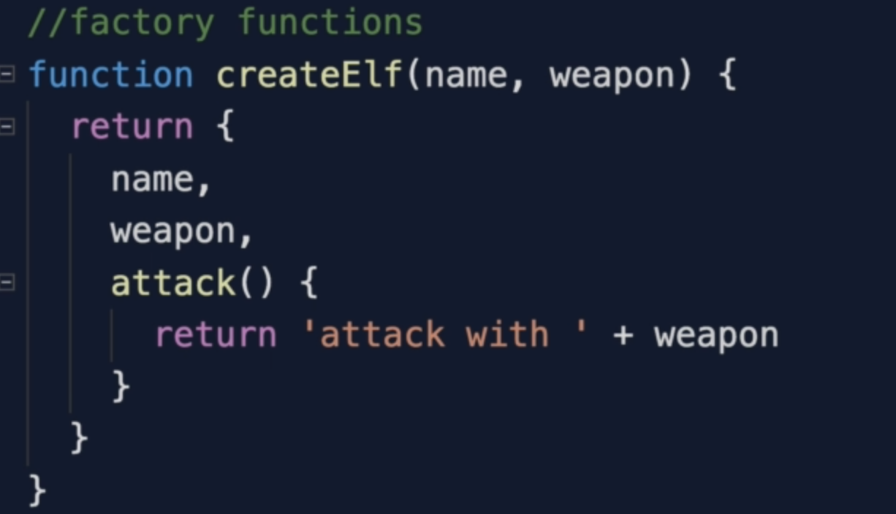

For variables, we can’t anything as there be different values every time, but for method we can take advantage of inheritance

5. OOP2 Object.create()  
With this, we can create prototype inheritance. We can make the prototype of an object to another object we we have studied above like this

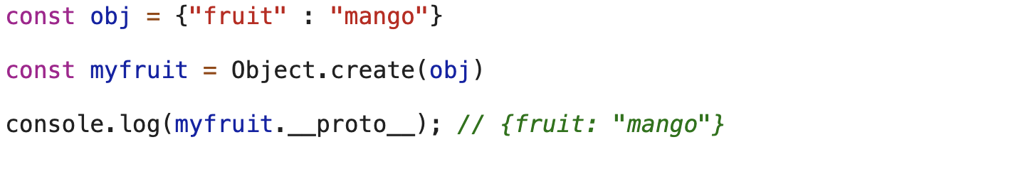

6. OOP3 Constructor Functions

To call constructor function have to use “this” while assigning propeties as shown below.

The “new keyword” returns an object for us automatically.

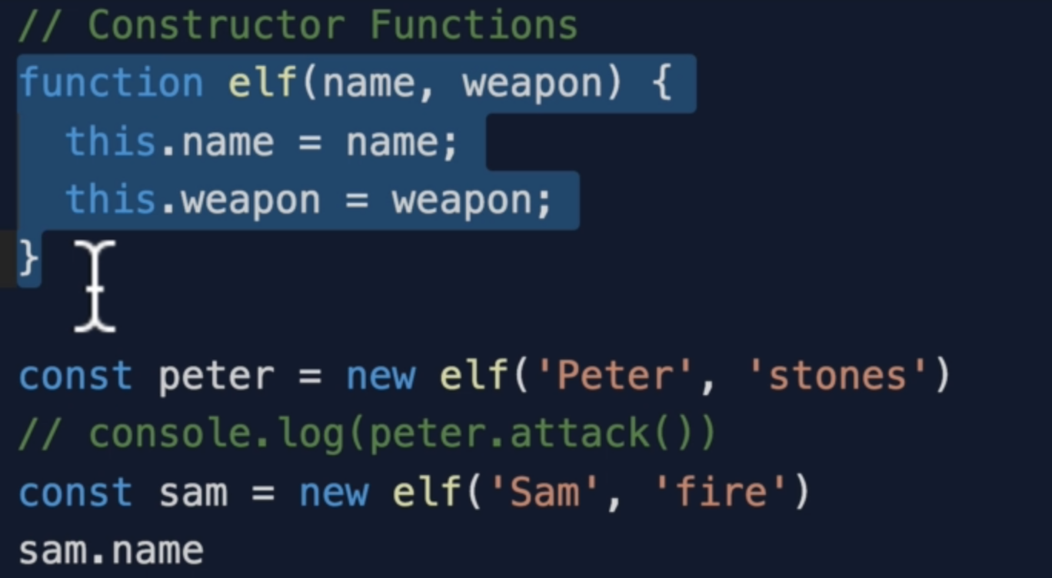

Every function has “this” and “arguments” which points to window object, but when we use new keyword to call a function, the “new” keyword points this to an object that created and return it automatically.

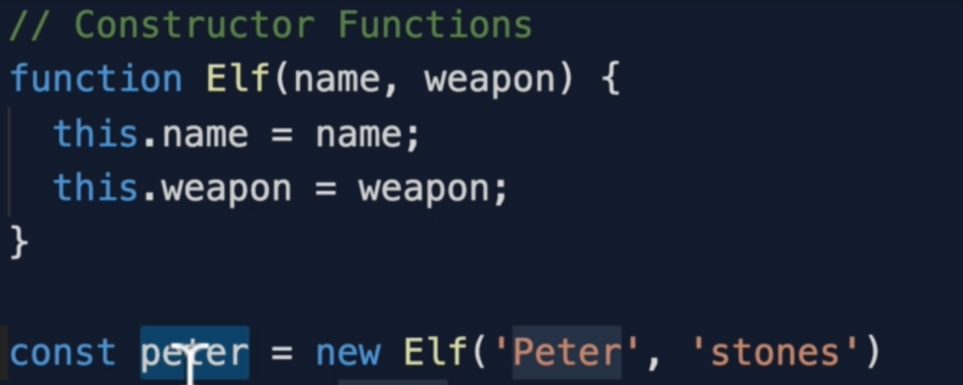

The prototype property is useless with any regular function, but when we use constructor function then the “prototype property” becomes useful.

**NOTE:**  “prototype property” is only available on functions!!

Arrow function will not work as Arrow function are lexically scoped that is they define “this” based on where they are written and in the below picture “this” is the global object because who’s calling attack() right now well there is no object surrounding it other than the global object.

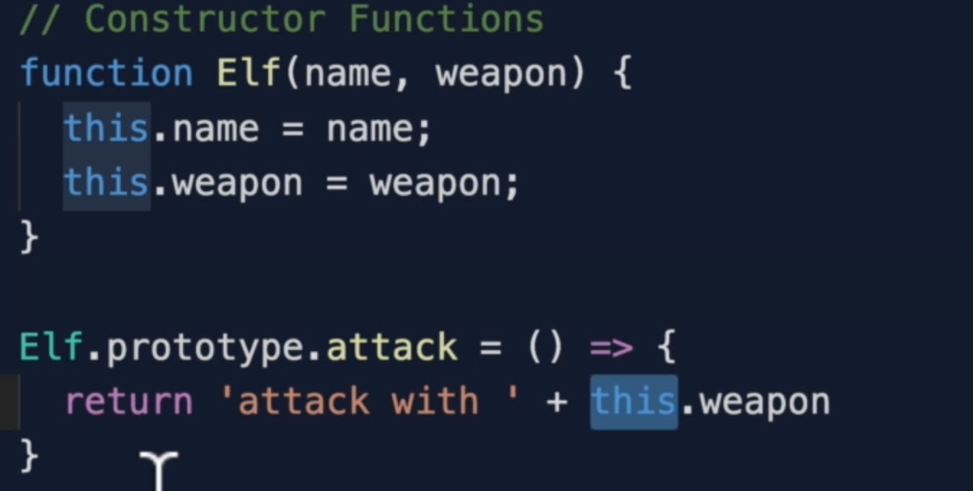

7. More Constructor Functions

Constructor function automatically creates prototypal chain for us.

If we create an object from a constructor then the prototype of that object will the constructor itself and that we can assess with **__proto__**

Example:

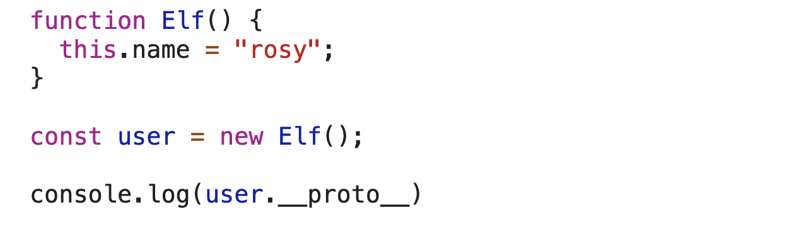

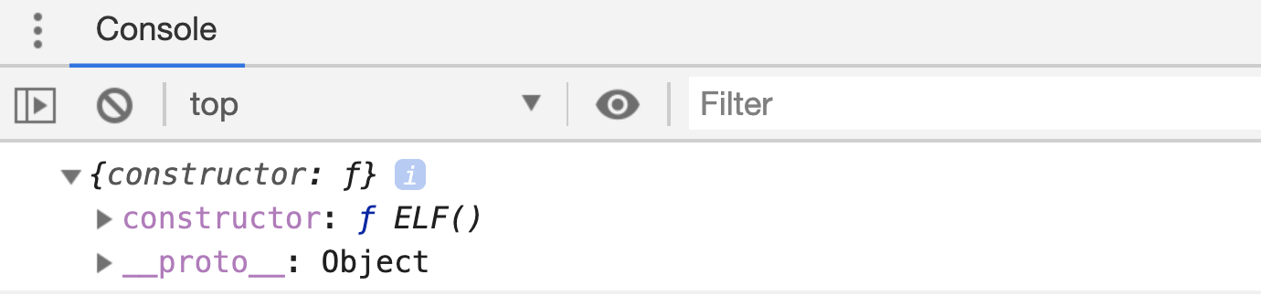

Example 2:

“this.name” will be undefined as function inside function points “this” to window object.

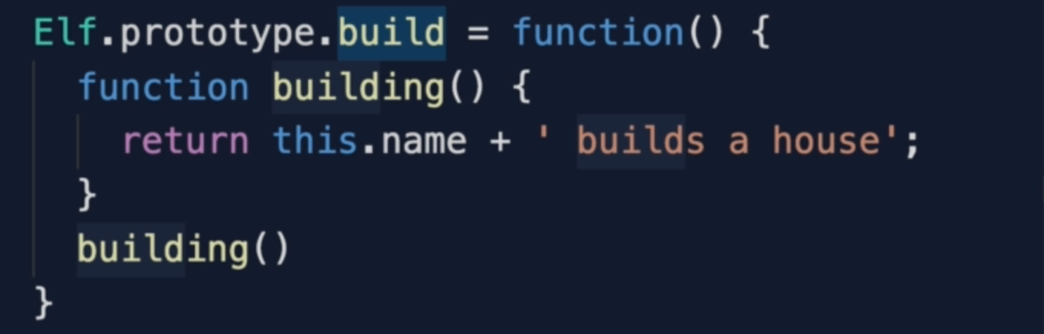

To solve the above problem, we can use arrow function.

The above problem can be solved using bind() method or self = “this” technique.

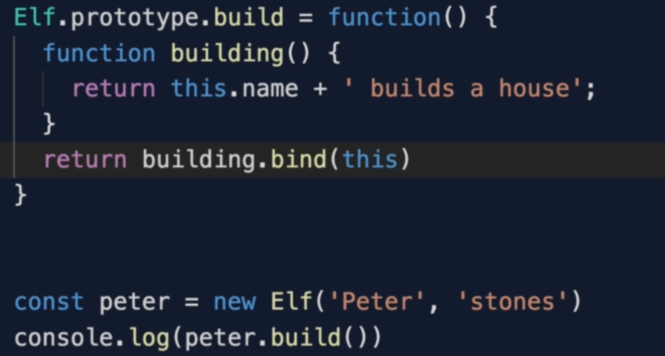

8. Funny Thing About JS…

If you create a number from “new Number(5)”, the type of this number will be an object.

If you create a number like “a = 5”, the type of this will be number and when we compare the 2 with ===, the result will be false.

Internally JavaScript creates a constructor for number so it has all the methods available to it like “toString or toFixed” etc.

Except null and undefined, we have constructor function for everything so that we have relevant methods that we can use.

9. OOP4 ES6 Classes

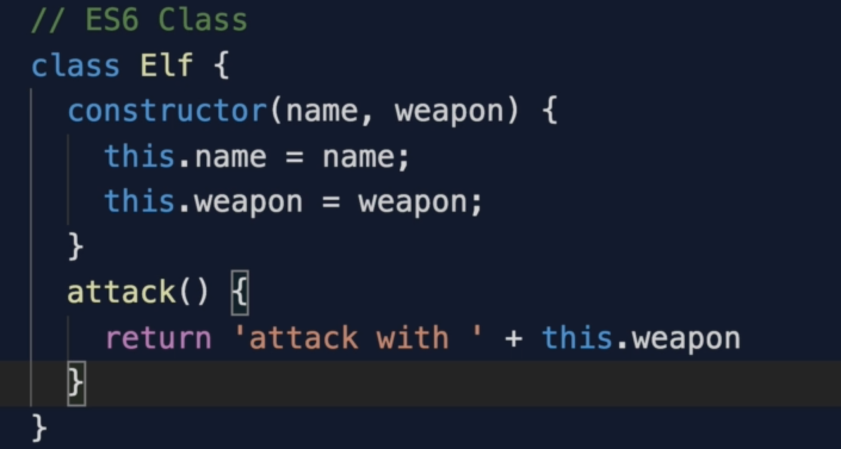

Note: The attack() function is created on the prototype internally.

10. Object.create() vs Class

All the functionality of the class can be created by Object.create()

11. this - 4 Ways

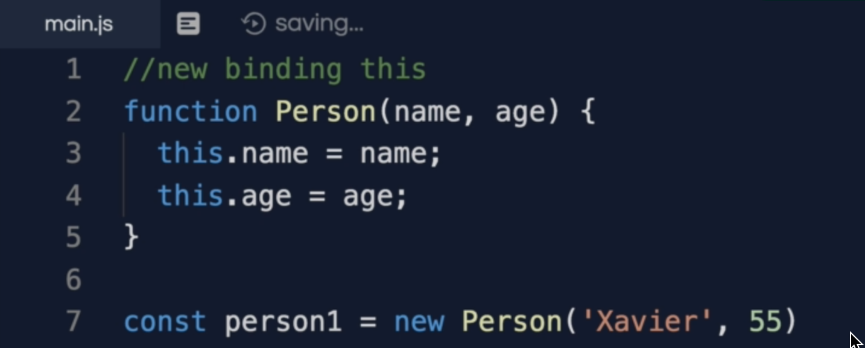

With this example, we can access “name” like “this.name”

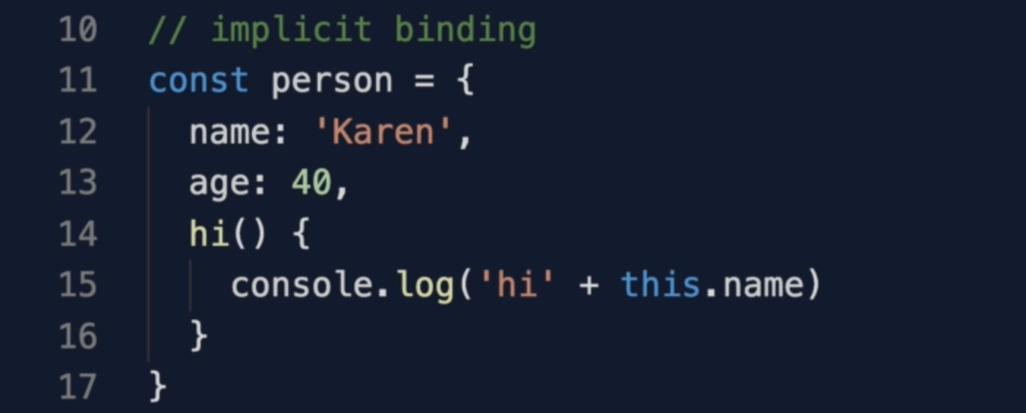

If we need to call a function which is on window object, we can do like this

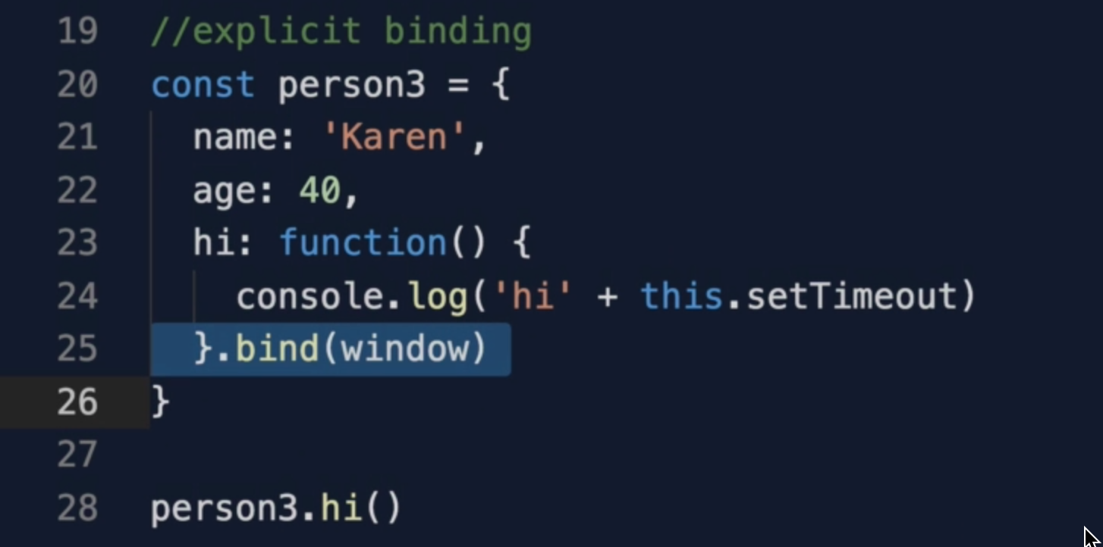

Arrow function: wherever we write the function, that’s what “this” binds to.

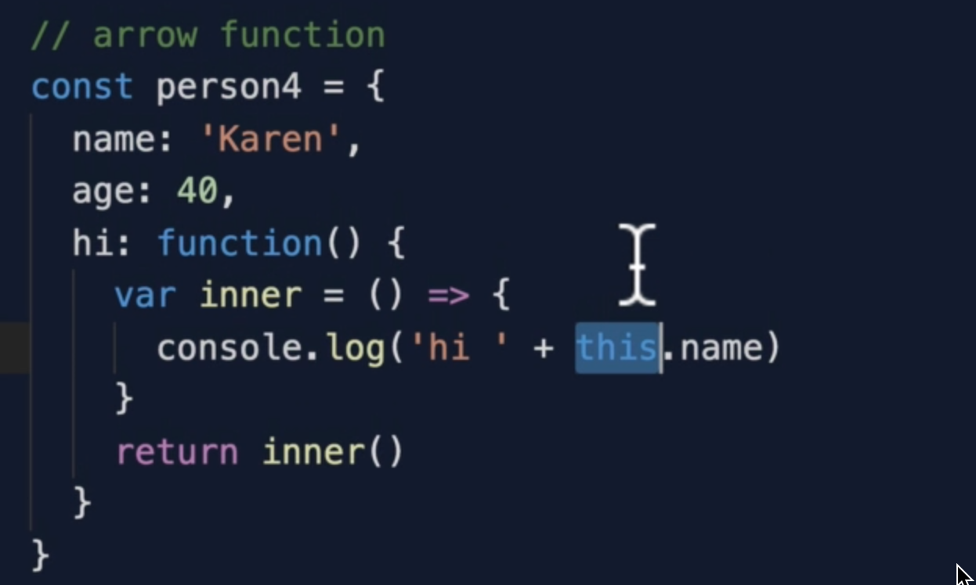

12. Inheritance

Note: method in a class declares on its prototype

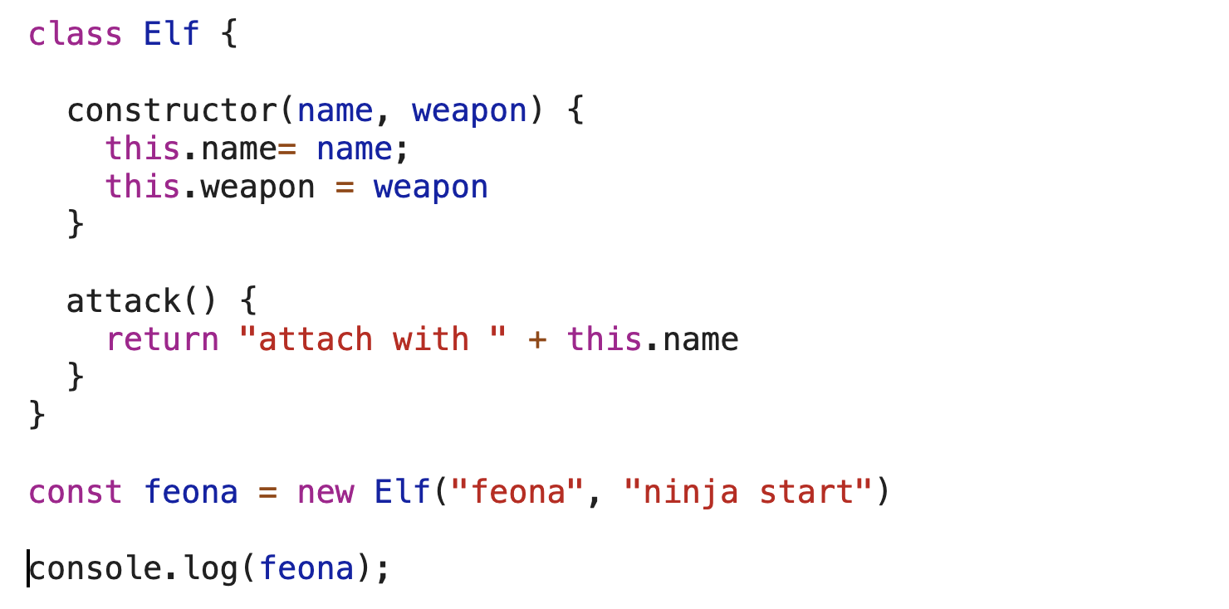

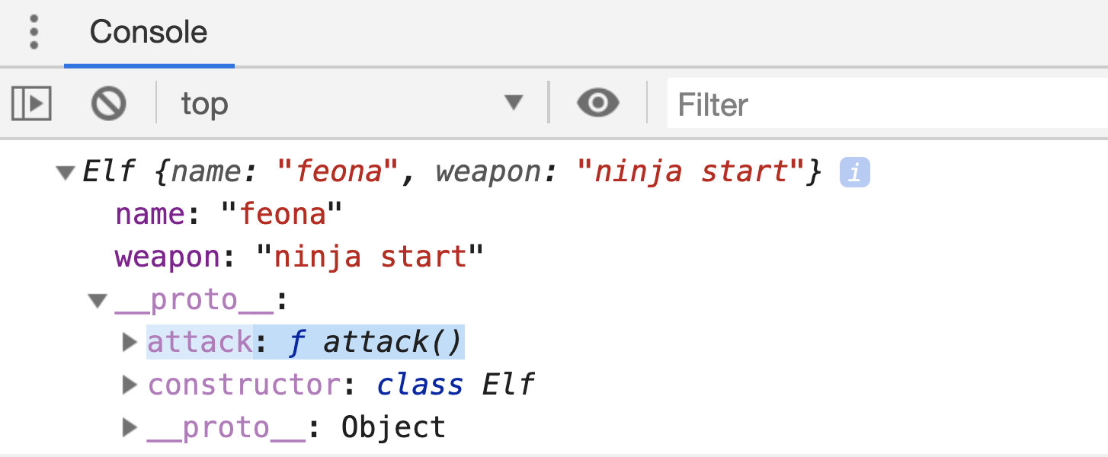

So If we copy the above “feona” object to a new object, only the properties copies, not the methods

Uncaught TypeError: oger.attack is not a function

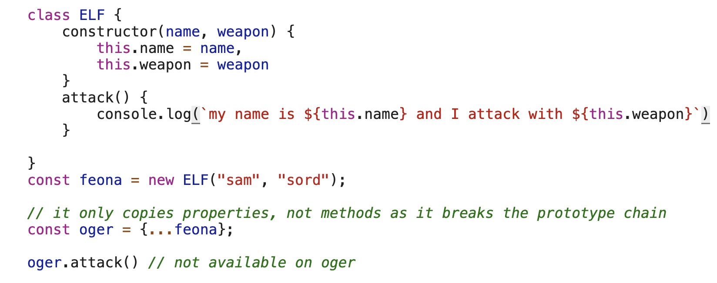

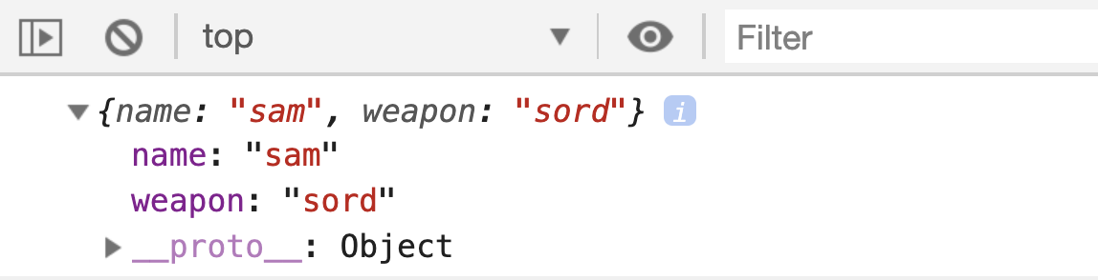

You can inherit all the properties and methods by extending a class and if you want to have your constructor in subclass than, you need to call super()

super() : it means that you are calling parent class and setting it’s properties.

Note: we have “this” available only after calling super()

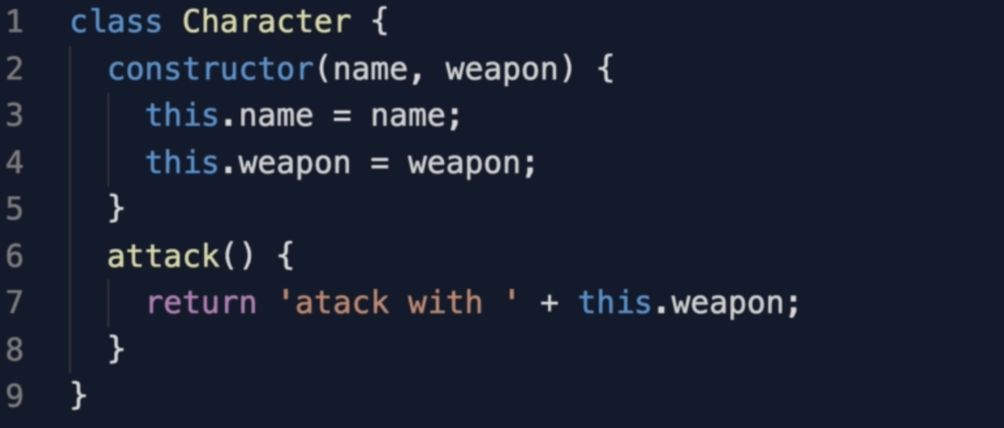

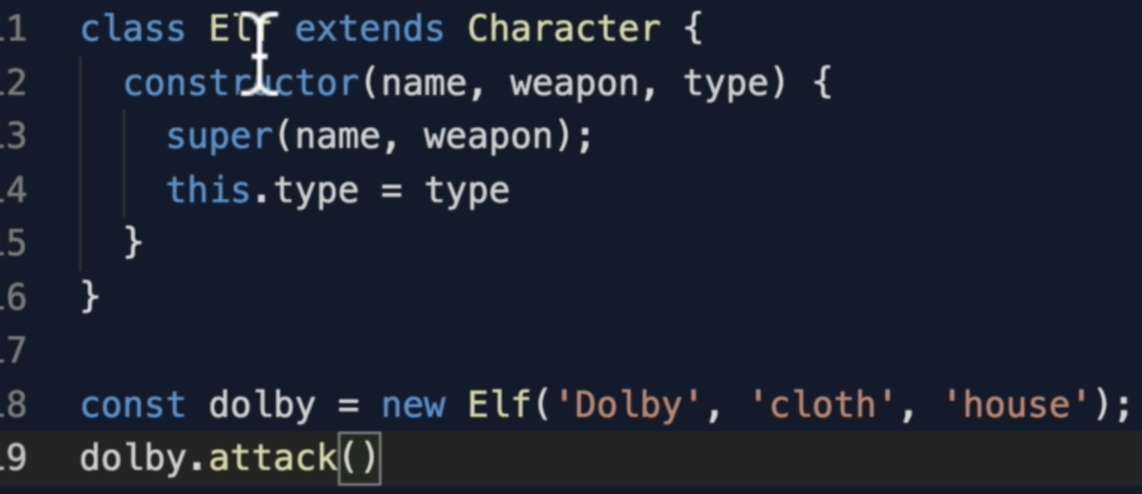

13. Inheritance 2

14. Public vs Private

Note: By convention we add **_** underscore to a method or properties to indicate that these are private.

16. 4 Pillars of OOP

Polymorphism: the ability to call the same method on different objects each object responding in a different way

The same method can be returned with or without parameters. This is also called method overloading and overriding

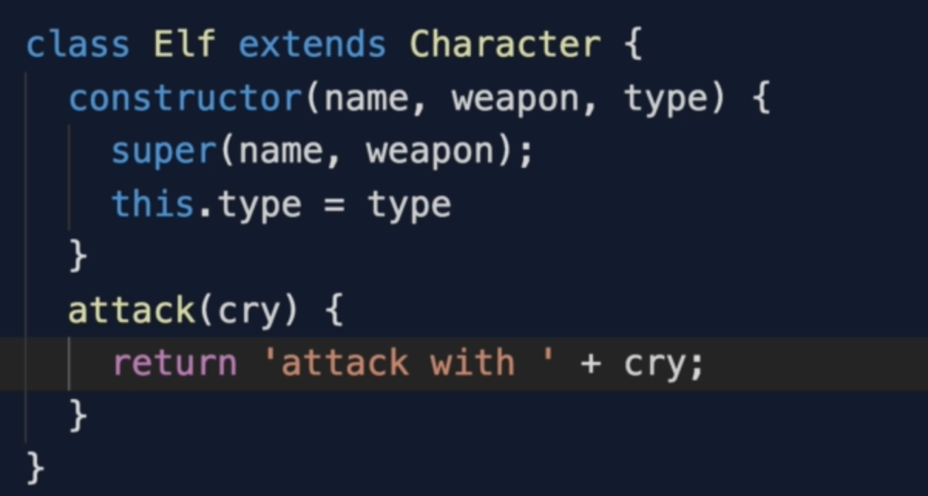

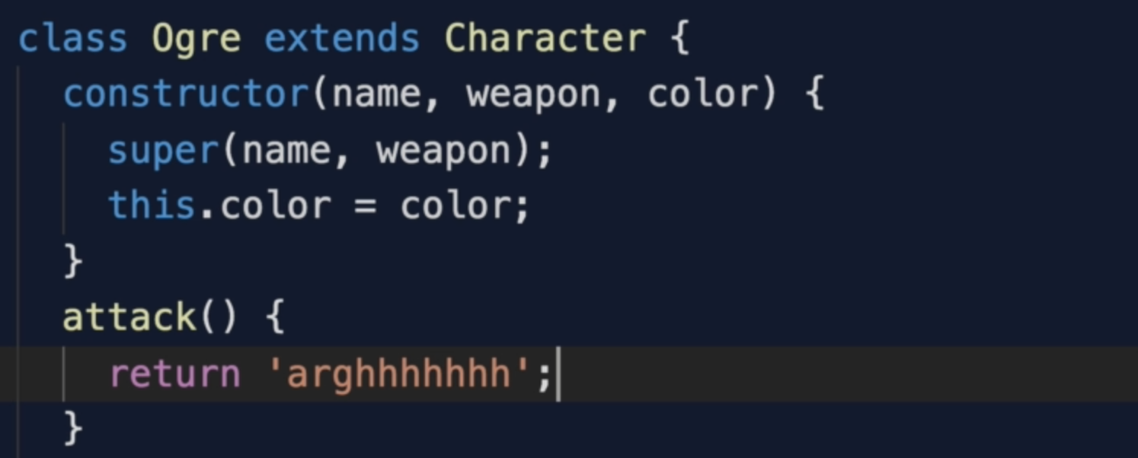

7. Functional Programming

1. Section Overview

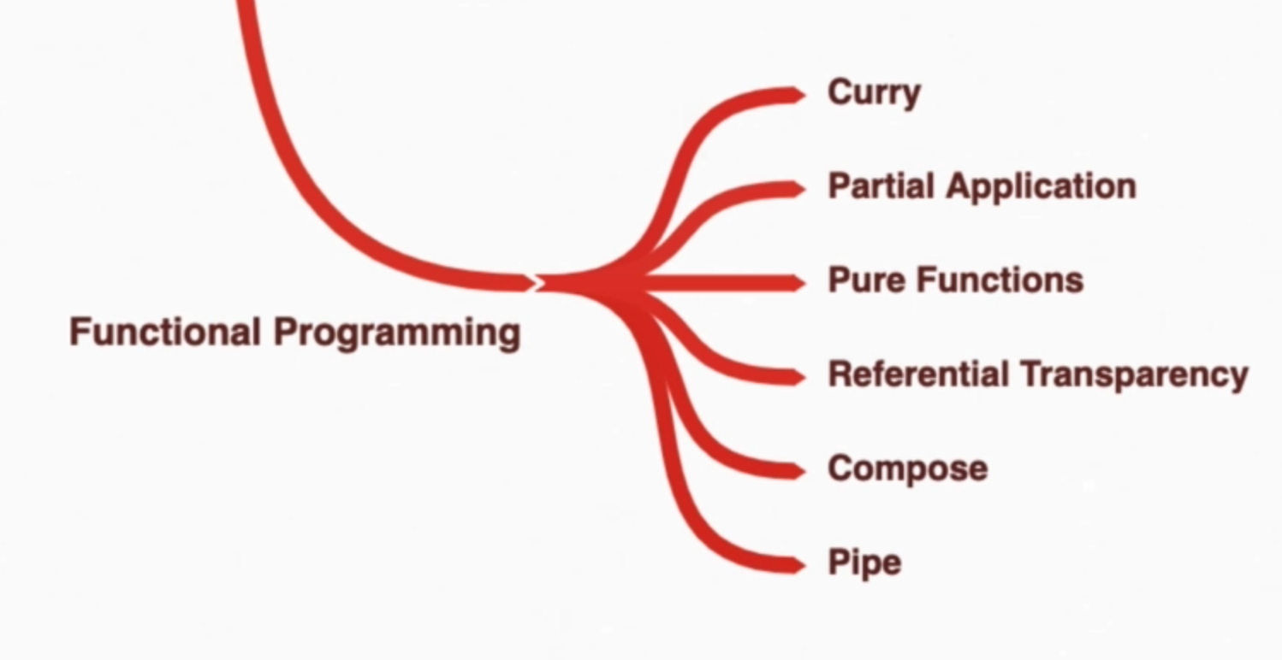



2. Functional Programming Introduction

Functional Programming is all about separation of concerns which object oriented programming does as well.

It’s all about packaging our code into separate chunks so that everything is well organized.

Functional programming separate data and functions. Functions operate on well-defined data structure like array and object rather than actually belonging to that data structure.

In Functional Programming we have one important pillar which is a “Pure function”

3. Exercise Amazon

This is the exercise

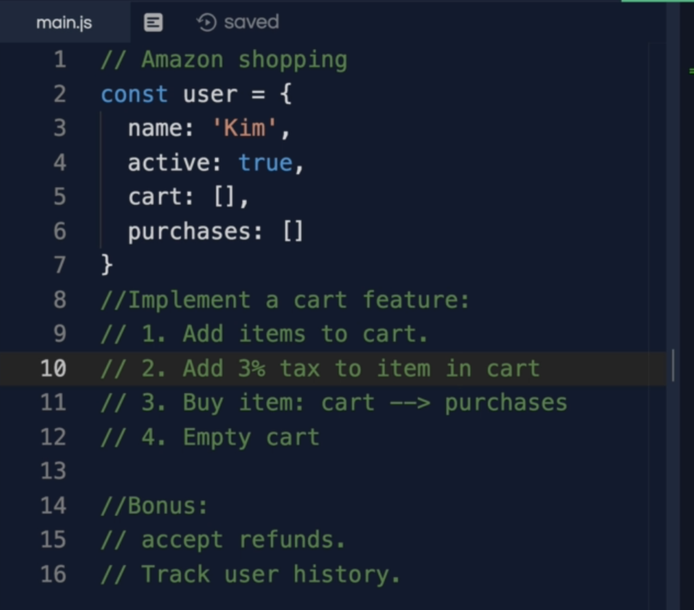

4. Pure Functions

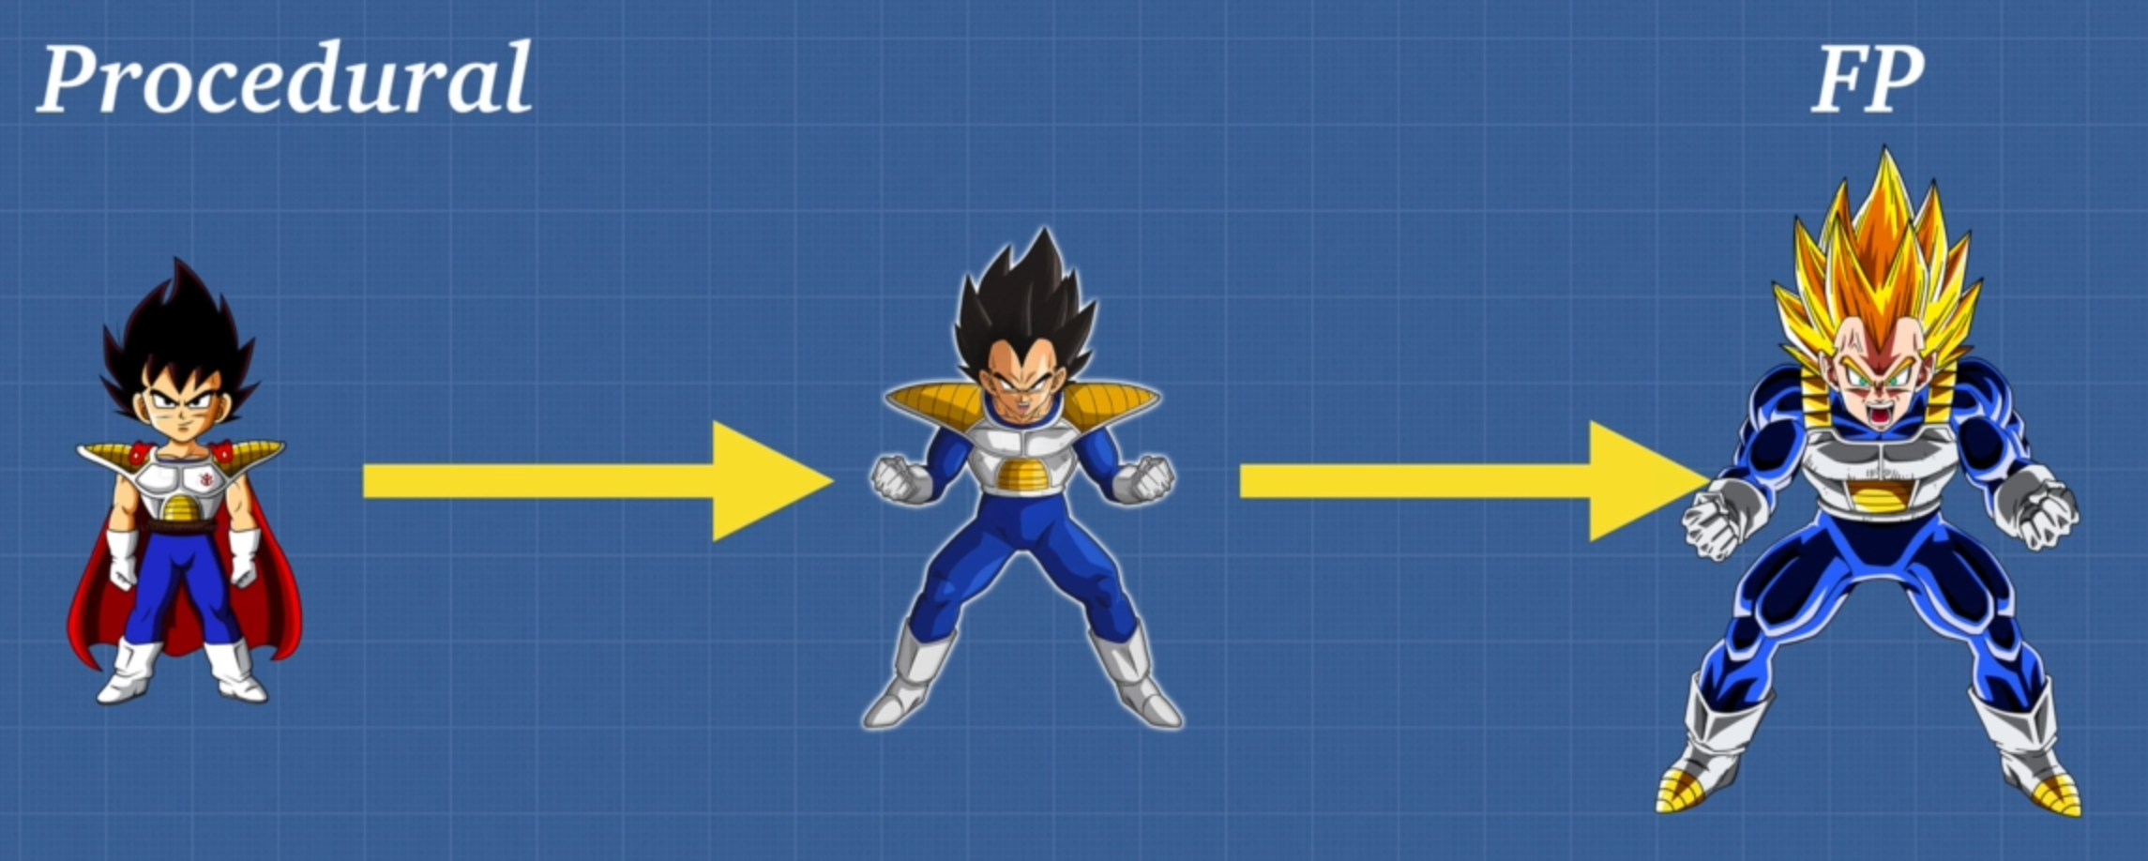

When it comes to pure function there are 2 main things

1. A function has to always return the same output given the same input

They can remember the output so next time they call it, it doesn’t have to calculate again and just return the result. It is called “Referential Transparency”

1. A function cannot modify anything outside of itself. No side effects.

An example of a NON-PURE function. It takes the input as pincode and the output it weather so we cannot predict and input and output is not same

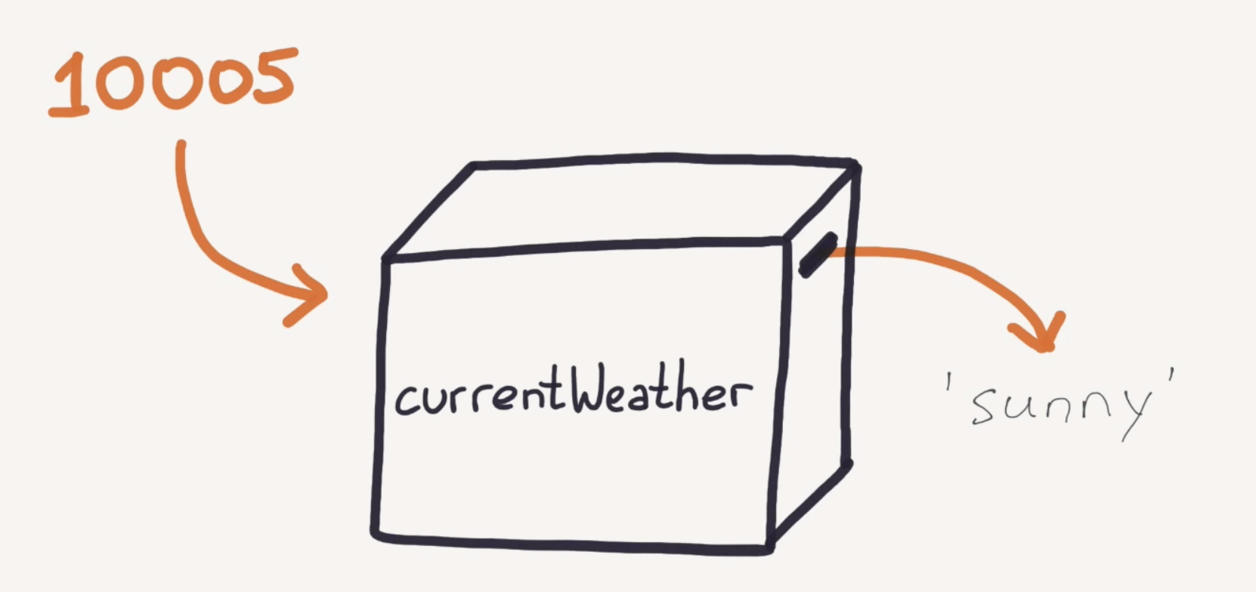

Below code is modifying outside array so not a pure function. Any function can modify this array we would not know who modifies what, and this can cause a lot of bugs.

This function has side effect as this modifying outside array

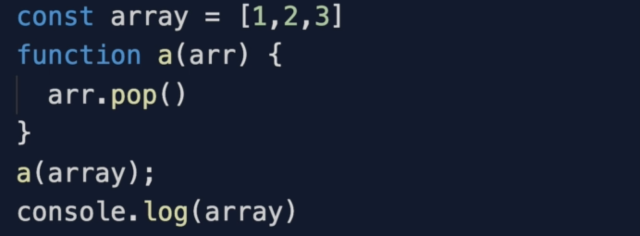

5. Pure Functions 2

These functions have no side effect as they are not modifying outside array instead returns a new array

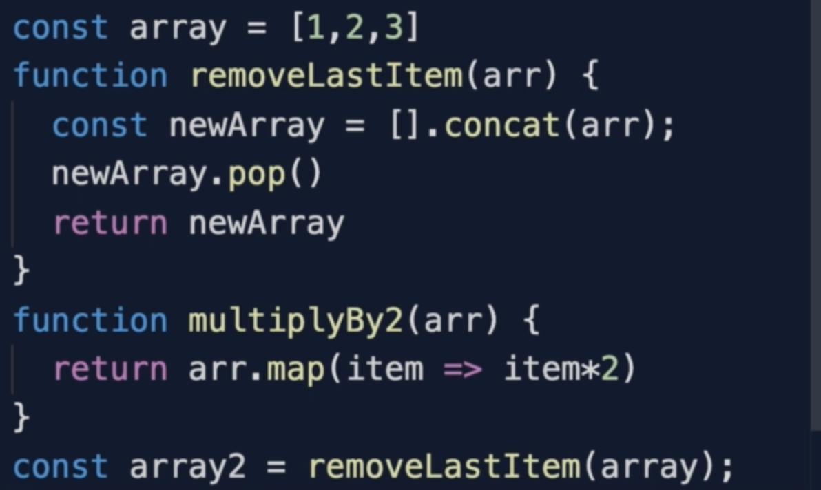

This function has side effect as it is outputting something to global scope

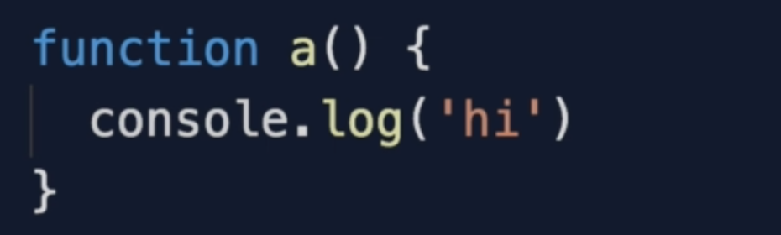

Let’s move to the second rule of pure function that is

Does the function returns the same output as given?

Referential transparency :

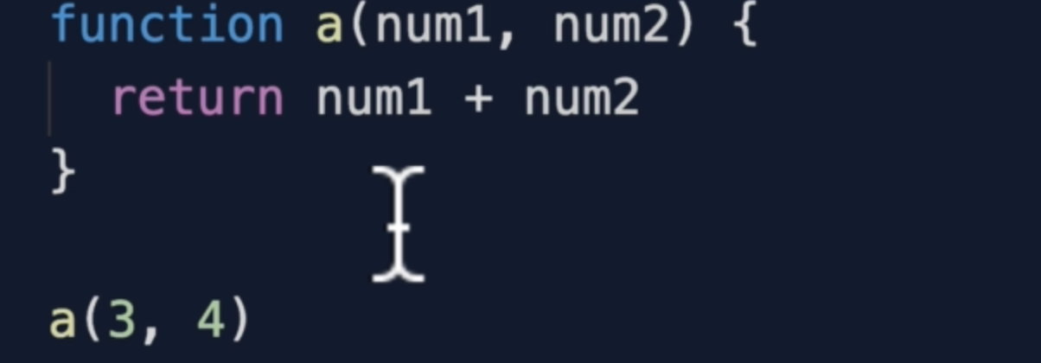

If we completely change function a(3, 4) into 7 which is this function’s result, this is called Referential Transparency

6. Can Everything Be Pure

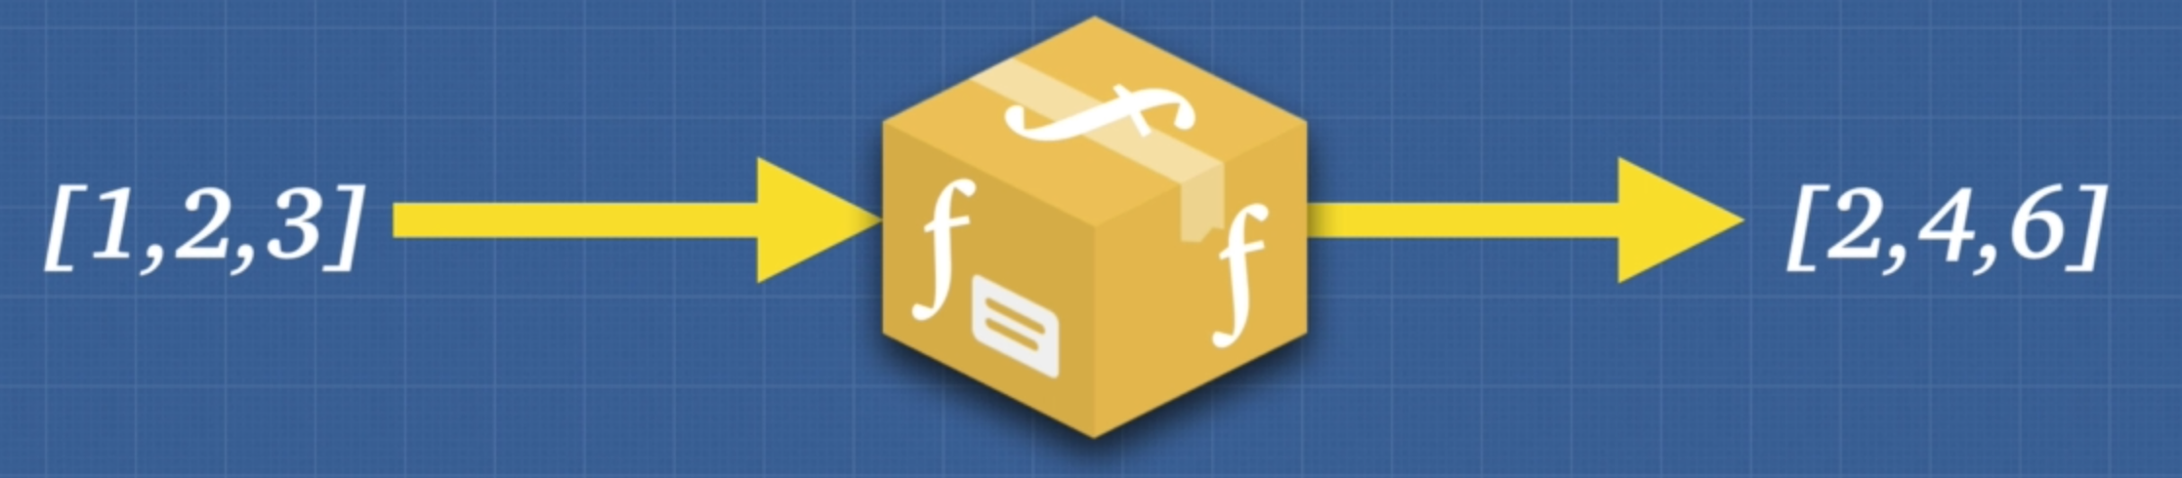

The goal of the functional programming is minimise side effect

This is what a perfect function is all about

7. Idempotent

Function or any request like API returns the same predictable result on calling multiple times is called “idempotent”

8. Imperative VS Declarative

Imperative code tells the machine what to do and how to do it

Declarative code tells the machine what to do and what should happen

This is imperative code. We are telling machine everything like starting point, increment value and when to end loop

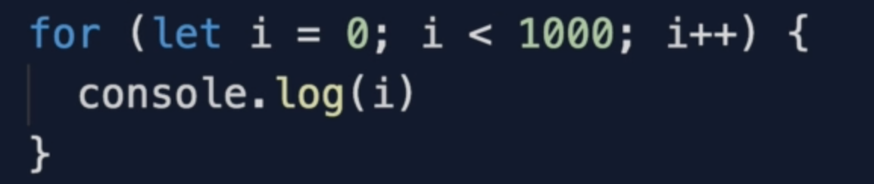

This is declarative code. We just asked to log each item of the array.

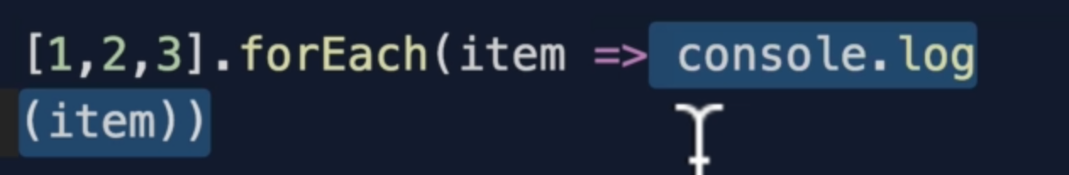

9. Immutability

immutability means not changing the data / state

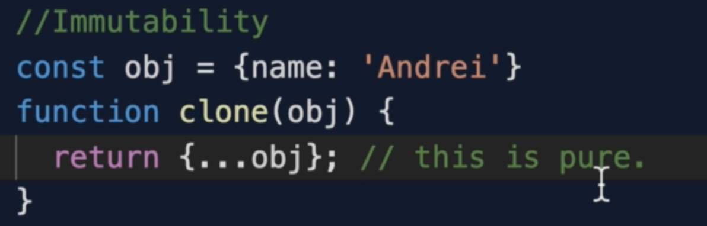

10. Higher Order Functions and Closures

Higher order function is a function that returns a function or take parameter as a function.

The closure function in the below code is not pure function as it is modifying the outer scope variable

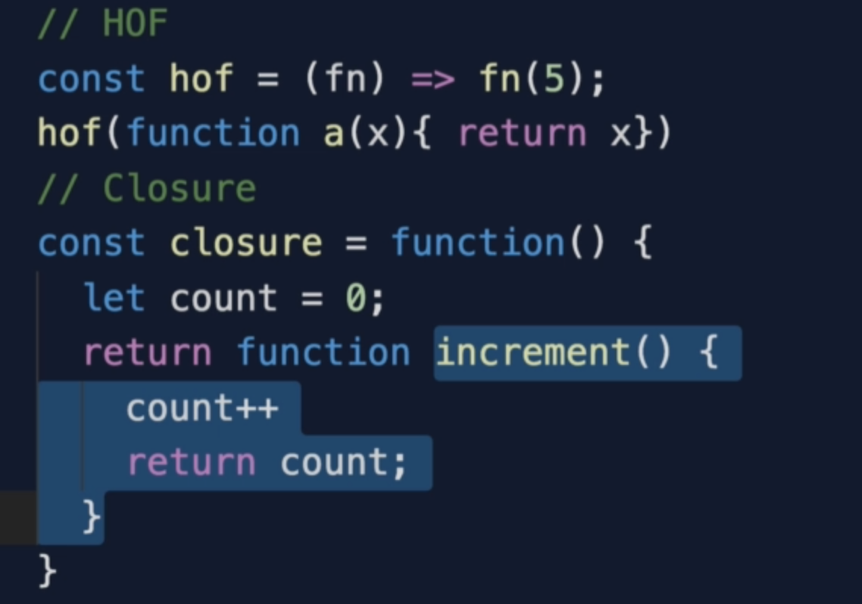

Now changed the above function into a pure function as it returns the same value and doesn’t change the outer value.

This creates data privacy

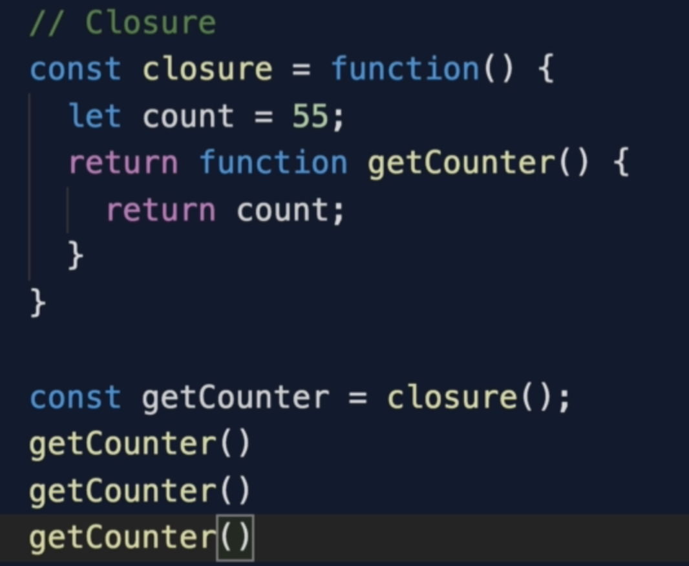

11. Currying

Currying function takes 1 parameter at a time and returns a function. So we can create multiple utility functions.

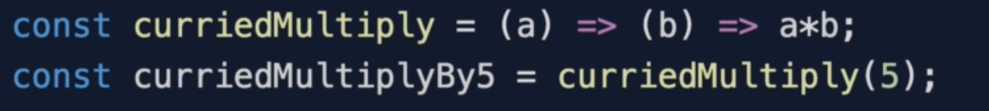

12. Partial Application

It is a process of producing a function with smaller number of arguments. Partial application with curry approach.

If we have 2 arguments in a function and we want to return a argument to 1st returned function and next 2 argument in the 2nd returned function.

Example partial application

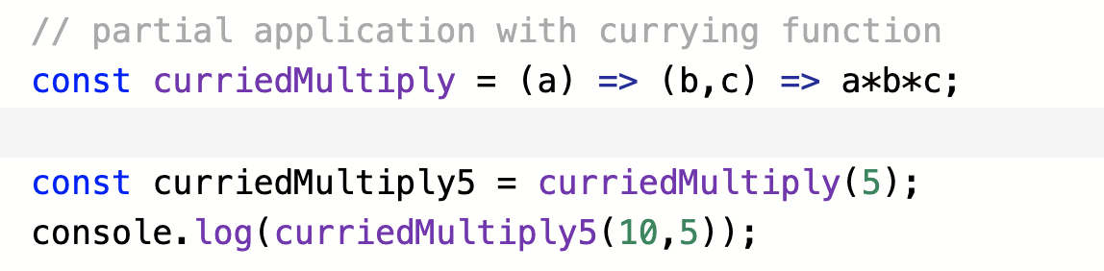

14. MCI Memoization 1

Memoization is a way of caching the result of a function based on param, if we pass the same param again, it doesn’t execute the code again instead it returns the code from cache.

Checking if a key exists in an object

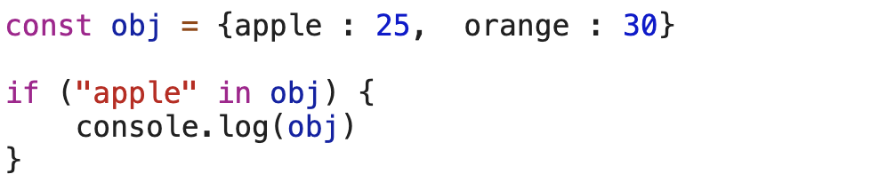

15. MCI Memoization 2

let’s use a closure to create a proper memoization function

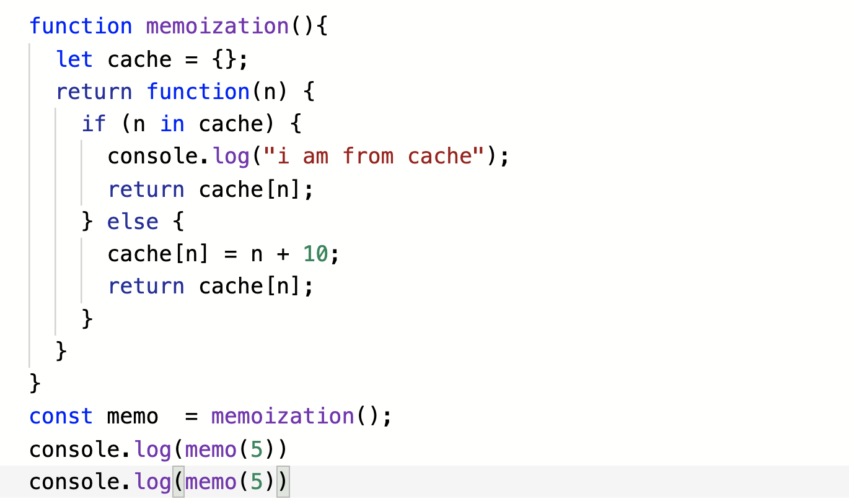

16. Compose and Pipe

Composition is the idea that any sort of data transformation that we do should be obvious

Multiple functions operate on data one by one

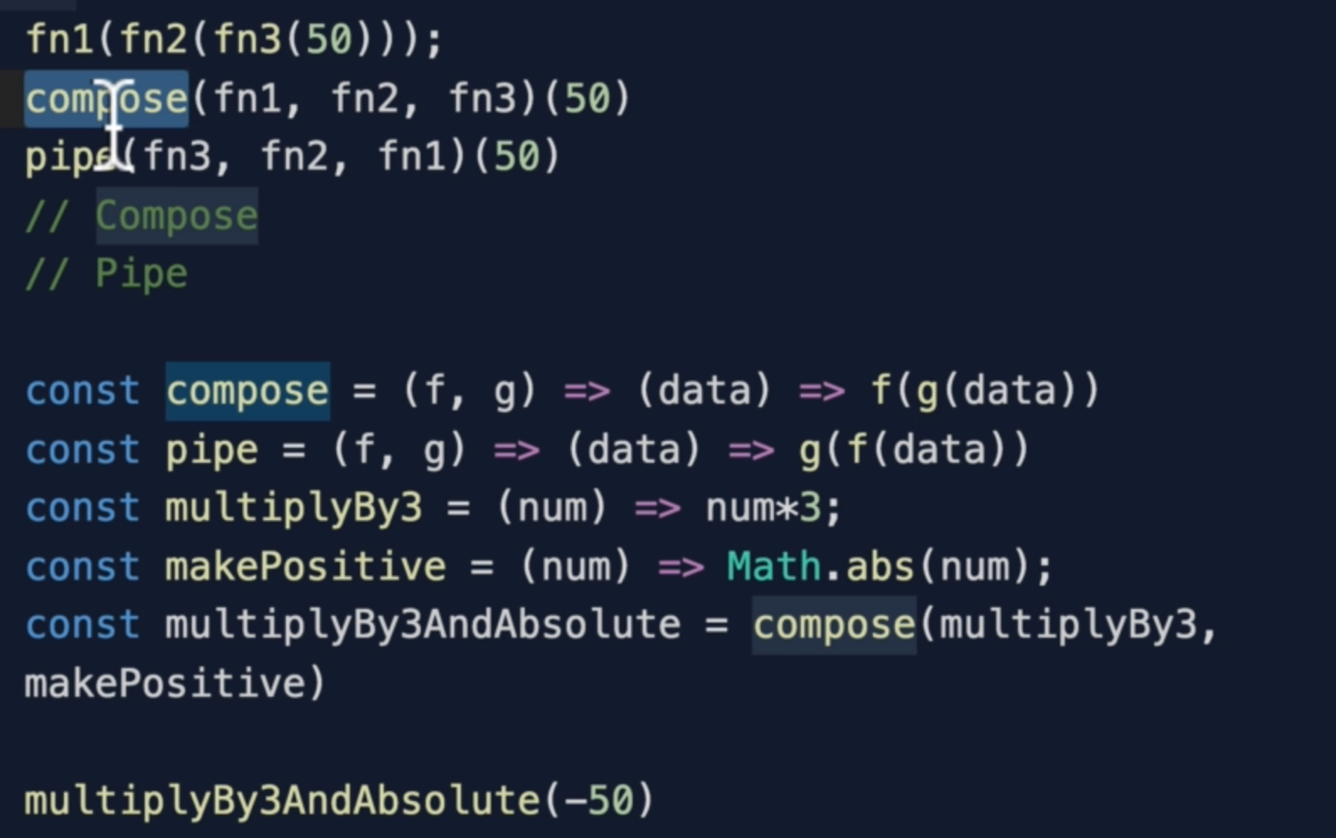

17. Arity

Arity: it means the number of arguments a function takes. That’s it!

A function should contain minimum arguments so it is easy manipulate

18. Is FP The Answer To Everything

Keeping function small, pure, composable, and the idea of immutability, allows us to have predictable output

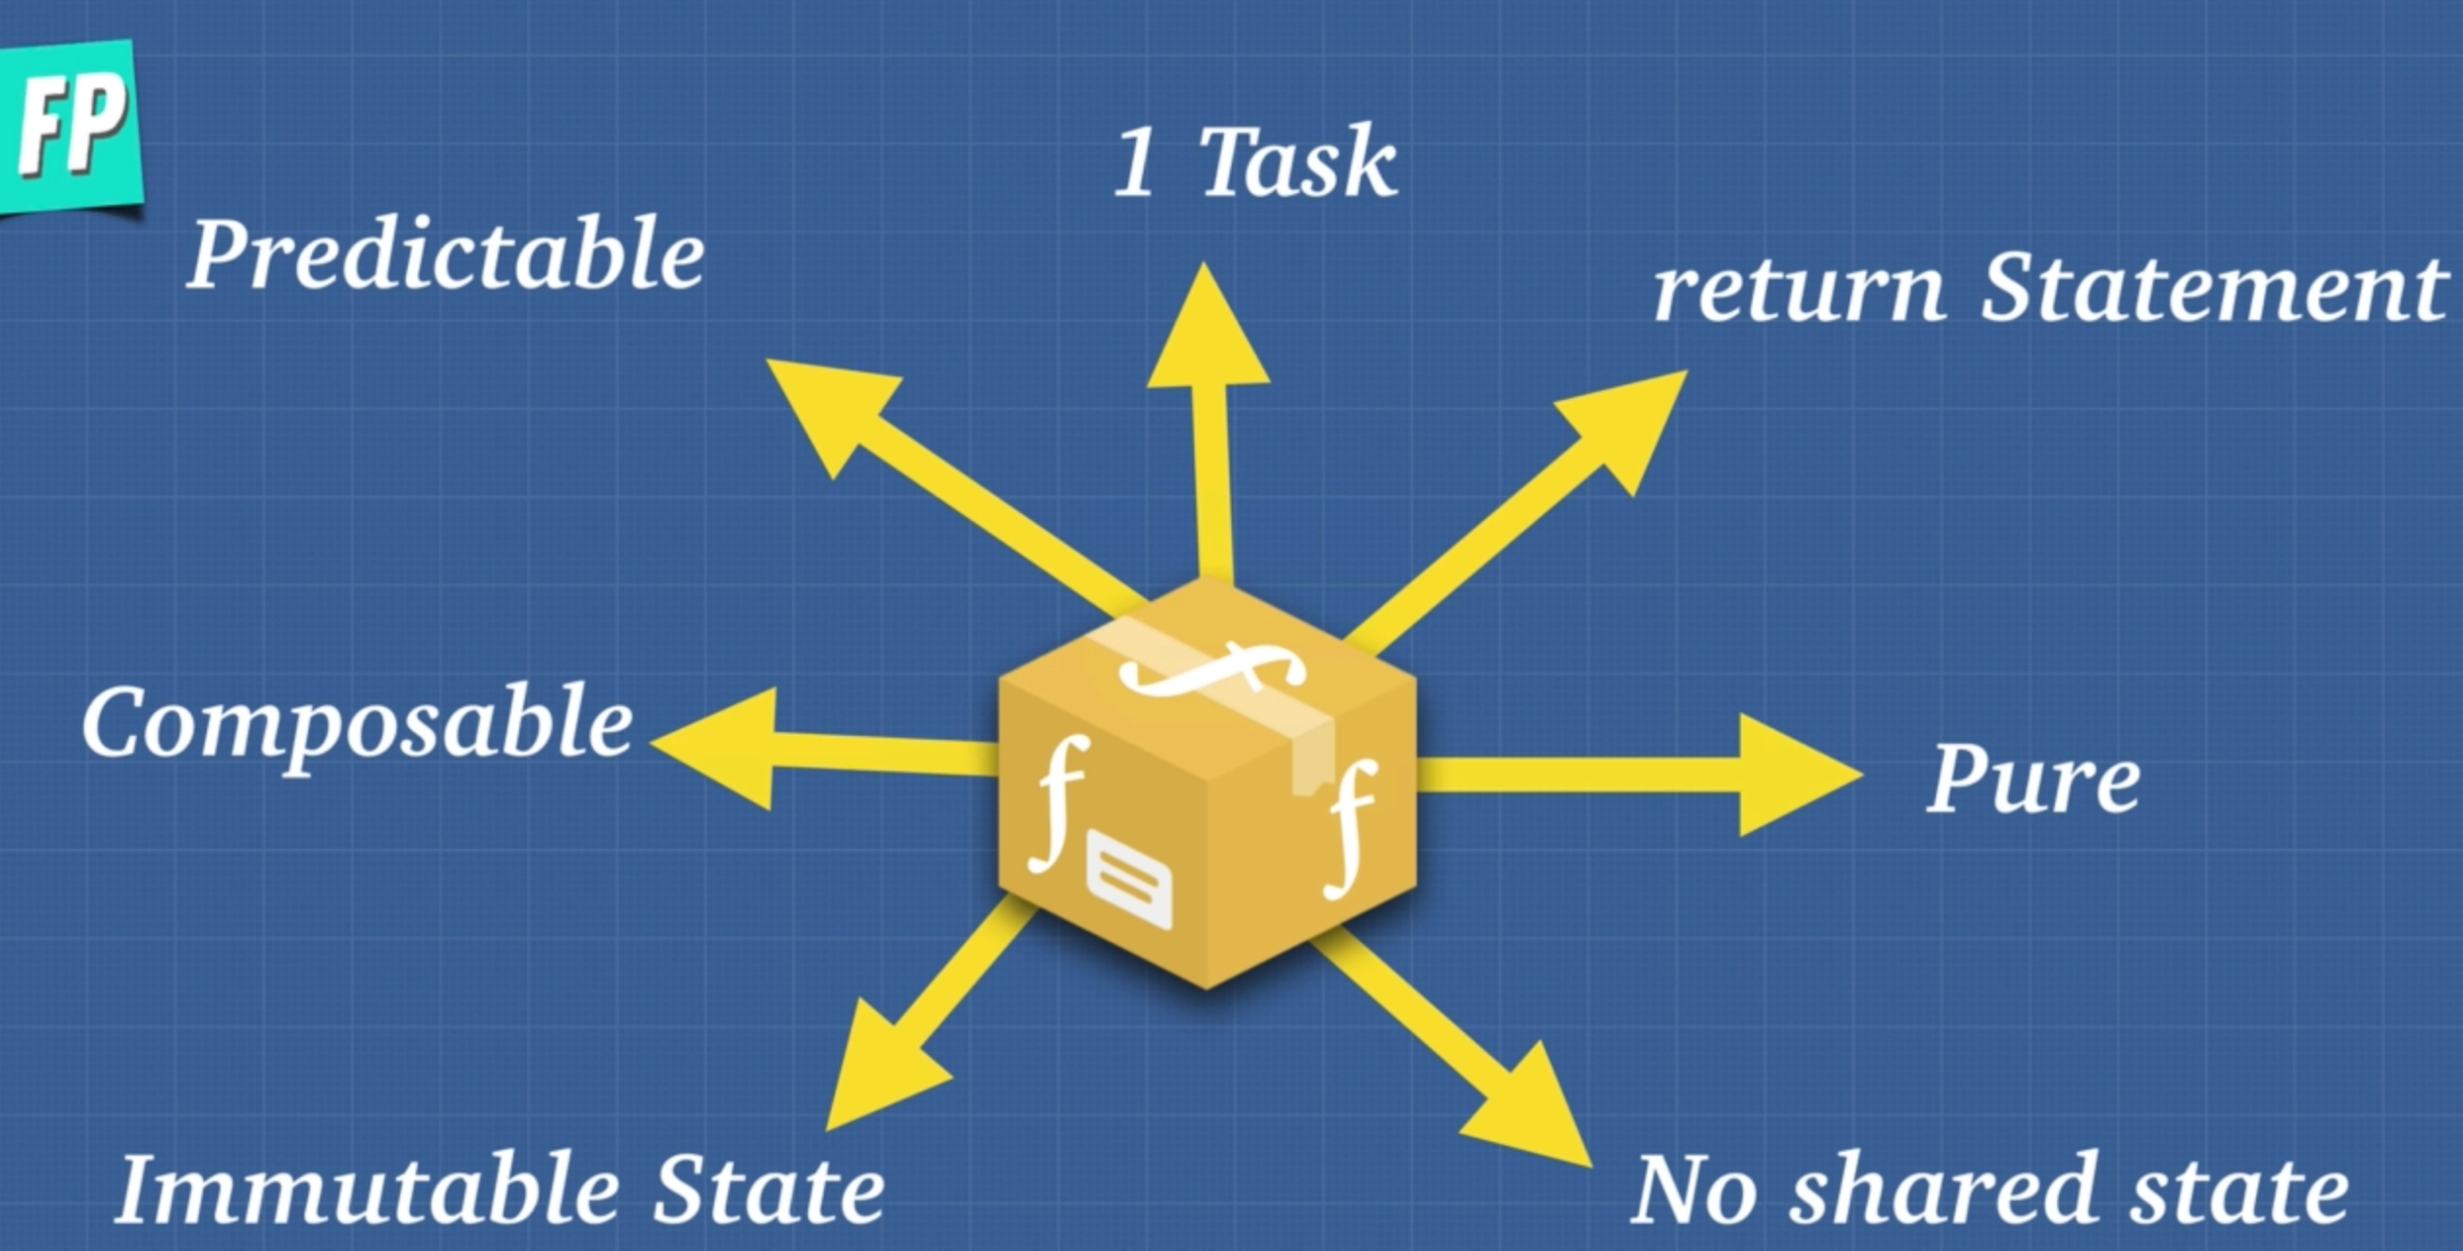

19. Solution Amazon

Now let’s apply the principle of functional programming into Amazon shopping cart solution.

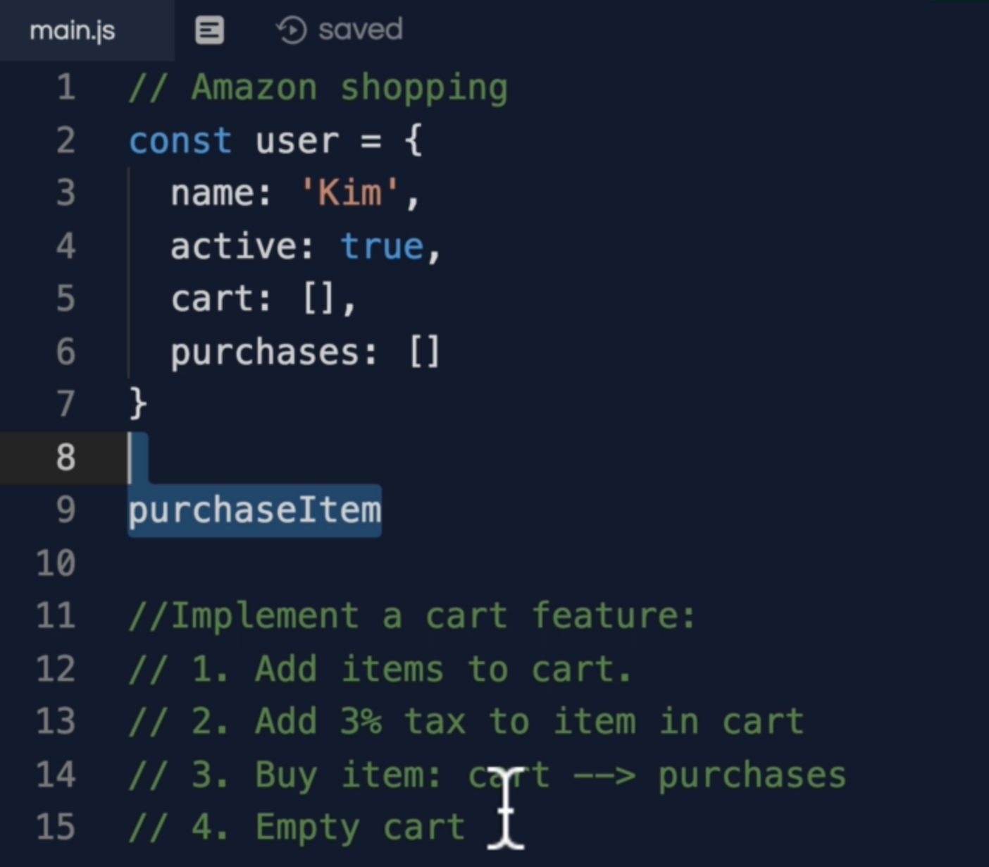

Rest we will do it later!

8. OOP vs FP

We will do it later!!!

9. Asynchronous JavaScript

later

Represents

represents

3. Array.isArray()

9. Asynchronous JavaScript

3. How JavaScript Works

Q. How does JavaScript actually works?

Q. Explain the difference between asynchronous and synchronous?

Q. Is JavaScript single threaded?

Ans: Single threaded means, it has only one call stack. It can do one thing at a time.

Note: it can be non-blocking by converting Synchronous to Asynchronous

What does a program do?

Ans: It allocates memory, parse, and execute.

JavaScript Engine

It consist of 2 parts

1. Memory Heap : all your variables and functions
2. call Stack : this is where you code runs and executes. It tells you where you are in the program

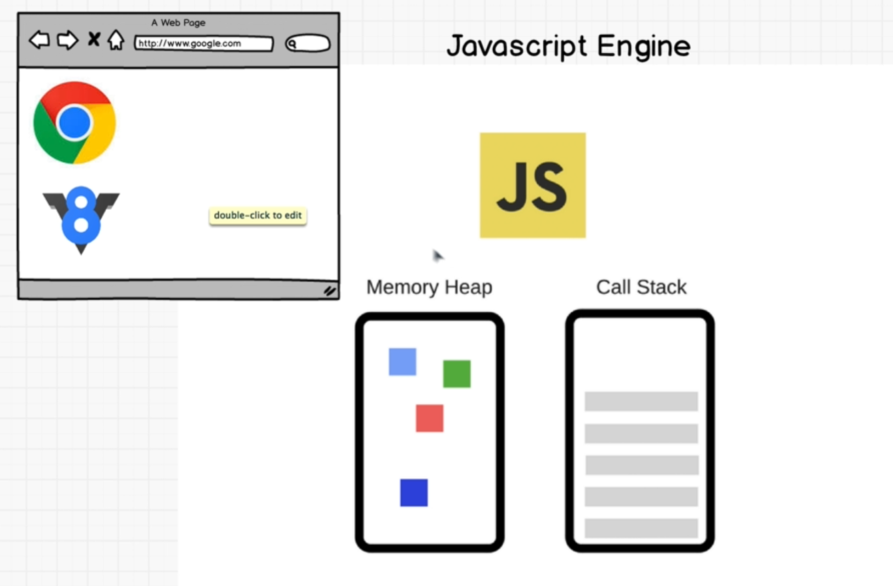

StackoverFlow we can create it using recursion

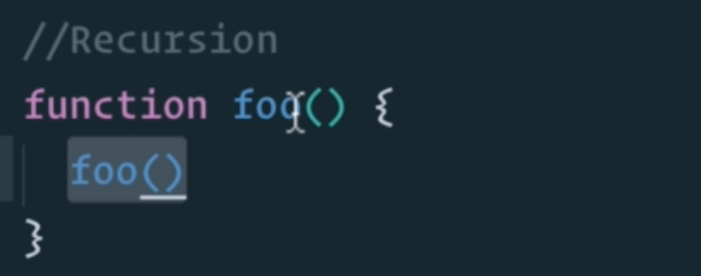

In order for JavaScript to run for the JavaScript Engine with memory head and call stack we need more than that and that is “JavaScript Runtime Environment”

“JavaScript Runtime Environment” is a part of the browser. It is included in a browser.

“JavaScript Runtime Environment” also has :

1. Web APis
2. Callback Queue
3. Event Loop

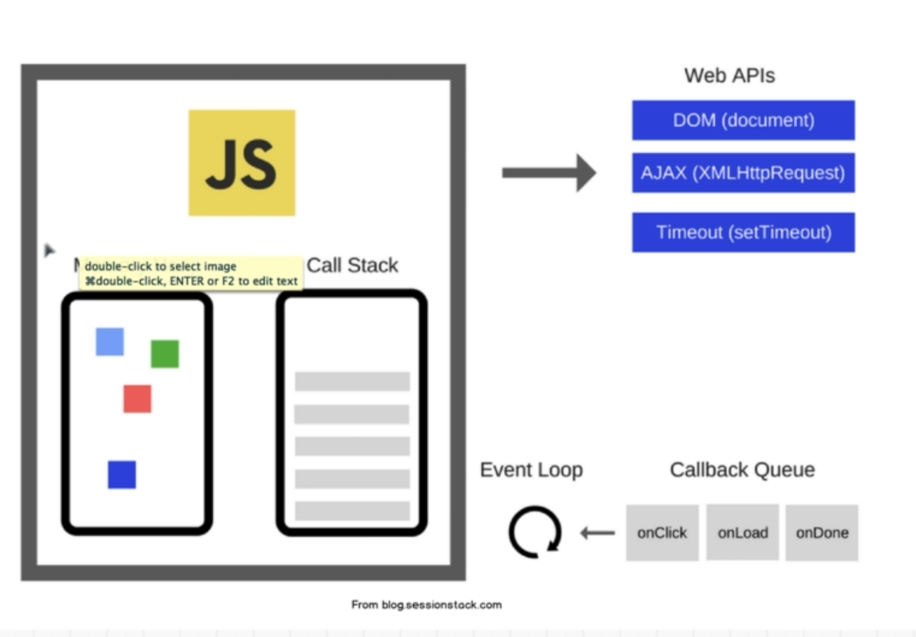

Note: setTimeout() is part of the webAPI. It is not technically part of JavaScript.

4. Promises

It is a feature of ES6.

The **Promise** object represents the eventual completion (or failure) of an asynchronous operation, and its resulting value.

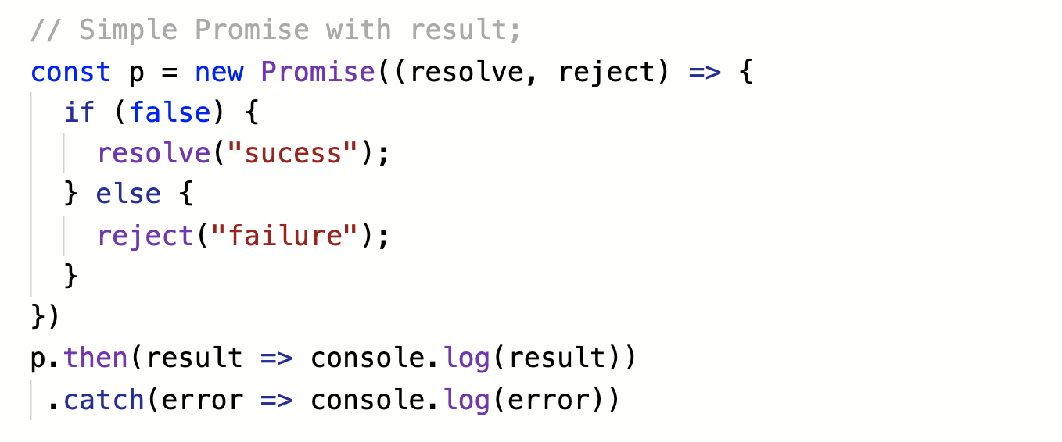

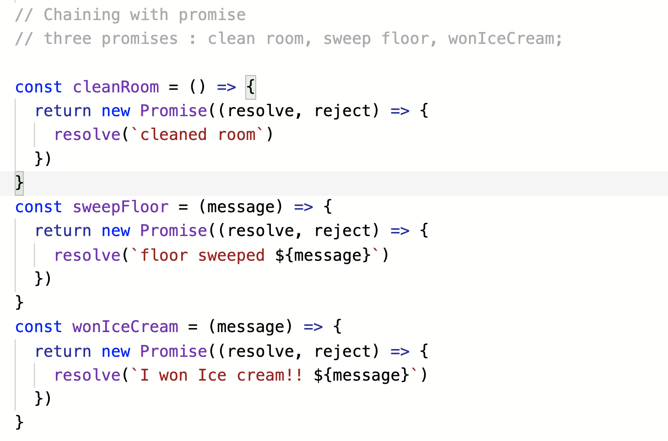

Calling above promises in chain

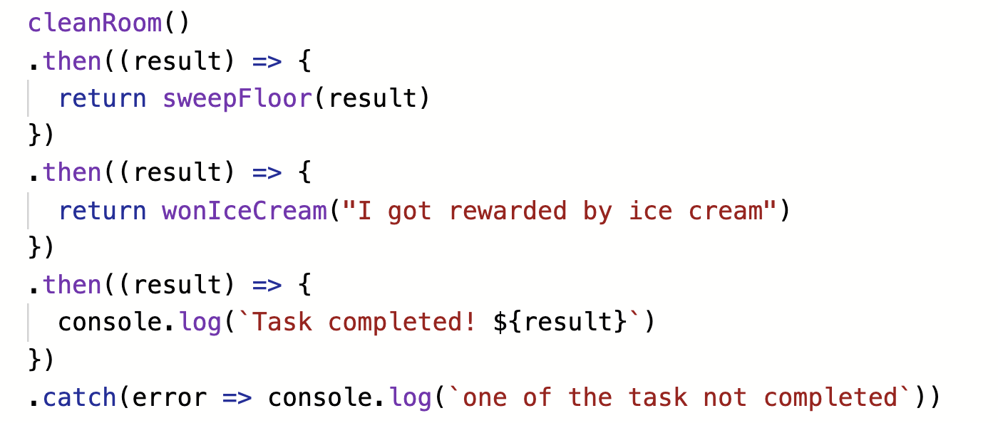

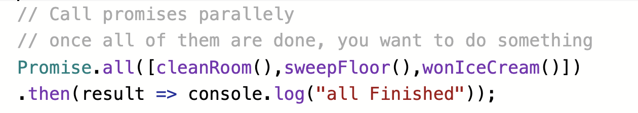

Let’s say you have 3 servers with the same data and you try to pull and as soon as you get first one shows up, you are satisfied because you get the data.

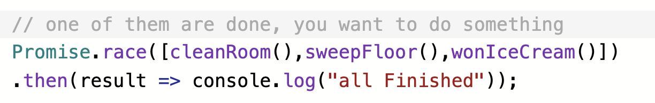

6. ES9 (ES2018)

8. Job Queue

Promise is not part of webAPI. JavaScript has a native way to handle asynchronous code if you use promise. ES6 introduced another queue called “JOB QUEUE”

Note: “JOB QUEUE” has higher priority than “webAPI CALLBACK QUEUE”

Event loop checks “JOB QUEUE” first and then move to callback queue

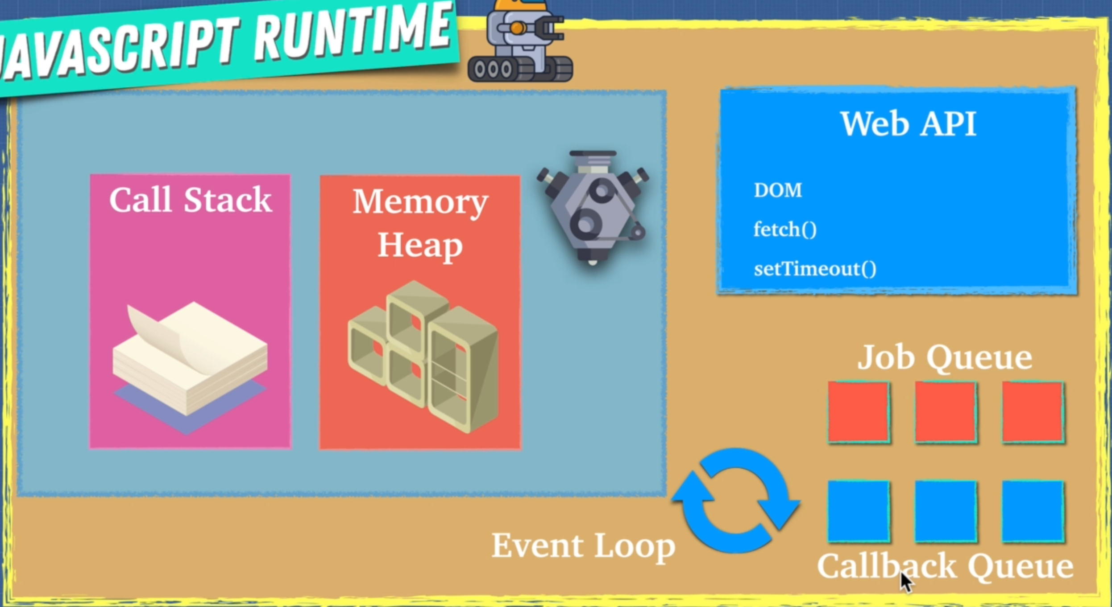

Note: some legacy browsers might not have “JOB QUEUE”

9. Parallel, Sequence and Race

10. Threads, Concurrency and Parallelism

Browsers

How to check if a value is Array

Ans:

const arr = []

arr.constructor === Array // true